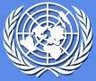

UN Disaster Management Team
(UNDMT)

CAMBODIA
DISASTER PREPAREDNESS & RESPONSE PLAN
(updated August 2011)

** DRAFT **

Contents Page

Introduction 3

Part A – Context Analysis 4
i) Flood (Impact, Forecast & Likelihood,
Geographical Patterns, Critical period) 5
ii) Drought (Impact, Forecast & Likelihood,
Patterns, Critical period) 7
iii) Conflict (Impact, Forecast & Likelihood, Patterns) 9

Part B – Potential Humanitarian Scenarios 10
i) Flood 10
ii) Drought 10
iii) Conflict 11

Part C – Coordination and Partnerships 15
i) UN Coordination 15
ii) Government Partnership 15
iii) NGO Partnership 15

Part D – Disaster Response / Activation & Initial Steps 16
- Activation of UN disaster response 16
ii) Needs Assessment 17
iii) Initial Steps Action Plan 18

Part E – Disaster Response / UN Agencies’ Roles & Responsibilities 19
i) Provisions for Physical Support by Sector 19
ii) Agencies’ Operational Modalities and Technical Support 20

Part F – UN Agency Field Presence 22

Part G – UN Emergency Fund Availability by Agency 23

Annex 1. – Composition of UN Disaster Management Team (UNDMT) 25
Annex 2 – Contact Details (Gvt, CRC, NGOs) 26
Annex 3. – Cambodia Hazard Calendar 27
Annex 4. – Technical Working Groups 28

Introduction

Despite recent socio-economic progress, Cambodia remains one of the poorest countries in Southeast Asia. With nearly 30 percent of Cambodians living below the poverty line, Cambodia is classified as a least developed, low-income, food-deficit country. Thirty years of conflict ending in the late 1990s, high population growth, low agricultural productivity and poor access to health and education services are contributing factors to continued poverty.

Cambodia is considered one of the most hazard-prone countries in South-East Asia. The major disasters faced by the country, are in order of prevalence, floods, droughts, typhoons, forest fires, landslides and storm. With approximately 70% of the population living agrarian existences, natural disasters can have devastating consequences on the livelihoods of the majority of Cambodians.

According to the 2010 Asia and Pacific Disaster Report 16 million Cambodians were affected by disasters between 1980 and 2009, the tenth highest among Asia-Pacific countries. The report estimates that 1.7 million (12.2%) Cambodians are currently exposed to floods. Based on these estimates Cambodia is ranked first among all countries in Asia in terms of the proportion of the population exposed to floods, while it is ranked fifth in terms of absolute numbers at risk.

Border dispute and occasional clashes between Thai and Cambodian military troops in recent years have also created future potential “man-made” conflicts. The clashes are part of an ongoing border dispute between Thailand and Cambodia relating to land near the UNESCO world heritage site of Preah Vihear temple. As tension along the Thai-Cambodia border continues, armed conflict or outbreaks of violence at along the border cannot be ruled out.

In recognition of the vulnerability of communities to the effects of natural disasters or conflicts, and the expected likelihood of their continued occurrence in Cambodia, the UN has worked to assist in the improvement and streamlining of disaster response and mitigation efforts. A central aspect of this is the coordination of preparedness and response activities of UN agencies under the UN Disaster Management Team (UNDMT). The UNDMT’s Disaster Preparedness and Response Plan aims to coordinate the various efforts of UN agencies to anticipate and undertake preparatory actions and plan a rapid, appropriate and effective course of action in the event of a slow or sudden onset natural disaster or conflict situation requiring UN intervention. This plan outlines resources UN agencies in Cambodia which could be available to support the Royal Government in its response to an emergency warranting a humanitarian response.

The Plan is focused on flood and drought preparedness and response, as these are the primary reoccurring natural hazards affecting Cambodia, but also on conflicts, as the border dispute with Thailand might trigger additional clashes in the future.. This plan does not cover proposed responses to an Avian Influenza (AI) pandemic. For AI pandemic preparedness and response, refer to the United Nations-Cambodia Contingency Plan for A Human Influenza Pandemic. The contingency plan is prepared by the UN Crisis Management Team which is chaired by World Health Organization (WHO).
PART A - CONTEXT ANALYSIS

Cambodia is ranked 124th on UNDP’s 2010 Human Development Rating list. Up to 30 percent of the population lives under the poverty line and 15percent are chronic poor. It is estimated that approximately 70percent of the population have agrarian based livelihoods and poverty statistics in the country are highest in households whose head is engaged in agriculture. The rural population is therefore most likely to be living in poverty and because of their reliance on the natural environment, the most vulnerable to the effects of disturbances to their environments, like natural disasters.

Cambodian weather patterns generally fall into a typical monsoonal wet and dry season (wet July-Oct, dry Nov-June). The country is traversed by two large water systems, the Mekong and the Tonle Sap. The Tonle Sap is tidal and usually operates as an alluvial reservoir for the overflow of the Mekong during the wet season. Local communities, especially those along the two water systems, have established traditional mechanisms for utilizing and coping with the annual monsoonal flooding and dry periods.

According to the 2010 Asia and Pacific Disaster Report 16 million Cambodians were affected by disasters between 1980 and 2009, the tenth highest among Asia-Pacific countries. The report estimates that 1.7 million (12.2%) Cambodians are currently exposed to floods. Based on these estimates Cambodia is ranked first among all countries in Asia in terms of the proportion of the population exposed to floods, while it is ranked fifth in terms of absolute numbers at risk.

It is not uncommon in Cambodia for both drought and flood to occur within the same year. In 2000, the country suffered the most devastating floods in 70 years which resulted in 347 deaths, the evacuation of 85,000 families and economic losses of US $150m. In 2001, the country was hit by another flood and a period of drought, causing US$36 million damage and causing food shortages for almost a million people. Moreover, in 2009, the Post Disaster Needs Assessment (PDNA) estimated the total damage and loss caused by Typhoon Ketsana to be USD 132 million (damage: USD 58 million and loss: USD 74 million). This co-existence of drought, typhoon storm and flood compounds the complexities of disaster response in a country with an already limited capacity to react.

Recent flood and drought patterns in Cambodia also indicate a heightening in severity and likelihood of both types of disaster. The country’s long coastline and lowlying land make it especially prone to the negative effects of climate change. Deforestation, population growth, urbanization, land misuse, environmental degradation, and continued industrialization, together with climate change, have contributed to less predictable seasonal patterns, abnormal water flows and more unexpected or extreme weather related events. This lack of weather predictability coupled with an erosion of traditional coping mechanisms means exposed populations are increasingly in need of natural disaster risk reduction and response assistance.
In respect to the contextual factors possibly triggering conflict, Cambodia and Thailand maintain a border dispute over a land surrounding the Preah Vihear temple (Choam Khsant district) and in the Samraong district (Oddar Meanchey Province). Thailand claims the ownership of 4.6 square kilometers (1.8 square miles) of scrub next to the temple. In 2008, Preah Vihear was enlisted by UNESCO as a World Heritage Site, and just a week after this event armies exchange fire at the border. Since then, periodic clashes between Cambodian and Thai soldiers have resulted in deaths, injuries and IDPs (Internally Displaced Populations) on both sides, with the additional disruption of people’s livelihood, heavily dependent in primary sector activities.

With tension along the Thai-Cambodia border (with large segments remaining without complete demarcation), continuing, armed conflict or outbreaks of violence at other points along the border cannot be ruled out. Moreover, Thailand upcoming elections (3 July 2011) and Cambodia’s appeal to the ICJ to interpret the verdict 1962, could create more tension on the diplomatic solving efforts.

i) Floods

Impact

Cambodia’s vast flood plain is one of the country’s most prominent geographical features. This makes large portions of the country naturally susceptible to annual flooding particularly along the Tonle Sap and Mekong river watersheds. The floods have both beneficial and harmful effects. Floods have a beneficial impact on agro-based livelihoods (e.g. improve soil moisture, fertility for agriculture, ground and surface water recharge and provide ecological benefit for fisheries) upon which hundreds of communities depend upon for their livelihood. In certain years, however, flooding becomes excessive and results in the lost of human life, destruction of crops and livestock, and damages to homes and the already fragile network of community infrastructure (e.g. school, health centers, local roads and bridges).

In 2000, Cambodia experienced the most damaging floods reported in over 70 years. According to the official report from the Royal Cambodian Governments National Committee for Disaster Management (NCDM), it was estimated that the floods directly affected over 3.4 million people and resulted in 347 fatalities, (80% of whom were children). Approximately 40% of annual wet-season rice areas were completely destroyed which had both immediate and ongoing consequences for communities who are largely reliant on seasonal yields for their livelihoods.

Forecast & Likelihood

The Mekong River Commission (MRC) releases daily reports on Mekong water levels which show the current water level against alarm and flood stage measurements, and a prediction of the level for each day in the next week. Measurements are taken from eight stations lining the Mekong reaching from Strung Treng in the North to Chau Doc (Bassac) in the South. The reports are available on the MRC website (http://www.mrcmekong.org/) and are sent by daily email to a number of DMT agencies. Seasonal precipitation forecasts are also available from the International Research Institute for Climate Prediction (IRI) (http://portal.iri.columbia.edu/portal/server.pt).

For 2011, heavy rains recorded in late-July and early August have triggered early warnings of flooding, notably for the Mekong basin. The situation will need to be followed closely.

Patterns

The country is naturally susceptible to two major flood types:

- Mekong flood – Cumulative rainfall in the upper catchments throughout the rainy season causes a slow but steady rise in water levels lasting for several days. This can be aggravated by two factors. First, when this combines with heavy rains around the Tonle Sap Lake, which affect the provinces around the lake and the southern provinces. Secondly, the most severe floods occur when heavy rains coincide with the arrival of tropical depressions and stroms. Mekong river floods are common occurrences in the provinces of Stung Treng, Kratie, Kampong Cham, Prey Veng, Svay Rieng, and Kandal.

- Flash flood – Repeated heavy rainfall in mountainous areas, which flows to stream and tributaries of the Mekong River branch of river often flash floods. These floods are swift and last only for a few days but often cause severe damage to crops and infrastructure especially in tributaries around the Tonle Sap Lake. Flash floods have been reported to affect the provinces of Kampong Thom, Kampong Speu, Kampot, Pursat, Battambang, Kampong Chhnang, Seam Reap, Odor Meanchey, Bateay Meanchey, Preah Vihea, Rattanakiri, and Kandal

A 2003 study identified 260 out of a total 1,621 communes that are prone to flood (See Map 1)

Map 1. Flood Prone Communities – Cambodia1

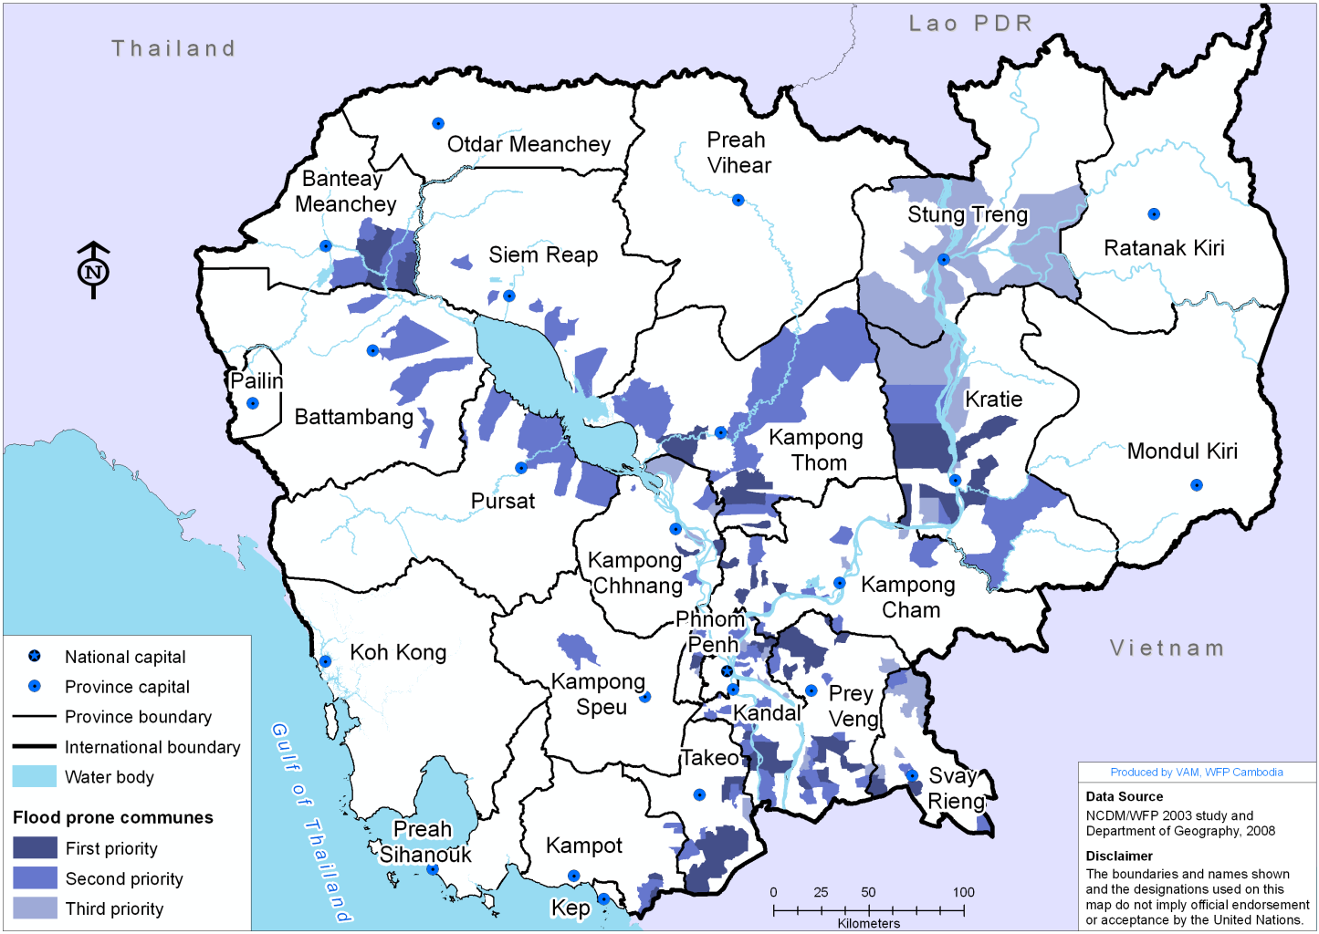

Critical period for flood

Seasonal floods normally occur along the Mekong River and the Tonle Sap Lake during the monsoon rainy season from July to October, with peak season usually from late August to early October See Appendix 3.

ii) Drought

Impact

Drought can have significant affects on communities, causing food insecurity, malnutrition, starvation, increased poverty, disinvestment in human capital and draining of household financial resources, livelihood disruption, population displacement, migration, loss of home gardens, increased incidence of diseases caused by lack of washing, inability to pay for health care, inability to repay loans and/or rents, water/sanitation concerns, asset sales, borrowing money and/or food/seed and food shortages and possible food price rises.

In regards to food security, over the 5 years previous to 2006, drought was the first biggest cause of crop failure after flooding. The magnitude of damage varies according to time, location and rice varieties.

Forecast & Likelihood

Unlike flooding, drought occurs gradually and does not have a definable beginning. Early warning triggers for drought include delayed onset of seasonal rains, low levels of rainfall, erratic rainfall distribution during cropping season and low early harvest yields.

Reports of drought are often made to local authorities at the village level and predictive reports are available from the International Research Institute for Climate Prediction (IRI).

Likelihood of occurrence in 2011

For 2011, MoWRAM’s weather forecast indicates in general normal condition in which the raining season would start in the second week of May and finish in early November. The rainfall would be evenly distributed throughout the country and would be in an equal level to the last few year’s average level. The same source insisted that short-term dry spell will likely occur in July in the plain region, whereas this phenomenon is unlikely to exist in the plateau and coastal regions.

Patterns

Droughts can occur in one part of the country while other parts of the country are experiencing heavy rains or floods. Recent precipitation data indicates a large discrepancy in regional weather patterns with many parts of the country receiving very high precipitation and other parts receiving very little.

The coastal areas, in the southwest of the country, receive the highest rainfall during the rainy season which is usually May to October. During the rainy season monsoon rains sweep across the country from the southwest to the northeast. The driest parts of the country are in the southeast and northwest. On average these areas receive less than 470 mm per annum during the rainy season.

The 2003 study identified 270 out of 1,621 communes in Cambodia are prone to drought. Map 2 indicates the areas where these communes are located.

Map 2. Drought Prone Areas - Cambodia.

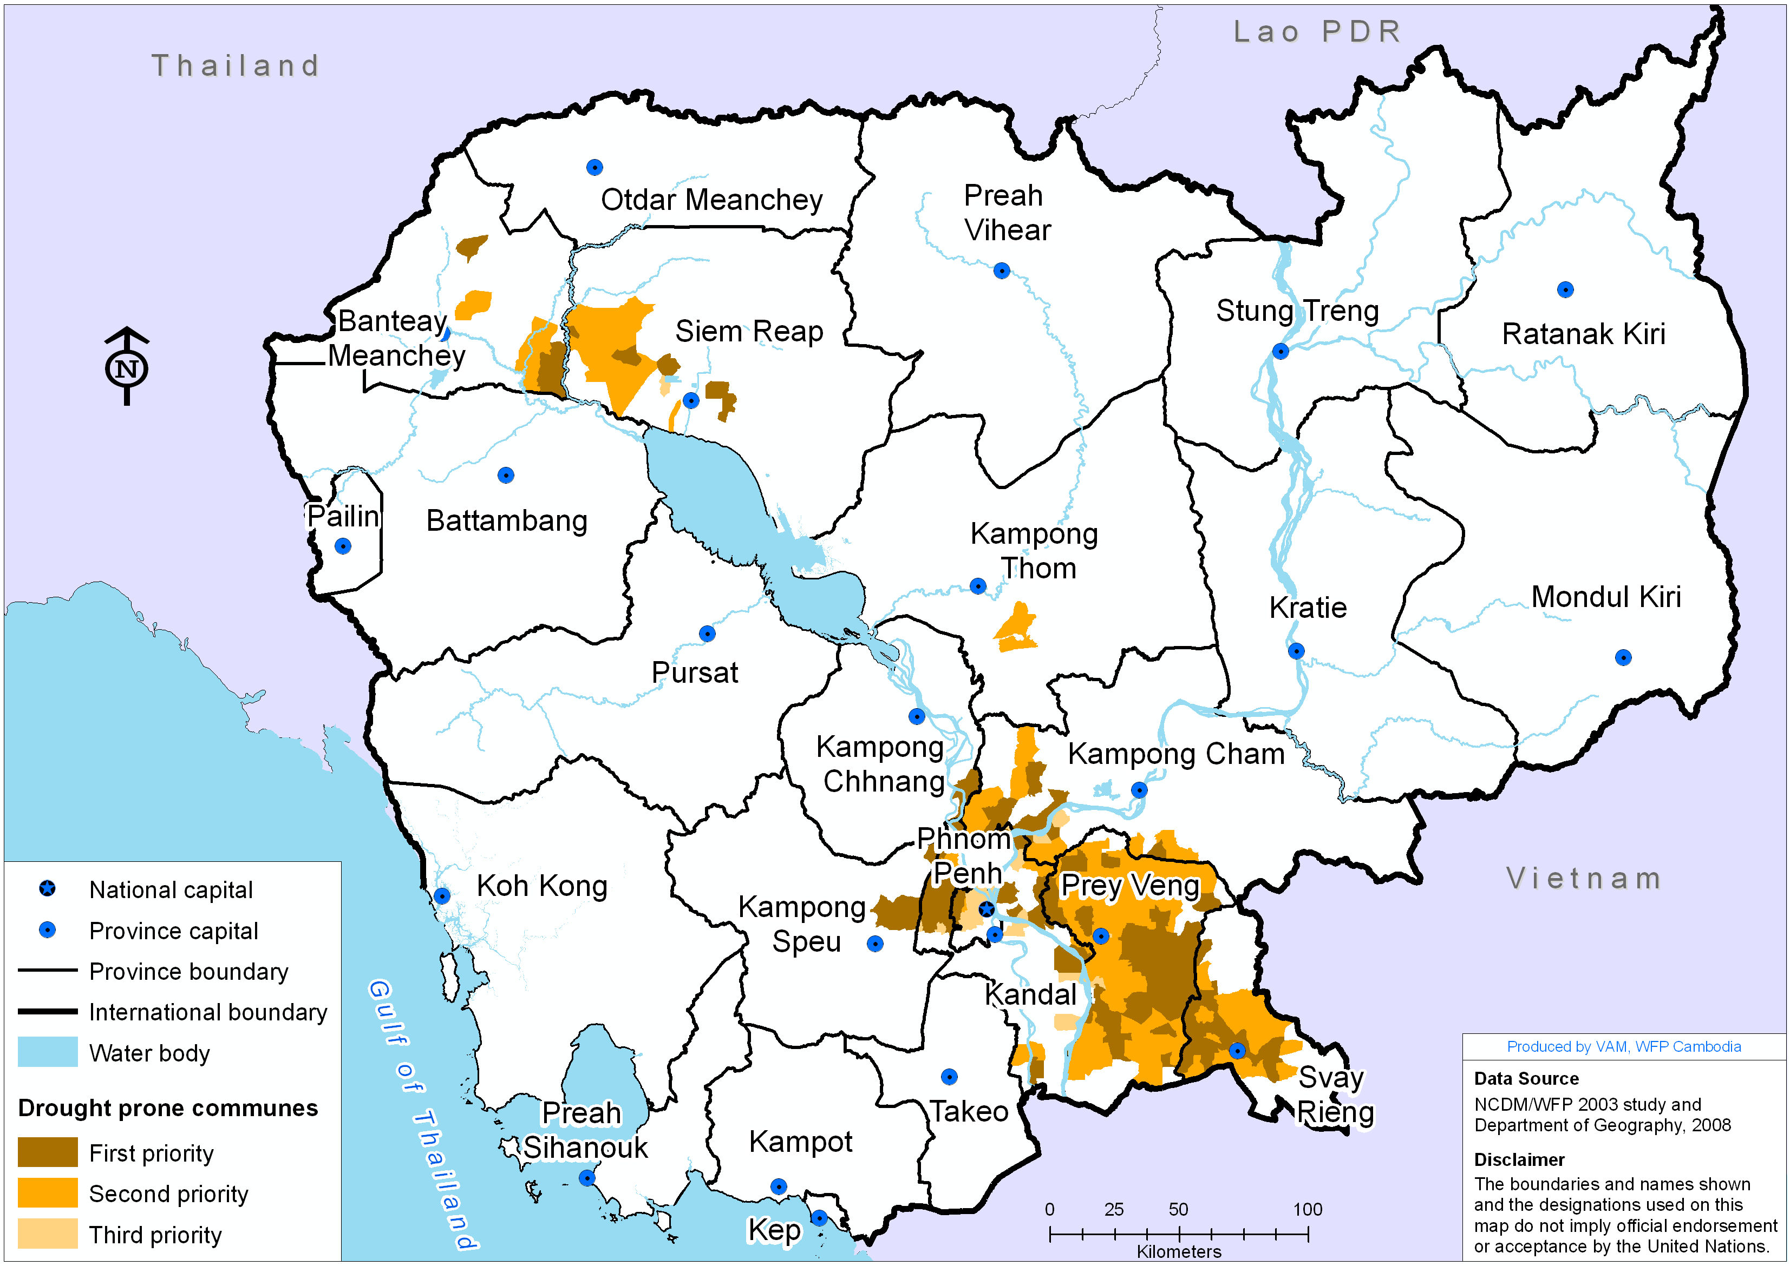

Critical period for drought

The most critical period for drought is from August to November during the annual lean season. See Appendix 3.

iii) Conflict

Impact

2011 border clashes have displaced thousands of households to safe areas. February 2011 events resulted in 2,500 HHs displaced in Preah Vihear province. In April 2011, border incidents caused 10,000 displaced families to be relocated in 13 sites in Oddar Meanchey province. In an attempt to organize the humanitarian response, and in prevention of future clashes, the Government has plans to develop a semi-permanent reception area in Chong Kal district (Oddar Meanchey). The location of the camp would have the capacity to accommodate up to 5,000 families.

Map 3. Conflict Areas and safe site locations - Cambodia.
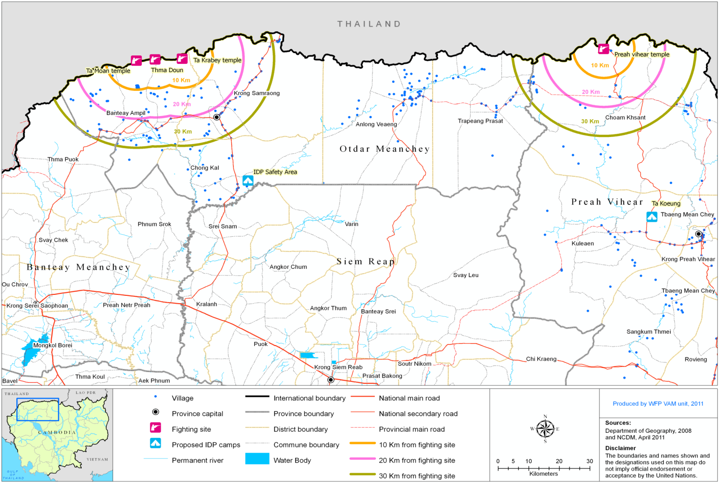

PART B - POTENTIAL HUMANITARIAN SCENARIOS

i) Floods

As indicated by Map 1 in Part A, communes around the Tonle Sap Lake and along the Mekong, particularly in the southern provinces along the Cambodian-Vietnamese border are the most vulnerable to flood.

Based on the 2003 study 260 communes are considered prone to flood as provided in table 1. Within the 260 communes covered by Map 1, vulnerable households have been identified based on the poverty rate (CDB 2009) and population in 2011 (estimated from the 2008 population census,. The number of anticipated beneficiaries rises from 39,546 households under mild case scenario to 127,687 households under worst case scenario.

ii) Drought

Based on a WFP study on disaster prone areas in 2003, around 292 communes are considered prone to drought as provided in table 2. Within the 292 communes that are vulnerable to drought, vulnerable households have been identified based on the poverty rate (CDB 2009) and population in 2011 (estimated from the 2008 population census) and food requirements for households at risk have been identified based on a standard food ration of 50Kg of rice per household. The number of anticipated beneficiaries rises from 56,188 households under mild case scenario to 121,979 households under worst case scenario.

iii) Conflict

The number of IDP movements were up very quick during the 2011 displacements with more than 2,000 HHs in February and around 10,000 HHs in April and demanded the humanitarian response from Government bodies (NCDM, PCDM), CRC and iNGOs.

As possible contingency plan, the Cambodian Government is developing a safe area in Chong Kal district to accommodate up to 6,000 families. Additionally there is another safe site in Preah Vihear.

The scenarios for this Contingency Plan were drawn based in recent events in the Thai-Cambodian border along the disputed Temple sites. Even when the possibility of a wider and escalated situation cannot be completely ruled out, the patterns observed lead us to develop provisions for the most likely situation. Regarding this scenarios were made for three different and increasing affected territories around the potential firing sites, ranging from a buffer area of 10 kilometers from the border around the sites and covering 13 villages and 10,480 persons (2,268 households), to a buffer area of 30 kilometers from the potential conflict sites embracing 135 villages with 125,866 persons (26,424 households).

Table 1. Estimate Population under Flood Scenario – Cambodia
No. | Province | 1st priority communes |  |  |  | 1st & 2nd priority communes |  |  |  | 1st, 2nd and 3rd priority communes
No. | Province | # of affected commune | Est. 2011 Population | Est. 2011 Poor HH | Est. 2011 Poor Population | # of affected commune | Est. 2011 Population | Est. 2011 Poor HH | Est. 2011 Poor Population | # of affected commune | Est. 2011 Population | Est. 2011 Poor HH | Est. 2011 Poor Population
1 | Banteay Meanchey | 4 | 35,078 | 2,301 | 11,349 | 13 | 139,078 | 8,810 | 42,948 | 13 | 139,078 | 8,810 | 42,948
2 | Battambang |  |  |  |  | 8 | 104,862 | 5,816 | 28,268 | 8 | 104,862 | 5,816 | 28,268
3 | Kampong Cham | 6 | 39,059 | 2,427 | 10,580 | 15 | 111,899 | 7,292 | 31,901 | 18 | 127,433 | 8,289 | 36,123
4 | Kampong Chhnang | 2 | 14,329 | 976 | 4,664 | 5 | 40,232 | 2,743 | 12,752 | 9 | 58,621 | 4,180 | 19,530
5 | Kampong Speu | 0 |  |  |  | 1 | 6,991 | 579 | 2,838 | 1 | 6,991 | 579 | 2,838
6 | Kampong Thorn | 6 | 48,160 | 3,307 | 15,706 | 31 | 258,063 | 18,157 | 84,689 | 31 | 258,063 | 18,157 | 84,689
7 | Kampot | 2 | 14,774 | 751 | 3,424 | 9 | 50,918 | 2,284 | 10,256 | 9 | 50,918 | 2,284 | 10,256
8 | Kandal | 14 | 133,625 | 5,780 | 27,022 | 43 | 405,837 | 16,656 | 79,054 | 50 | 446,439 | 18,492 | 87,623
9 | Koh Kong | 0
10 | Kratie | 8 | 63,339 | 5,111 | 24,081 | 12 | 92,95 | 7,730 | 37,034 | 17 | 122,781 | 10,199 | 48,880
11 | Mondul Kiri | 0
12 | Phnom Penh | 0
13 | Preah Vihear | 0
14 | Prey Veng | 16 | 143,503 | 9,307 | 38,408 | 27 | 239,654 | 15,912 | 66,850 | 30 | 264,010 | 17,445 | 73,822
15 | Pursat | 0 |  |  |  | 13 | 92,314 | 7,149 | 33,592 | 13 | 92,314 | 7,149 | 33,592
16 | Ratanak Kiri | 0
17 | Siem Reap | 0 |  |  |  | 9 | 91,231 | 5,364 | 26,405 | 9 | 91,231 | 5,364 | 26,405
18 | Preah Sihanouk | 0
19 | Stung Treng | 0 |  |  |  |  |  |  |  | 18 | 61,945 | 4,741 | 24,212
20 | Svay Rieng | 3 | 26,847 | 1,812 | 7,230 | 7 | 48,627 | 3,106 | 12,692 | 15 | 102,028 | 6,497 | 26,677
21 | Takeo | 15 | 132,881 | 7,774 | 35,468 | 18 | 161,329 | 9,522 | 43,459 | 19 | 163,675 | 9,684 | 44,254
22 | Otdar Meanchey | 0
23 | Kep | 0
24 | Pailin | 0
 | Total | 76 | 651,593 | 39,546 | 177,933 | 211 | 1,843,990 | 111,121 | 512,740 | 260 | 2,090,390 | 127,687 | 590,119

Note: 2011 population is estimated based on 2008 Population Census. Poverty is estimated based on CDB 2009

Table 2: Estimate Population under Drought Scenario – Cambodia
No. | Province | 1st priority communes |  |  |  | 1st & 2nd priority communes |  |  |  | 1st, 2nd and 3rd priority communes
No. | Province | # of affected commune | Est. 2011 Population | Est. 2011 Poor HH | Est. 2011 Poor Population | # of affected commune | Est. 2011 Population | Est. 2011 Poor HH | Est. 2011 Poor Population | # of affected commune | Est. 2011 Population | Est. 2011 Poor HH | Est. 2011 Poor Population
1 | Banteay Meanchey | 2 | 14,043 | 1,021 | 4,539 | 4 | 40,802 | 3,057 | 14,251 | 4 | 40,802 | 3,057 | 14,251
2 | Battambang | 0 |  |  |  | 0 |  |  |  | 0
3 | Kampong Cham | 14 | 118,821 | 6,821 | 29,627 | 28 | 222,753 | 13,373 | 58,109 | 31 | 250,148 | 14,600 | 63,426
4 | Kampong Chhnang | 1 | 12,371 | 899 | 4,763 | 1 | 12,371 | 899 | 4,763 | 1 | 12,371 | 899 | 4,763
5 | Kampong Speu | 7 | 68,505 | 3,938 | 19,449 | 7 | 68,505 | 3,938 | 19,449 | 7 | 68,505 | 3,938 | 19,449
6 | Kampong Thorn | 0 |  |  |  | 3 | 25,495 | 1,539 | 7,544 | 3 | 25,495 | 1,539 | 7,544
7 | Kampot | 0 |  |  |  | 0 |  |  |  | 0
8 | Kandal | 36 | 265,248 | 10,427 | 50,907 | 43 | 333,663 | 13,500 | 65,874 | 56 | 475,908 | 17,858 | 86,607
9 | Koh Kong | 0 |  |  |  | 0 |  |  |  | 0
10 | Kratie | 0 |  |  |  | 0 |  |  |  | 0
11 | Mondul Kiri | 0 |  |  |  | 0 |  |  |  | 0
12 | Phnom Penh | 3 | 32,248 | 22 | 106 | 4 | 37,625 | 22 | 106 | 22 | 603,542 | 817 | 4,072
13 | Preah Vihear | 0 |  |  |  | 0 |  |  |  | 0
14 | Prey Veng | 35 | 320,539 | 21,566 | 88,469 | 100 | 792,082 | 52,662 | 217,388 | 102 | 813,618 | 53,213 | 219,962
15 | Pursat | 0 |  |  |  | 0 |  |  |  | 0
16 | Ratanak Kiri | 0 |  |  |  | 0 |  |  |  | 0
17 | Siem Reap | 6 | 56,689 | 3,253 | 15,961 | 20 | 148,914 | 9,749 | 46,262 | 21 | 158,752 | 10,232 | 48,722
18 | Preah Sihanouk | 0 |  |  |  | 0 |  |  |  | 0
19 | Stung Treng | 0 |  |  |  | 0 |  |  |  | 0
20 | Svay Rieng | 19 | 137,719 | 8,242 | 33,393 | 42 | 268,049 | 15,583 | 63,653 | 45 | 286,864 | 15,827 | 64,766
21 | Takeo | 0 |  |  |  | 0 |  |  |  | 0
22 | Otdar Meanchey | 0 |  |  |  | 0 |  |  |  | 0
23 | Kep | 0 |  |  |  | 0 |  |  |  | 0
24 | Pailin | 0 |  |  |  | 0 |  |  |  | 0
 | Total | 123 | 1,026,184 | 56,188 | 247,214 | 252 | 1,950,260 | 114,323 | 497,399 | 292 | 2,736,007 | 121,979 | 533,563

Note: 2011 population is estimated based on 2008 Population Census. Poverty is estimated based on CDB 2009..

Table 3. Estimate Population under Conflict Scenario – Cambodia
Province | District | Commune | Scenario I (10 km from conflict site) |  |  | Scenario II (20 km from conflict site) |  |  | Scenario III (30 km from conflict site)
Province | District | Commune | No. affected  villages | Population 2011 | Household 2011 | No. affected  villages | Population 2011 | Household 2011 | No. affected  villages | Population 2011 | Household 2011
 | Banteay Ampil |  | 11 | 6,305 | 1,319 | 34 | 20,696 | 4,360 | 70 | 40,547 | 8,628
Otdar Meanchey | Ampil |  | 2 | 856 | 186 | 12 | 7,735 | 1,682 | 27 | 15,171 | 3,298
Otdar Meanchey | Beng |  | 0 | 0 | 0 | 0 | 0 | 0 | 15 | 7,435 | 1,616
Otdar Meanchey | Kouk Khpos |  | 1 | 543 | 111 | 9 | 5,045 | 1,030 | 10 | 5,646 | 1,152
Otdar Meanchey | Kouk Mon |  | 8 | 4,906 | 1,022 | 13 | 7,916 | 1,649 | 18 | 12,295 | 2,561
Otdar Meanchey | Samraong |  | 0 | 0 | 0 | 6 | 8,649 | 1,827 | 46 | 65,185 | 13,479
Otdar Meanchey | Bansay Reak |  | 0 | 0 | 0 | 4 | 6,270 | 1,334 | 5 | 7,467 | 1,589
Otdar Meanchey | Bos Sbov |  | 0 | 0 | 0 | 1 | 820 | 174 | 8 | 5,428 | 1,155
Otdar Meanchey | Koun Kriel |  | 0 | 0 | 0 | 1 | 1,559 | 318 | 15 | 21,788 | 4,447
Otdar Meanchey | Ou Smach |  | 0 | 0 | 0 | 0 | 0 | 0 | 6 | 10,844 | 2,357
Otdar Meanchey | Samraong |  | 0 | 0 | 0 | 0 | 0 | 0 | 12 | 19,659 | 3,932
Otdar Meanchey | Sub-Total |  | 11 | 6,305 | 1,319 | 40 | 29,345 | 6,187 | 116 | 105,733 | 22,107
Preah Vihear | Trapeang Prasat |  | 0 | 0 | 0 | 0 | 0 | 0 | 11 | 8,968 | 1,802
Preah Vihear | Preah Pralay |  | 0 | 0 | 0 | 0 | 0 | 0 | 5 | 4,803 | 1,001
Preah Vihear | Tumnob Dach |  | 0 | 0 | 0 | 0 | 0 | 0 | 6 | 4,164 | 801
Preah Vihear | Choam Khsant |  | 2 | 4,175 | 949 | 4 | 7,639 | 1,736 | 8 | 11,165 | 2,515
Preah Vihear | Choam Ksant |  | 0 | 0 | 0 | 0 | 0 | 0 | 1 | 824 | 165
Preah Vihear | Kantuot |  | 2 | 4,175 | 949 | 4 | 7,639 | 1,736 | 7 | 10,341 | 2,350
Preah Vihear | Sub-total |  | 2 | 4,175 | 949 | 4 | 7,639 | 1,736 | 19 | 20,133 | 4,317
TOTAL |  |  | 13 | 10,480 | 2,268 | 44 | 36,984 | 7,923 | 135 | 125,866 | 26,424
Note: 2011 population is estimated based on 2008 Population Census.

PART C – COORDINATION & PARTNERSHIPS

i) UN Coordination:

- The UNDMT’s Preparedness and Response Plan is updated annually and as the situation changes.
- WFP is the designated chair of UNDMT.
- Other UNDMT members are: FAO, IOM, UNDP, UNFPA, UNICEF, UNHCR, WHO, UNRCO
- UN Resident Coordinator’s Office is the focal point for the Office for the Coordination of Humanitarian Affairs (OCHA).

As part of its preparedness activities, the UNDMT meets regularly to:

- Compile key information about disaster risks and preparedness arrangements in country;
- Coordinate the assistance of the various UN organizations/agencies in relation to national disaster preparedness arrangements;
- Draw up and regularly review an action/preparedness plan for the UN system at country level so that humanitarian assistance is timely, coherent and effective;
- Review the implications of known and potential hazards for the development process in the country.

The UNDMT reports to the UN Country Team.

ii) Government partnerships

The UNDMT works closely with the National Committee for Disaster Management (NCDM) in disaster coordination, preparedness and response. In the event of a natural disaster or conflict, it is expected that UNDMT will work closely with NCDM to assess the severity of the crisis to identify immediate and medium term relief needs, to coordinate UN-wide response actions, mobilise resources, identify and address geographical and service delivery gaps and overlaps, prepare reports and disseminate information, evaluate actions taken and to plan and mobilise resources for recovery and rehabilitation.

If the humanitarian situation is serious enough for NCDM to request external assistance, the chair of UNDMT would mobilize UNDMT members and, if necessary, provide the UN Resident Coordinator with the necessary information to launch a UN Inter-Agency Appeal. Lessons learned from the past indicate that such UN appeal should be launched within the first two weeks of a declared emergency, if not earlier, to hope being able to mobilize any funding from the international community.

iii) NGO partnerships

The occurrence of a disaster, natural or manmade, usually requires collaboration with a range of NGO partners. For example in 2000, the Cambodian Red Cross (CRC) performed a large amount of assessment and distribution work in relation to flood relief in collaboration with UNDMT members and NCDM.

UNDMT members actively participate in country-level partnerships, such as the Cambodia Disaster Risk Reduction Forum, which aim to bring together government, donors, international organizations and NGOs to share information and harmonize interventions on disaster management and response.

Within the fields of emergency preparedness and emergency response, the main NGO counterparts should be the CRC and the NGO Forum. Leadership in emergency preparedness and response within the NGO forum is usually assured by Oxfam, Save the Children and/or CARE.

PART D – DISASTER RESPONSE / ACTIVATION & INITIAL STEPS

i) Activation of UN Disaster Response

Based on past experience, it is anticipated than Government capacity coupled to the CRC’s and complemented by NGOs’ assets, will provide the first line of humanitarian response to any minor, localized humanitarian operation. In the past, such national capacity has been able to meet the immediate needs of beneficiary caseloads of up to 10,000 to 40,000 individuals (or 2,000 to 10,000 households) without UN assistance. In the event of a major disaster/conflict and a Government request for UN emergency assistance, the UNDMT would activate and coordinate the UN system response and ensure liaison with the Government mainly through the National Committee for Disaster Management (NCDM) and other lead partners.

- WFP in its capacity as chair of UNDMT will coordinate the activities of the UNDMT. This involves the calling of meetings, information sharing and liaison with NCDM.
- Relevant UNDMT Member agencies will take the lead in supporting and liaising with national departments for actions related to their respective mandates and technical area of expertise.
- The UNRC and respective UNDMT members will keep donors and international NGOs informed of the UN system position and activities with regard to emergency situations.

Cluster Approach

If a “new” emergency was to require multi-sectoral response with participation of a wide range of international humanitarian actors, the cluster approach would be activated. To the extent possible, the cluster approach would be established utilizing existing coordination mechanisms. As such, overall responsibility for coordination would continue to rest with the NCDM while sectoral coordination clusters would be established using the existing technical working groups (see Annex 4) where appropriate. Such activation would entail the following:

- The Resident Coordinator (RC), in close coordination with UNDMT chair, would consult with relevant partners;
- The RC would propose leads/co-leads for each major sectoral area (cluster) and inform the Emergency Response Coordinator (ERC) accordingly;
- The ERC would share the proposal with the Global Cluster Leads;
- The ERC would ensure agreement at global level and would communicate agreement to RC and partners within 24 hours of receiving the proposal;
- The RC would inform Government and all partners.

Global Cluster leads

Cluster | Lead Agency
Agriculture | FAO
Camp coordination and camp management | UNHCR (conflict)  IOM (nat disaster)
Early Recovery | UNDP
Education | UNICEF  Save the Children
Emergency shelter | UNHCR (conflict)  IFRC (nat disaster)
Emergency telecommunications | WFP
Food security | WFP  FAO
Health | WHO
Logistics | WFP
Nutrition | UNICEF
Protection | UNHCR
WASH | UNICEF

OCHA

In the event of a natural disaster or conflict the United Nations RC Office, in close coordination with the UNDMT Chair, will liaise with the Office for the Coordination of Humanitarian Affairs (OCHA) and the United Nations Department of Safety and Security to ensure that:

- Collegial decisions are taken with regard to OCHA-supported joint needs assessment and preparation of an Inter-Agency Appeal (IAA) for international support; and
- Coordinate the preparation of inter-agency appeals.
- Coordinate the fielding of UN assessment teams, including UNDAC teams.
- Provide for security under the UNDSS scheme.
- Prepare and circulate joint press releases and liaise with the media as needed.

- Liaise with all concerned, including UN Agencies, NGOs, donors and Government.

ii) Needs Assessment

Following steps could be followed in the event of a breaking new emergency:

- UNDMT could decide (even prior having received official Government request for assistance) to field a rapid UN humanitarian need assessment (in close collaboration with NCDM and NGOs) by deploying UN assets already based in areas close to the affected area
- Based on initial findings of rapid assessment, further UNDMT consultations with NCDM and NGOs could lead to the decision to field a more comprehensive needs assessment with relevant methodology and possible support from UN agencies’ HQs and OCHA

iii) Initial Steps Action Plan

Within 48 hrs
N° | Activities | By who?
1 | Declare the emergency, convene meeting with partners for information and mobilization | Gvt/NCDM, UNDMT Chair
3 | Convene a meeting with UNDMT members | UNDMT Chair, UNDMT members
4 | Activate the Inter-Agency Contingency Plan | UNRC, UNDMT Chair, UNDMT members
5 | Implement the Cluster Approach and activate the necessary Clusters using existing coordination mechanisms to the extent possible | UNRC,
6 | Deploy a joint rapid needs assessment mission to affected areas | UNRC, UNDMT Chair, UNDMT members
8 | Start emergency relief based on rapid assessment | UNDMT members field assessment team
9 | Submit information/situation report to agency/partner hierarchy | UNDMT members field assessment team
Within 1 week
10 | Mobilize emergency funds/stocks available | UNDMT Chair, UNDMT members
11 | Decide on resource mobilization options: Flash Appeal, NGO proposals, pooled funding, agency appeals, CERF, IRA/EMOP, DREF…  Decide on reinforcement of coordination (UNDAC) | UNRC, UNDMT Chair, UNDMT members
13 | Revise the strategic intervention plan and the division of roles and responsibilities | UNDMT Chair, UNDMT members
15 | Deploy required additional staff, resources and other assets | UNDMT Chair, UNDMT members
16 | Establishment of a multi-sectoral response according to identified priorities | UNDMT Chair, UNDMT members
18 | Collect and consolidate data for information bulletins (sitreps, needs analysis) | UNDMT reporting unit
First 2 weeks
22 | Consolidate information, analyse gaps and material assistance flow | UNDMT Chair, UNDMT members
23 | Conduct thorough evaluations and plan 6 months intervention, identification of immediate consequences and induced effects | UNDMT Chair, UNDMT members
24 | Media briefings and press releases | UNDMT reporting unit

PART E – DISASTER RESPONSE / UN AGENCIES ROLES & RESPONSABILITIES

- Provisions of physical support by sector

Food

WFP’s - The WFP Country Director/Representative has the authority to approve Immediate-Response Emergency Operation (IR-EMOP) up to a total of US$ 500,000 in support of an immediate food aid response.

Health

UNICEF - Will assist in provision of healthcare if required as part of a coordinated response. Currently UNICEF has a stand by MoU with Cambodian Red Cross.

WHO - has produced guidelines on the appropriate donation of medicines and the management of unwanted donations, as well as standard lists of medicines that are useful in emergencies. The UNDMT will play a role in awareness raising with donors and embassies on appropriate donations and provide support to the government in refusing and disposing of inappropriate and/or contaminated donations.

If requested by the MOH, WHO can procure supplies and equipment needed for emergency relief or for control and containment of outbreaks. Experts and consultants can also be fielded to address specific technical issues.

Water & Sanitation

UNICEF - follows up with the central medical store the availability of chloramine tablets. If required UNICEF is ready to procure on short notice additional stocks of chloramine tablets to replenish MOH stocks.

UNICEF is currently coordinating with provincial authorities, Cambodian Red Cross (CRC) and Provincial Committee for Disaster Management (PCDM) the safe areas established in Prey Veng and Stung Treng to determine their readiness in case of emergency.

Shelter

UNDP - would appeal for funds to provide shelters and other needed items in case of an acute crisis.

Non Food Items

- Agencies’ Operational Modalities and Technical Support

FAO - would develop a response programme and appeal for funds as well as advising the relevant government bodies, UN forums, NGOs and donors involved in agricultural, livestock, food security and food-based nutrition assistance on the needs and the coordination mechanism for the response.

IOM -

UNDP – has a number of avenues for updating information. Though the UNDP-SIDA-DFID funded programme on Partnership Support on Decentralization and Deconcentration, the programme has deployed a senior provincial advisor and 3-10 technical staff in each province. UNDP will work with these contacts in order to update information or coordinate and facilitate planning and disaster response in case an emergency happens or is declared. In Cambodia, the provincial personnel have the capacity to plan, coordinate and support relief response at a provincial and district level.

UNDP will support the RGC’s appeal for funds in a disaster and will support the coordinating role of the Resident Coordinator.

UNFPA - would participate in joint rapid gender sensitive assessments and mapping and work with partners to support emergency reproductive and sexual health interventions in areas of need. This includes speedy access to emergency reproductive health kits as per the Minimum Initial Service Package.

UNFPA currently provides support to the Ministry of Planning, Ministry of Health, Ministry of Education, Youth and Sport, Ministry of Interior’s Department of Local Administration, Ministry of Women’s Affairs and numerous non-governmental organizations. This includes support to the decentralized level in 14 priority provinces and 18 priority Operational Districts. Given the existing capacity, and decentralized financing and implementation structures, UNFPA can quickly channel resources to reach communities in need in the case of a disaster or humanitarian emergency.

As partner to Ministry of Health (MOH)/National Centre for Health Promotion (NCHP), UNFPA is ready to support communication campaigns through TV/radio for safe delivery, family planning and prevention of STI/HIV/AIDS and gender awareness in emergency settings.

UNHCR –

UNICEF’s - response is guided by the organization key corporate commitments in emergencies, as well as current interagency agreements. These include support to rapid assessment, and potential immediate support under areas of commitments and mandate for children in emergencies.

UNICEF’s support can be activated first in the six provinces where it has physical presence, i.e. Kampong Speu, Kampong Thom, Oddar Meanchey, Prey Veng, Stung Treng and Svay Rieng and can be expanded to other parts of the country depending on the scale and severity of the concerned emergency. UNICEF field teams coordinate with the office of the Governor, provincial departments of Health, Education, Rural Development and the Provincial Committee for Disaster Management (PCDM) on emergency response issues.

UNICEF works with MOH and MOInfo to broadcast during the floods TV/radio spots on the use of chloramines tablets, prevention of drowning and snake bite, AnteNatal Care (ANC) and immunization during emergency situations.
UNICEF will reprint flood education materials if needed for distribution to communities in high risk provinces.

WFP - will liaise with the National Committee for Disaster Management (NCDM) to conduct needs assessment(s) and implement necessary intervention to assist most vulnerable populations in case of disasters.

If required WFP would advance food from its Country Programme stocks and/or appeal for funds for a specific response to drought, floods, conflict, and other emergency situations.

WFP’s warehouses in the following locations could be immediately accessed, should there be an urgent need:

- A central warehouse (15,000 mt capacity) in Phnom Penh:
- Provincial warehouses in:
- Kampong Cham (3,000 mt)
- Siem Reap (2,500 mt)
If the scale of the response warrants it, WFP would share pertinent Logistics information via an online platform to support the operational decision making of all actors.

WHO- does not provide direct assistance to the public or to provincial/local government. They work only with national government and only act in response to a direct request for assistance. During an emergency, WHO works through the Emergency and Disaster Management Committee of the MOH, and also with NCDM and the UNDMT.

The WHO country office will draw on additional technical and other support, when needed, from the WHO Regional Offices and Headquarters, and other specialised health groups such as the Global Outbreak Alert and Response Network (GOARN) for rapid response to disease outbreaks. This may involve the time-limited deployment of health crisis response and recovery teams.
WHO can also provide technical support and advice to NGO, UN agencies and donors when requested.

Also, WHO has assisted the MOH to develop IEC material to be used during floods and emergency situations to help prevent disease and promote safe behaviours.

PART F – UN Agency Field Presence

The following agencies have a physical presence in the field (ie. staff and other assets based in the field with rapid deployment capacity).
Province | FAO | UNDP | UNICEF | UNFPA | WFP | WHO
Banteay Meanchey |  | X |  |  | X
Battambang |  | X | X
Kampong Cham |  | X |  |  | X
Kampong Chhnang |  | X |  |  | X
Kampong Speu |  | X | X |  | X
Kampong Thom |  | X | X |  | X
Kampot |  | X
Kandal |  | X
Kep |  | X
Kratie |  | X |  |  | X
Koh Kong |  | X
Mondulkiri |  | X
Oddar Meanchey |  | X | X |  | X
Pailin |  | X
Preah Vihear |  | X |  |  | X
Prey Veng |  | X | X |  | X
Pursat |  | X |  |  | X
Rattanakiri |  | X
Siem Reap | X | X |  |  | X
Sihanoukville |  | X
Stung Treng |  | X | X |  | X
Svay Rieng |  | X | X |  | X
Takeo |  | X

PART G – UN EMERGENCY FUND AVAILABILITY BY AGENCY

Agency | Emergency Funds | Comments
FAO | US$ 200,000 | The FAO Representative will have full authority for approval of commitments under the TCP Facility up to US$ 200,000 per biennium which could be targeted towards inter alia technical assistance in the area of disaster mitigation, prevention and preparedness. FAO will earmark equivalent to 17.5 percent of total TCP appropriation every biennium for emergency TCP assistance targeted more to address long-term needs than the short-term needs (i.e. provision of inputs). Moreover, FAO can rapidly access the Special Fund for Emergency and Rehabilitation Activities (SFERA) to conduct needs assessment and field additional staff to support the FAO Country Office.
UNDP | US$ 100,000 | The UNDP Resident Representative has the delegated authority to approve an allocation of up to US$ 100,000 under the Bureau for Conflict Prevention and Recovery (BCPR) Thematic Trust Fund TRAC 3 Category II Funding mechanism, which may include support for coordination functions of the Royal Government of Cambodia (through the National Committee for Disaster Management or any other government designated coordination entity) or the UN Resident Coordinator. Activities include recruitment of emergency management personnel to assist in coordination, needs assessments and resource mobilization, including formulating an appeal for international assistance, equipment, planning and management of rapid deployment of relief supplies, and equipment to facilitate immediate support to affected population. To support the financing of technical cooperation to prevent or reduce the severity of a crisis, the UNDP may use TRAC 3 (category I and III) resources, managed by the BCPR.
UNFPA |  | The UNFPA Representative has the delegated authority to reallocate regular resources, in discussion with local partners, to support necessary response measures. Additional human and financial resources can be made available through UNFPA Humanitarian Response Unit to access emergency reproductive health kits and initiatives with regards to sexual and gender based violence as appropriate.
UNICEF | US$ 100,000 | The UNICEF Representative has the authority to divert up to US$ 100,000 from regular resources for an emergency response.
WFP | US$ 500,000 | The WFP Country Director/Representative has authority to approve Immediate-Response Emergency Operation (IR-EMOP) up to a total of US$ 500,000 to purchase food to meet the immediate relief needs caused by a new emergency. The funds will be used only for the local purchase and delivery of basic food items.
WHO | US$ 5,000 at country level, plus regional and HQ funds upon specific request | The WHO Representative has the authority to release up to US$ 5,000 for any emergency response, based solely on an urgent request from the government. Additional emergency funds are readily available at regional and HQ level, but these require an expenditure plan and the disbursement must be accounted for in the normal way.  The WHO representative has the authority to re-programme project funds to emergency relief, if requested to do so by the Government

Annex 1 – Composition of UN Disaster Management Team (UNDMT)
In addition to the Heads of Agencies, each agency has appointed a emergency focal point.

Name of Agency | Members
 | UNDMT Member | Alternate | Focal Point
WFP (Chair)  Tel: (855) 023 212 137/8 | Jean-Pierre DeMargerie  WFP Country Director  M:012 812 040  jean-pierre.demargerie@wfp.org | Edith Heines  Deputy Country Director  M:012 812075  edith.heines @wfp.org | Joachim Groder  M: 012952785  joachim.groder@wfp.org  Chanthoeun Meng  M:012 880 462  chanthoeun.meng@wfp.org  Gustavo Goy  M : 078405039  gustavo.goygarcia@wfp.org
FAO  Tel: (855) 023 216 566 | Ms Nina Brandstrup  FAO Country Director  M: 012 923 229  nina.brandstrup@fao.org | Mr. Chuop Paris  M: 017 3131 366  Paris.Chuop@fao.org | Etienne Careme  M: 092 339 684  Etienne.Careme@fao.org  Seung Soy  M: 012 717 480  Seung.Soy@fao.org
IOM | STEFAN Iuliana Stefan  Head of mission  M:  istefan@iom.int
UNDP  Tel: (855) 023 216167  /211205/  216872 | Sophie Baranes  UNDP Representative  M: 012 812 723  sophie.baranes@undp.org |  | Lay Khim  M: 012 808 199  l.khim@undp.org
UNFPA  Tel: (855) 023 216295 | Dr. Marc DerveeuwUNFPA Representative  M: 012 333 151  … @unfpa.org |  | Ms. Sarah Knibbs  knibbs@unfpa.org  Solim Ly  M: 012 981 668  ly@unfpa.org
UNHCR | Ms. May Fong Choong  Head of mission  kawauchi@unhcr.org
UNICEF  Tel: (855) 023 426 214/215  (855) 023 427 957/8 | Mr.Richard Bridle  UNICEF Representative  M: 012 898 028  rbridle@unicef.org |  | Chhaya Plong  M: 012 948 506  cplong@unicef.org  Ms. Winarta Hilda  012 416 905
UNRCO  Tel: (855) 023 216167  /211205/216872 | Douglas Broderick  UN Resident Coordinator & UNDP Resident Representative  douglas.broderick@one.un.org | Ann Lund  M:012 732 107  Ann.lund@one.un.org
WHO  Tel: (855) 023 216 610 | Dr. Peter vanMaaren  WHO Representative  M: 012 976 976  vanMaarenP@wpro.who.int | Michel Thieren  M:012 8768767  thierenm@wpro.who.int | Dr. Nasir Hassan  M:012 905 565  hassanm@wpro.who.int

Annex 2 – Contact details for NCDM and NGO Partners

Name of Agency | Key Individuals
 | Responsible | Alternate | Remark
NCDM  Tel: | Name: H.E. Ross Sovann  Deputy Secretary General  Tel:  Email:ross.sovann@ncdm.gov.kh | Name: Chanborith ROS  Assistant to DSG  Tel: 855-12 676 239  Email: chanborithros@ncdm.gov.kh
CRC  Tel: | Name:  Tel:  Email: | Name:  Tel:  Email:
Oxfam  Tel: | Name: Francis Peres  Country Director  Tel: 012815353  Email: FPerez@Oxfam.org.uk | Name:  Tel:  Email:
Care  Tel: | Name:  Tel:  Email: | Name:  Tel:  Email:
SCF  Tel: | Name:  Tel:  Email: | Name:  Tel:  Email:

Annex 3. Cambodia Hazard Calendar

Annex 4. Technical Working Groups

No | Technical Working Group | Chair/Co-Chair | Lead Donor Facilitator | TWG Focal Point & Head of Secretariat | Resource Person
1 | Agriculture and Water | H.E. Mr. Chan Tong Yves  Secretary of State  Ministry of Agriculture, Forestry and Fisheries  twgaw@camnet.com.kh  H.E. Mr. Veng Sakhon  Secretary of State  Ministry of Water Resources and Meteorology  sakhonv@online.com.kh | Ms. Katherine Mitchell  Second Secretary of Development Cooperation  AusAID  Mr. Etienne Careme  Operation Coordinator for Emergency programme  FAO | Mr. Mak Mony  Chief of Coordination, M&E  mak.mony@yahoo.com  twgaw09@gmail.com  Mr. Tith Bone  Executive Officer  tithbone@yahoo.com
2 | Decentralization and Deconcentration | H.E. Mr. Sak Setha  Secretary of State  Ministry of Interior | Ms. Janelle Plummer  Sr. Governance Specialist  World Bank  Mr. Nicola Crosta  Representative  UNCDF | H.E. Ngan Chamroeun  Deputy Director General  General Dpt. of Local Administration, MOI  ngan.chamroeun@ncdd.gov.kh  Mr. Ma Onn Ma On Nath  Officer of the Cooperation and Liaison Unit of the Policy Team, NCDD  maonnath@ncdd.gov.kh | Mr. Noel Matthews  D&D DP Coordinator, WB  nmatthews@worldbank.org  nmatthews@worldbank.org
3 | Education | H.E. Im Sethy  Minister  Ministry of Education, Youth and Sports | Mr. Richard Bridle  Representative  UNICEF | H.E. Mr. Nath Bunroeun Secretary of State Head of the TWG Secretariat efa_cambodia@online.com.kh  Mr. Sam Sereyrath  Director of Planning Dept.,  MoEYS  edu_sr@camnet.com.kh  Mr. Lim Sothea  Deputy Director Planning Dept.  sothea9992000@yahoo.com | Ms Chie Takahashi  Education Specialist, UNICEF  ctakahashi@unicef.org
4 | Fisheries | H.E. Mr. Nao Thuok  Delegate of Government  Director, Fisheries Administration  Ministry of Agriculture, Forestry and Fisheries | Mr. Jacob Kahl Jepsen  Counsellor  Royal Danish  Embassy/DANIDA | Mr. Chan Danith  Officer, the Head of TWG Secretariat  ch.danith@gmail.com
5 | Food Security and Nutrition | H.E. Mr. Rath Virak  Secretary General  Council for Agriculture & Rural Development  H.E. Mr. Nuth Chansokha  Secretary of State  Ministry of Planning | Mr. Jean-Pierre de Margerie  Country Director  WFP | HE. Mr. Srun Darith  Deputy Secretary General, CARD  card@online.com.kh  Mr. Mam Borath  Deputy Director of Social Planning Dpt., MOP  borathmam@yahoo.com | Mr. Kurt Burja , WFP  kurt.burja@wfp.org
6 | Forestry and Environment | H.E. Chheng Kimsun  Delegate of Government  Director of Forestry Administration  Ministry of Agriculture, Forestry and Fisheries | Mr. Jacob Kahl Jepsen  Counsellor  Royal Danish  Embassy/DANIDA | Mr. Sok Srun  Secretary of the TWG Secretariat  twgfe@wicam.com.kh
7 | Gender | H.E. Dr. Ing Kantha Phavi  Minister  Ministry of Women's Affairs | Ms. Sophie Baranes  Deputy Country  Director  UNDP  Mr. Yukiharu Kobayashi  Senior Representative  JICA Cambodia Office | Ms. Nhean Sochetra  Director of Gender Equality  Dept., MoWA  nheansochetra@online.com.kh | Ms. Nadamoto Satoko  Project Formulation Advisor, JICA Cambodia Office  Nadamoto.Satoko@jica.go.jp  Ms. Pich Thyda Programme Officer pichthyda.cm@jica.go.jp
8 | Health | H.E. Mr. Mam Bunheng  Minister  Ministry of Health | Dr. Pieter JM van Maaren  Representative  WHO | Prof. ENG HUOT  Secretary of State  enghuot@online.com.kh  Dr. Moeung Vannarom  Deputy Director DIC, MOH  narom@moh.gov.kh sec_twgh@online.com.kh
9 | HIV/AIDS | H.E. Mr.Kao Try  Vice-Chair of National AIDsAuthority | Dr. Ms. Dora Warren  Director, US CDC (US Government)  US Embassy | H.E. Dr. Tia Phalla  Vice Chair, NAA  phalla_tia@yahoo.com  H.E. Dr. Hor Bunleng  Deputy Secretary General  Bunleng04@yahoo.com  Dr. Sim Kimsan  Director of Resource Mobilization  kimsansim68@yahoo.com
10 | Infrastructure Regional Integration | H.E. Mr. Tram Iv Tek  Minister  Ministry of Public Works and Transport | Mr. Yasujiro SUZUKI  Chief Representative  JICA | Mr. Pheng Sovicheano  Deputy Director General  MoPWT  psovicheano@online.com.kh | Mr. Morihata Shingo  Representative, JICA  Morihat.shingo@jica.go.jp  Mr. Seak Pengkeang Program Officer seakpengkeang.cm@jica.go.jp
11 | Land | H.E. Mr. Prak Horm  Secretary of State  Ministry of Land Management,  Urban Planning and Construction | Mr. Hady Raid  Counsellor  German Embassy  Mrs. Monique Angers | Mr. Tep Thorn  Deputy Director General of Administration  tepthorn@yahoo.com
12 | Legal and Judicial Reform | H.E. Mr. Suy Mong Leang  Secretary General of Secretariat General of CLJR | Mr. Michael Engquist  Senior Program Officer  DANIDA  Mrs. Stephanie Garvey  Democracy & Governance Officer,  Office of General Development  USAID | Mr. Pen Bunchhea  Deputy Secretary General of Secretariat General of CLJR P_bunchhea@yahoo.com
13 | Mine Action | H.E. Mr. Prak Sokhonn  Minister attached to the PM  Secretary of State  Council of Ministers | Ms. Sophie Baranes  Deputy Country  Director  UNDP | H.E. Leng Sochea  Deputy Permanent Secretary General, CMAA  lsochea@gmail.com  leng_sochea@yahoo.com  H.E. Mr. Hem Vandy  Assistant in Affairs of the Mine Action  hemvanndy@hotmail.com | Ms. Melissa Sabatier  UNDP  Melissa.sabatier@undp.org
14 | Partnership and Harmonization | H.E. Mr. Chhieng Yanara  Minister Attached to the PM Secretary General  CDC/CRDB | Ms. Elena Tischenko  Country Director  UNDP  Mr. Karl-Anders Larsson  Deputy Country Director  SIDA | Mr. Ros Salin  Deputy Director of Policy Dept  CDC/CRDB  ros.salin@crdb.gov.kh | Ms. Suzuki Keiko, JICA Suzuki.Keiko@jica.go.jp  Mr. Nhean Tola  nheantola.cm@jica.go.jp
15 | Planning and Poverty Reduction | H.E. Mr. Ou Orhat  Secretary of State  Ministry of Planning | Mr. Douglas Broderick  UN Resident Coordinator  Mr. Qimiao Fan  Country Manager  WB | H.E. Tuon Thavrak  Director General, MOP  thavrak@mop.gov.kh thavrak@gmail.com  Mr. Theng Pagnathun  Deputy Director General  MOP  pagnathun@online.com.kh  Mr. Poch Sovanndy  Deputy Director General, MOP  sovanndypoch@yahoo.com | Ms.Ann Lund  UN Coordination Specialist  Ann.lund@un.org.kh  Mr. Carlos E. Sobrado  Sr. Poverty Specialist  World Bank csobrado@worldbank.org  Mr Neak Samsen  Poverty Specialist, WB  sneak@worldbank.org
16 | Private Sector Development | H.E. Mr. Sok Chenda  Minister attached to the PM  Secretary General of CDC  Secretary General of Private Sector  Development Committee Council for the Development of Cambodia | Mr. Julian Clarke  Trade Economist  WB | Mr. Suon Sophal  Deputy Director of Public Relations and Promotion , CIB  cdc.cib@online.com.kh  sophalsuon@gmail.com
17 | Public Administrative Reform | H.E. Mr. Ngo Hong Ly  Secretary General  Council for Administrative Reform | Ms. Leap April  Sr. Public Sector Management Specialist  WB  Ms. Katharina Huebner  Program Director  GTZ | H.E. Mr. Chhuon Chham  Deputy Secretary General  CAR  chhuonchham@yahoo.com  Ms. Phlek Ryneth  Deputy Director  phlek_ryneth@yahoo.com
18 | Public Financial Management | H.E. Dr. Aun Porn Moniroth  Minister attached to the PM  Secretary of State  Ministry of Economy and Finance | Ms. Leap April  Sr. Public Sector Management Specialist  WB | H.E. Dr. Sok Saravuth  Director of Budget Dept.  MEF  soksaravuth@yahoo.com  Mr. Youk Bunna  Director of Personal Dept. and Deputy head of Secretariat  youkbunna@yahoo.fr
19 | Rural Water & Sanitation | H.E.Mr. Chea Sophara  Minister  Ministry of Rural Development | Mr. Richard Bridle  Representative, UNICEF | H.E. Mr. Sao Chivoan  Secretary of State, MRD  saochivoan@online.com.kh  Mr. Chea Samnang  Director of Rural Health Care Dept.  cheasamnang@online.com.kh  Mr. Mao Saray  Project Director, MRD  maosaray@online.com.kh  Mr. Bun Kheang  Admin Officer  bunkhng@yahoo.com

According to the Cambodia Socio-Economic Survey (CSES) the poverty rate decreased from 35 percent in 2004 to 30 percent in 2007. The results of the CSES 2009 are not yet available. An alternative measure of poverty – the predicted poverty rate - can be derived from the Government’s Commune Database. According to this measure, 25.8 percent of the population was poor in 2010.
UNESCAP, Asia Pacific Disaster Report, 2010.
According to the Cambodia Socio-Economic Survey (CSES) the poverty rate decreased from 35 percent in 2004 to 30 percent in 2007. The results of the CSES 2009 are not yet available. An alternative measure of poverty – the predicted poverty rate - can be derived from the Government’s Commune Database. According to this measure, 25.8 percent of the population was poor in 2010.
UNESCAP, Asia Pacific Disaster Report, 2010.
Royal Government of Cambodia. National Committee for Disaster Management, Post Disaster Needs Assessment. March 2010.
WFP, MoWRAM, NCDM. Mapping vulnerability to natural disasters in Cambodia. 2003.
UNDP’s presence in the field = Partnership for Local Governance (PLG)

