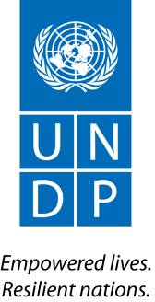
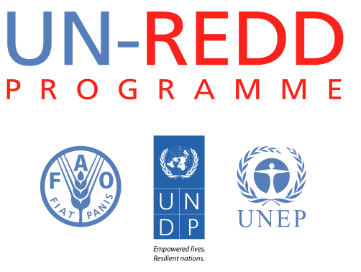

Strengthening Transparency and Accountability for REDD+ in Africa
A Workshop Report

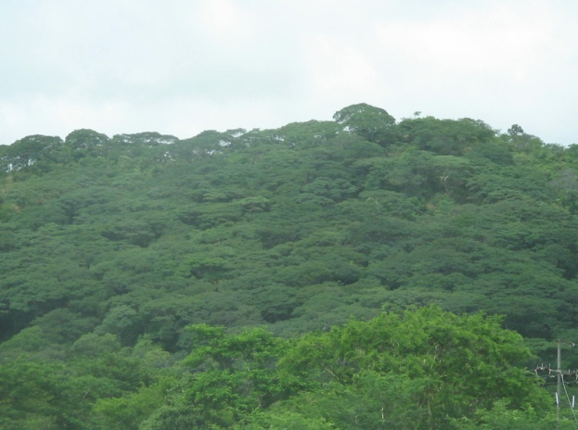 | 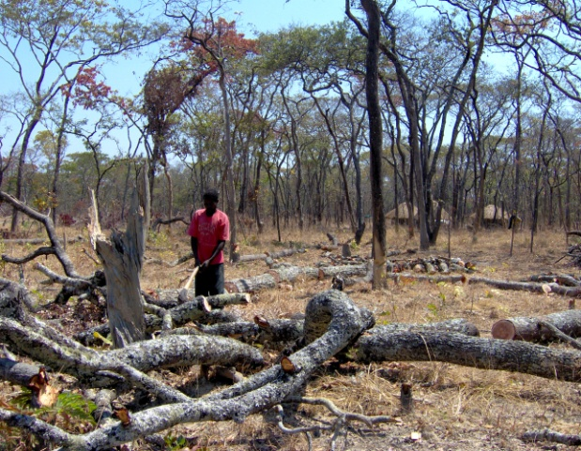 | 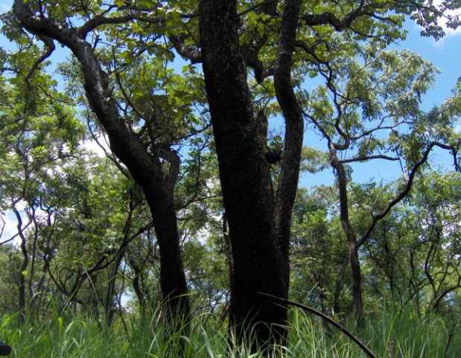
24-26 April 2012
Lusaka, Zambia

Table of Content

- Background………………………………………………………………………………………………………………………….1
  - Objectives of the Workshop………………………………………………………………………………………….2
  - Participants……………………………………………………………………………………………………….………….2
  - Outcome of the workshop…………………………………………………………………………………………….2
- Governance, anti-corruption and REDD+ …………………………………………………………………………….3
  - The relevance of governance for REDD+……………………………………………………………………….3
  - The evolving discourse on anti-corruption and its relevance to REDD+ …………….……….…4
  - Early country initiatives - joint presentations ……………………………………………………..………..5
    - Democratic Republic of Congo (DRC) ………………………………………………………..………..5
    - Zambia ……………………………………………………………………………………………………..…………6
    - Nigeria ……………………………………………………………………………………………………….……….7
    - Kenya ………………………………………………………………………………………………………….………8
- High-level policy dialogue …………………………………………………………………………………………………..9
- Initiatives and tools to address corruption risks and to measure effectiveness of anti-corruption actions …………………………………………………………………………………………………………….10
  - Measuring and Assessing Corruption: UNDP’s Experience ………………………………………….10
  - Governance Diagnostics Tool, Forest Carbon Partnership Facility ………………………………11
  - Transparency International’s (TI) Integrity Assessment Methodology ………………………..11
- Country-specific risk mitigation actions …………………………………………………………………………….12
- Conclusion ………………………………………………………………………………………………………………………..14
Annex 1 - Joint Statement by Workshop Participants
Annex 2- Country specific corruption risk analyses
Annex 4 – Workshop Evaluation Survey Result
Annex 3 - List of Participants

Background
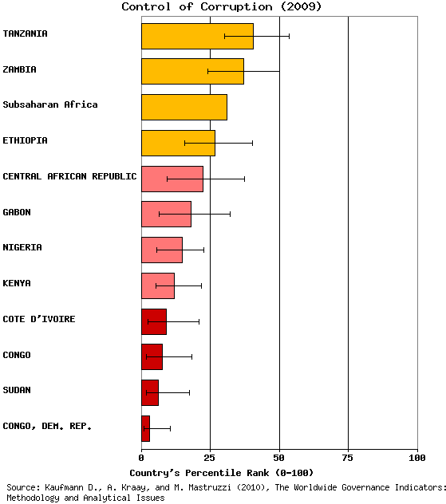
The REDD+ mechanism (Reducing Emissions from Deforestation and Forest Degradation in Developing Countries) offers significant financial incentives to encourage countries to cut carbon emissions from their forest sector, through the conservation of standing forests and more sustainable forest activities. According to FAO data, roughly one-fifth of Africa, or about 6.3 million square kilometres, is covered by forests. However, Africa’s forests declined by an average of around 4 million hectares (or 0.5-0.75%) per year every year from 1990 to 2005. The significant forest reserves and carbon stocks found in Africa’s forest-rich countries and the need to reverse the negative rate of change in forest cover make the investment through REDD+ opportune. In addition to direct benefits to preserving the forest ecology and reducing carbon emissions, successful implementation of REDD+ could potentially assist countries work towards expanding sustainable livelihood options and better economic opportunities to their citizens, and thereby contribute to the achievement of national development goals, including the MDGs.

In spite of the enormous potential benefit of REDD+, the underlying political and socio-economic vulnerabilities in many of the UN-REDD partner countries in Africa pose a significant challenge to the realization of REDD+ objectives. For instance, the average score on controlling corruption in those countries participating in UN-REDD programmes in Sub-Saharan Africa is (17.4) only about half of that of the Sub-Saharan Africa average (31%). Besides, these countries also suffer from weak forest governance regimes. These factors make these countries vulnerable to corruption and to the mismanagement of resources, compromising not only the potential gains from implementing REDD+ programmes, but also the very sustainability of the mechanism.

In an effort to promote transparency and accountability in REDD+ systems, UNDP is helping countries identify and mitigate potential corruption risks in the design, implementation and payment distribution processes of REDD+. UNDP’s Global Thematic Programme on Anti-corruption for Development Effectiveness (PACDE) in partnership with the UN-REDD Programme has organized two awareness raising and training sessions in Nepal and Thailand for Asia-Pacific region bringing in REDD+ experts and Anti-corruption practitioners. Similarly, this workshop in Africa is part of the capacity development effort of PACDE and UN REDD programme and will build upon the findings and lessons from the Asia-Pacific experience. The UN-REDD Programme and PACDE, together with the UNDP-Zambia office and the Regional Centers, organized this workshop in Lusaka (Zambia) on 24 - 26 April 2012.

Objectives of the workshop
The main goal of this workshop was to sensitize participants on why and how to address corruption risks in REDD+ processes. Specifically, the workshop set out the following objectives:
- Discuss the foundation for addressing corruption risks in REDD+
- Identify anti-corruption measures and tools for the different phases of REDD+, including through a reflection on existing anti-corruption measures in the forestry sector that could also affect REDD+
- Share progresses and lessons learned on existing activities initiated in UN-REDD African partner countries
- Highlight linkages between anti-corruption for REDD+ and on-going governance activities supported by UNDP and the UN-REDD programme, and
- Provide incentives for collaborating and networking on the anti-corruption agenda for REDD+.

Participants
The workshop brought together over 70 participants from 7 UN REDD partner countries in Africa (the Democratic Republic of the Congo, Ethiopia, Kenya, the Republic of Congo, Tanzania and Zambia). The target audience had a mixed composition, comprising officials from anti-corruption agencies (15 participants), activists and researchers from civil society and indigenous peoples’ organizations (16 participants), members of national REDD+ teams (5 participants), other relevant ministries (10 participants) and UN country staff (10 participants). They were joined by international experts from development partners, specialized non-governmental organizations, UN agencies and the World Bank representatives from country, regional and global offices. Women represented more than one third of the participants (37%). Please see annex 4 for details.

Outcomes of the workshop
- The workshop has initiated unprecedented dialogue between anti-corruption agencies and national REDD+ teams, which led to identifying and even drafting country action plans to examine prioritized corruption risks in REDD+.
- The findings of the workshop inform the focus, nature and delivery of UN-REDD Programme targeted support on anti-corruption for REDD+ in 2012 and onwards.
- A set of declarations of intention were made by the delegations:
(i) Kenya’s Ethics and Anti-Corruption Commission pledged to dedicate a climate finance specialist to mainstream anti-corruption in climate-related activities and finance;
(ii) DRC’s UNDP and National REDD+ Coordination teams engaged to enhancing their existing collaboration on the issue, in partnership with in the Observatory of the Code of Ethics for Civil Servants (Observatoire du Code d’Ethique Professionnel des agents publics de l’Etat); and
(iii) the UNDP-Nigeria office, together with federal and state governments, plans to replicate this workshop in Cross River State (which is the country's REDD+ pilot state).
- The consolidation of a cross-disciplinary community of practice that will continue exchanging experiences, information and knowledge (both online, using UNDP platforms, and in selected events)
- A joint statement (Annex 1) of intention by all workshop participants, prepared and agreed upon during the workshop, was adopted.
The workshop evaluation survey result showed the overall satisfaction of participants (please see annex 3 for the survey findings).

Governance, anti-corruption and REDD+

The relevance of governance for REDD+
One characteristic that makes REDD+ distinct is the fact that it’s a performance-based payment system for the delivery of forest carbon benefits that are measureable, verifiable and reported. This offers countries the incentive to put in place the needed governance and institutional infrastructure for effective and equitable REDD+. The latter is also stipulated in the Cancun Agreement, which attests that REDD+ needs to be underpinned by good governance systems.
Identifying and curbing corruption risks in the design, implementation and benefit distribution phases of REDD+ processes is key to ensure confidence in the system. Otherwise, perceived or actual corruption could undermine the credibility of the mechanism in the eyes of both beneficiaries and potential investors and financiers. For instance, local stakeholders won’t forgo the current income they derive from forest for unpredictable benefits. Hence, corruption, if left unchecked, has the potential to jeopardize the very benefits that a well-designed REDD+ mechanism may bring, i.e. mitigate emission, reduce poverty and improve livelihoods.
There was consensus among the participants that different countries have very different governance and corruption contexts. Hence, it is important to take into account existing national anti-corruption strategies, when they exist, and actions, and build upon them. In countries where for example there is no law on access to information, these provisions can be embedded into REDD+ laws and regulations. Of course, decrees and laws are a good start, but engagement of stakeholders needs to reach the local level.
UN-REDD Social and Environmental Principles and Criteria were cited as a guiding framework for UN-REDD activities, including on supporting partner countries to develop systems of safeguards. Engagement of multi-stakeholders, free, prior and informed consent (FPIC), and participatory decision-making for REDD+, already being supported by the UN-REDD Programme, lay the foundation for promoting governance and mitigate corruption risks. The importance of making information about the REDD+ available, timely, understandable, accessible and useable could prove to be key to hold people and institutions to account.

The evolving discourse on anti-corruption and its relevance to REDD+
Anti-corruption is an evolving agenda. In the past, the emphasis has long been on moral issues and criminalization and, over the last decade, on the development of norms and standards. Since 2006, the focus has shifted towards the elaboration of implementation mechanisms. On the other hand, frustration seems to grow in relation to lack of impact, processes such as asset recovery taking too long, prosecution failing to catch the big fish, etc.
In 2010, the MDGs summit’s decision that explicitly called for addressing corruption has been hailed as momentous. However, in reality, little has changed. The MDG Acceleration Framework that emerged after the summit does not seem to be integrating Anti-corruption instruments adequately, and national MDG reports continue to often fell short of capturing the impact of corruption on MDGs.
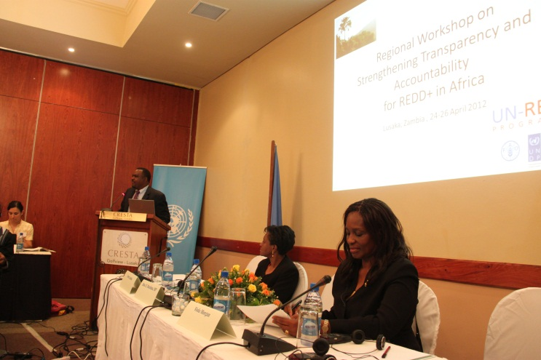
Consequently, the work on corruption prevention is moving towards more targeted sector-specific intervention. For example, UNDP, together with specialized UN agencies, has begun integrating anti-corruption into Education and Health, Water and Sanitation, and Environment and Climate Change. Although interest towards a sectoral approach to anti-corruption is rising, ensuring coordination and collaboration in inter-ministerial mechanisms is easier said than done.
One promising initiative is the coming together of sector specialists (experts from ministries of forestry, land, natural resources and environment) and law enforcement bodies including anti-corruption agencies in the context of the UN REDD programme. This workshop hence represented one of such efforts. Beyond encouraging cross-discipline collaboration and sharing of experience, this kind of gathering introduces the available anti-corruption tools and instruments that can be used to make REDD+ more fair, accountable and transparent.
A panel of five representatives of anti-corruption agencies from Kenya, Zambia, Ethiopia, and Congo discussed and shared their respective experience. Overall, the engagement of the anti-corruption agencies in REDD+ related activities remains marginal for most part due to the newness of the initiative itself. Similarly, cooperation with law enforcement bodies and sector ministries hasn’t always been strong.
Nevertheless, the agencies are undertaking a number of initiatives to increase their impact on domestic accountability regimes. In Kenya, the anti-corruption commission had put in place a national anti-corruption plan. Through the Public Service Integrity Programme (PSIP), the commission has trained integrity assurance officers (“Integrity champions”) in line ministries. In an effort to deepen its corruption prevention work, the commission has embarked on a countrywide education programme for public servants on anti-corruption laws, causes and consequences of corruption, and the benefits of prevention strategies. The commission also works in the identification of loopholes in organizational systems and the provision of advice.
The anti-corruption commission of Zambia has led the formulation of the National Anti-Corruption policy and, as part of its prevention work, supported several community education and curricular development on civic education. One of the recent accomplishments of the commission was the establishment and piloting of integrity committees in about 20 ministries and departments. The emphasis is to control corruption from within, through curbing administrative corruption and strengthening integrity systems.
Although the anti-corruption and ethics commission of Ethiopia is undertaking a number of prevention and social mobilization work, in terms of REDD+ related sectors, it has not looked at corruption risks in the natural sector per say. But the commission’s engagement on corruption control related to land administration and investment could be something to build on. There was also recognition by the anti-corruption representatives that there is a need to put in place specific provisions, mandates and resources (human and financial) to fully assist national REDD+ strategies and programmes.

Early country initiatives - joint presentations by REDD+ experts and the anti-corruption
Prior to the workshop, national REDD+ focal points and practitioners from anti-corruption agencies (from DRC, Kenya, Nigeria and Zambia) worked on a joint presentation reflecting on the pace of progress in national anti-corruption as well as national REDD+ programmes. Beyond pulling out the context and issues, the process of preparing the joint presentation allowed practitioners from the two disciplines to begin a working relationship.

Democratic Republic of Congo (DRC)
Overall Context
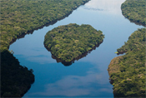
DRC, with the second largest tropical forest in the world, has great potential for REDD+. Despite its enormous resources, DRC suffers from political instability, conflict and weak institutions. Lack of human and financial resources hindered the process of decentralization. Elections remain irregular, eroding the legitimacy of power. Corruption in DRC appeared to be endemic and unpunished. Corruption is believed to have affected service delivery as well as law enforcement. The management of public finance lacks transparency and control bodies such as the court of accounts or the general finance understaffed. As a result, 50% of expenditures happened outside of the formal chain of expenditures.
DRC put in place a national anti-corruption policy in 2010 under the OCEP through a participative process. However, the policy still awaits approval by authorities. The country is also a signatory of the SADC Anti-corruption protocol and the UNCAC. Donors support several initiatives. UNDP has one of the largest anti-corruption programme. However the absence of national vision, coordination and political will hamper meaningful impact.
Corruption Risks in REDD+
Preliminary assessments reveal that the involvement interest groups who might influence the design of REDD+. This range from politicians and high functionaries involved in logging to armed forces present in forest areas and companies engaged in oil and agribusiness. Fiscal fraud and money laundering also pose significant risk.
Linkages between environment/REDD+ experts and anti-corruption practitioners is beginning to happen. Recent relevant initiatives in this area include training in investigative journalism, manual adapted to REDD+; Strengthening CSO capacities that will include REDD+; Awareness of economic and financial; and training of justice system. Moreover, an innovative initiative being piloted in DRC is an Online Registry where all carbon projects will have to register online providing the government the opportunity to validate each project and to monitor performance. This has the potential to promote transparency and reduce corruption risks.

Zambia
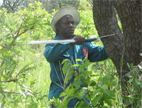
Overall Context
Zambia is poised to benefit from REDD+ mechanism due partly to a significant forest cover (66% of total land or about 49.9 million ha) and a deforestation rate of 250,000ha to 300,000ha of per year. Several global surveys show corruption as a challenge in Zambia. For instance, The World Bank presents Zambia’s score in controlling corruption at 30% while Transparency Zambia pegs Zambia’s Bribe Payers Index at 14% (An individual has 14% chances of encountering a bribery situation). The National Governance Baseline Survey of 2004 reported that 40% of the respondents indicated having been asked for a bribe. Auditor General’s annual report shows huge sums of money amounting to hundreds of billions of kwacha misappropriated, stolen, mismanaged or unaccounted for every year.
The Anti-Corruption Commission of Zambia generates an average of 500 cases and prosecutes about 10% of the cases of which it secures about 40% convictions per year. The commission has signed a MOU with the Auditor General’s Office to share information. Its corruption prevention interventions include setting up of integrity committees, operating system reforms, and participative monitoring of vulnerable operations. Governance and anti-corruption issues have also been added to the school syllabus.
Corruption Risks in REDD+
Potential corruption risks that could affect REDD+ include dishonesty, greed, desire for personal wealth etc.; exclusion of the public from decision making process due to lack of information, resources, capacity and influence; high monetary returns from corruption and the evading of statutory obligations; high demand for cheap timber by the International Market; and appointment of officials to high level positions who make decisions in favor of the appointing authorities.
Some of the areas vulnerable to corruption include bidding process for concessions for harvesting hardwood especially in Western, Southern and North Western Provinces of Zambia; acquisition of land rights through traditional systems; declaring timber volumes, cutting outside timber areas and tax evasion; exporting of unprocessed timber; exploiting of the forest for charcoal and exporting of Charcoal; and issuing of permits and licenses. The anti-corruption initiatives that Zambia launched involved educational programs targeting traditional rulers; reengineering of cultural and traditional beliefs and practices which promote corruption.

Nigeria
Overall Context
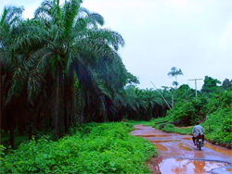
Nigeria is one the resource endowed nations in Africa. The country is the ninth largest oil exporter in the world and with proven reserve of 37.2 billion bbl it is ranked tenth in the world. However, political instability, corruption, inadequate infrastructure, and poor macroeconomic management placed the country at the lower end of the human development index (156 out of 187 countries with comparable data). Niegria’s forest resources (estimated to cover over 9.6 million hectares) suffers from the fastest rate of deforestation at 3.7%.
Corruption in Nigeria, which is considered to be endemic and pervades all levels of government, remains a main driver behind unsustainable utilization of its resources including forests. A recently carried out political economy study identified several factors behind corruption in Nigeria. These include elite capture of oil revenues (resource curse); political corruption (which takes the form of rent seeking from private sector as well as the use of such rents to preservation and/or extend power through favouritism and patronage politics); weak legal and institutional capacities including law enforcement; lack of civic engagement which can partly be explained by the acceptance of bureaucratic corruption as a reality.
Corruption Risks in REDD+
According to the Nigerian Law, forest resource management is the responsibility of the State government. But states differ in their forest management practice. Cross River State hosts more than 50% of Nigeria’s remaining rain forest and mangrove and there is overwhelming political will to protect them. This has informed the two track approach which makes Cross River State the model for implementation of the REDD for other States.
The two-track approach in Nigeria’s REDD+ readiness process comprises (i) the development of institutional and technical capacities at Federal level, and (ii) carrying out institutional, strategy-building and demonstration activities in Cross River State. If no risk mitigation measures put in place, the aforementioned corruption situation would naturally pose significant risks to the success of REDD+ in the country. There are Interventions that can benefit REDD+ including Corruption risk assessment at state level; Strengthen public procurement systems; and the development of national and state anti-corruption strategy, which hasn’t been adopted nevertheless offers opportunities to incorporate REDD+ specific concerns in it.
Collaboration between Anti-corruption and REDD+ experts in Nigeria is only starting, but growing (the preparation to this workshop contributed to this). Government departments involved in implementing the national REDD+ strategy could benefit from understanding and applying existing anti-corruption and integrity tools and adopting the Participatory Governance Assessment (PGA) tools to address the risk associated with REDD+. Likewise, the on-going anti-corruption programmes and initiatives need to incorporate REDD concerns in planning and implementation stages.

Kenya
Overall Context
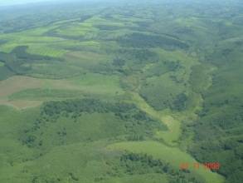
Kenya is one of the 28 UN REDD partner countries. Corruption is recognized as a serious challenge. Changing minds and attitudes of Kenyans has been cited as one of the main challenges. Kenyans have, through the years, adopted an ambivalent attitude towards corruption. The attitude is one of uncertainty compounded by tolerance, indifference and/or resignation - that corruption is so pervasive. The legal process itself is often used and abused by accused persons to frustrate the progress and hearing of cases. Well-paid, senior lawyers mount great resistance, employ every trick in the book and make it virtually impossible to conclude matters. Constitutional applications and applications for adjournment for one reason or another are legion.
Corruption also fights back. Suspects routinely intimidate investigators and witnesses. The public money and property stolen is itself employed to fight the legal process. The link between grand corruption and politics also comes to the fore. Politicians routinely obstruct the Commission’s work. When targeted, as they often are, politicians regularly resort to tribal or ethnic bunkers, claiming that it is their community that is under unwarranted attack, whereas in actual fact it is their personal actions that are under scrutiny.
Corruption Risks in REDD+
There are corruption risks related to land administration and public financial management that could also affect REDD+ processes. These risks include bribery to facilitate government-to-private sector land deals or to facilitate unsustainable extraction of resources such as timber. Disregarding customary rights and access to resources by local communities and indigenous people is another challenge. Corruption risks linked to fund management involve lack of proper financial management systems among grant management entities; double accounting; fraudulent procurement; conflict of interest (funding “own” projects); biased fund disbursement (based on tribal, irregular geographic focus basis); politicization of grant funded project; etc.
There are, however, encouraging interventions initiated by the Kenya Anti-corruption Comission that could be of use to mitigating corruption risks in REDD+. In 2010, for instance, the commission trained 30 Corruption Prevention Committee members and 50 Integrity Assurance Officers in the Ministry of Forest. It has signed Performance Contracts with the Government of Kenya. The Kenya Forestry Research Institute and Kenya Forest Service have also committed to formulate governance instruments such as (Anti-corruption policies, Corruption Prevention plans, code of conduct among others) as well as undertake Corruption Risk Assessment and formulating strategies to seal corruption loopholes. These initiaitves provide a solid base to get experts from the froest ministry and anti-corruption to work together in the REDD+ context.

High-level policy dialogue
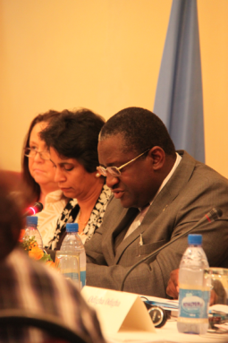
A high-level policy dialogue took place, chaired by Ms. Kanni Wignaraja, United Nations Resident Coordinator in Zambia, with a key note address by the Honorable Wylbur Simuusa, M.P., Minister of Land, Natural Resources and Environmental Protection of Zambia, and with comments from a panel composed by Ms. Veerle Vandeweerd, UNDP Director of Environment and Energy, Mr. Rueben Lifuka, Director of Transparency International Zambia and member of the Board of Directors of Transparency International, and Mr. Odigha Odigha, Chairman of the Forestry Commission of Cross River State of Nigeria. The Policy Dialogue placed the issues of transparency and accountability for REDD+ into the broader context of climate policies and international negotiations under the UNFCCC, the need for governance around climate finance, and the Rio +20 agenda.
The minister reiterated Zambia’s pledge to charting a green economy trajectory and the important role REDD+ could play. Zambia recognizes corruption as a major driver of deforestation and hence REDD+ Systems being put in place in the country must take into account an effective way to mitigate corruption risks. Review of legislation – forest act and policy and the enacted Anti-corruption bill demonstrates the country’s commitment.
The forum recognized that such an event as ground breaking and charting new domains and ahead of the curve. Of course in REDD+ governments are still negotiating and good progress made in Durban though operational modalities still remain to be defined. The discussions and tools in this event will not only be important for REDD+ and to inform the negotiations, but will pave the road for all the work done in mitigation
Deliberating on climate change finance - turning carbon into a credible good -, the forum highlighted the opportunities and challenges it present. By making carbon a marketable good, the dynamics of the negotiations are changing. Forests and ecosystems will become tradable goods in the future as well. There will be a forest carbon market separate from other carbon market. Putting in place a transparent, accountable and equitable system will allow forest-dependent communities to benefit from it. Experience taught us that development aid without good governance fails
The current approach and practice of anti-corruption in Africa offers a mixed picture. Given the observed gaps in skills, institutional set up and independence of anti-corruption entities, REDD+ brings with it additional burden. Hence, understanding the implications and supporting country’s anti-corruption infrastructure should also be a priority for national readiness processes. Civil society could play a critical role in this regard.
On this occasion and throughout the workshop the organizers and the United Nations publicly appreciated the hosting support of the government of Zambia.

Initiatives and tools to address corruption risks and to measure effectiveness of anti-corruption actions
A number of useful initiatives and tools to assess and measure corruption that can be applicable to REDD+ have been developed by international organizations.

Measuring and Assessing Corruption: UNDP’s Experience
Interest to measure and assess the incidence, nature and impact of corruption is growing. This can easily be seen from the plethora of tools and indices already out there. While the value of corruption measurement remains vital to fighting it. For instance, measurement gives corruption a face, help quantify and qualify corruption, inform reforms, monitor and evaluate anti-corruption interventions.
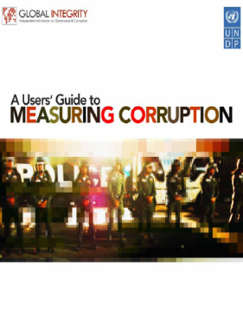
Nevertheless, the current landscape of tools and measures suffer from a number of shortcomings in the way users apply them.
- Comparison problem: Almost all tools and methodologies not suitable for cross-country comparison
- Practitioners want actionable data, and existing global indicators are inadequate
- Perception-based data are too vague to be useful for policy reform (although frequently used as advocacy tools)
- Different tools seems to be assessing the different concepts
- Many tools are not customized to country specificities and thus are not useful and not seen as more ‘credible’ by policymakers
- Lack of pro-poor, gender sensitive indicators
Obviously each tool has its advantages and disadvantages and its utility depends on the purpose of the measurement. UNDP focuses on country-based and nationally owned corruption measurement and assessment. Results from country-led assessments easily feed into policy-making processes (e.g., reforms). Nationally-owned process help develop national capacity on measurement. When these national assessment processes engage broader stakeholder, it strengthen local ownership.
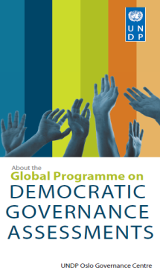
UNDP’s approach to country-led participatory governance assessments (PGAs) developed by the Oslo Governance Center (OGC) to generate governance data that is measurable over a period of time. PGAs for REDD+ will be critical in the development of national systems providing relevant information on how safeguards are promoted, addressed and respected as recommended in the Cancun Agreement.
In 2011, about four PGAs got launched in Indonesia, Vietnam, Ecuador and Nigeria. Anti-corruption is identified as one of the thematic focus of the PGA. It specifically examines the existence and effectiveness of an anti-corruption strategy and mechanism specifically designed for REDD+. For example, the on-going PGA excerise in Nigeria comprises Corruption Risk Assessments in the water, health and education sectors at Federal level and in Selected States.

Governance Diagnostics Tool, Forest Carbon Partnership Facility
The Forest Carbon Partnership Facility (FCPF) complements the UNFCCC negotiations on REDD+ by demonstrating how REDD+ can be applied at the country level and by learning lessons from this early implementation phase. FCPF applies a Forest Governance Diagnostic Tool, developed jointly by PROFOR and FAO, as a practical tool for the assessment and monitoring of forest governance. This constitute a move away from ad hoc efforts at improving governance towards a systematic approach.
The tool consists of a set of indicators and a protocol for scoring the indicators which relies on structured multi-stakeholder inputs. It helps identify governance weaknesses and reforms especially associated with the fundamental drivers of deforestation, and ways and means to address them. Piloting experiences, from Burkina Faso, Kenya and Uganda, have confirmed the feasibility of using the results to design forest governance reforms for REDD+.
As can be seen in the figure below, The common framework is organized as 3 pillars of governance:
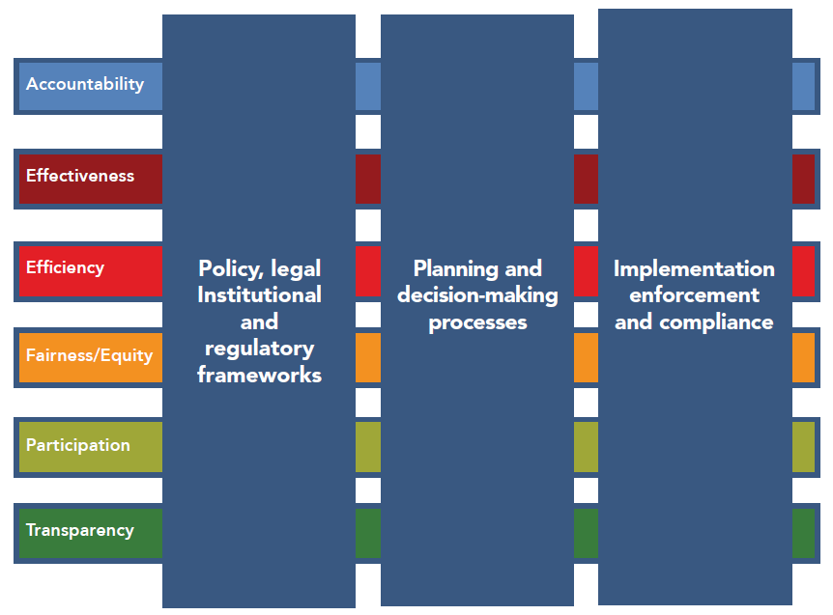
- good policies, laws, and institutions;
- good decision-making processes; and
- good implementation
While each of this pillar is divided into more specific components and subcomponents, the whole framework reflects six underlying principles of good governance: accountability, effectiveness, efficiency, equity/fairness, participation, and transparency. In the context of REDD+, this approach can facilitate consensus-building around contentious issues of sharing of carbon benefits, recognition of traditional and indigenous rights, etc.

Transparency International’s (TI) Integrity Assessment Methodology
TI developed a Manual for Assessing Integrity in the Development and Implementation of Forest Carbon Projects and National REDD+ Strategies. This assessment prodcues a country-specific prioritised list of corruption risks for REDD+ along with available instrument to mitigate the identified risks. It employs a multi-stakeholder approach to work with governments, parties involved in REDD and donor communities and ensure anti-corruption measures are considered in REDD developments at country level. This methodology is being piloted in Papua New Guinea, Indonesia and Vietnam.

Country-specific risk mitigation actions
An on-line perception based survey has been administered among national REDD+ focal points, anti-corruption practitioners and UNDP colleagues from UN REDD partner countries in Africa. The survey focused on measuring participants’ understanding of the likelihood and potential impact of corruption risks in the different phases of REDD+ in their respective countries.
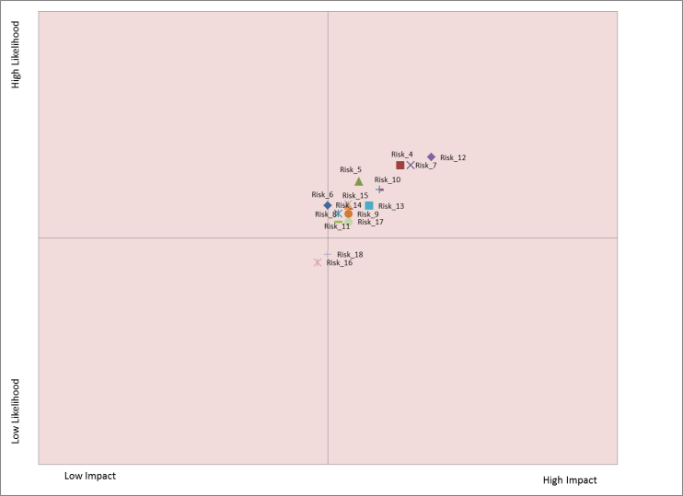
Having analyzed the survey results based on how likely a given corruption risk might occur and its perceived impact, the following top five risks have been identified.
- BDSs are designed behind closed doors to the disadvantage of deserving beneficiaries
- Project developers or interest groups bribe public officials to ensure that the land areas they own are allocated to, or excluded from, REDD+ plans
- Loggers exert undue influence to exclude large areas of high value timber from areas designated for conservation
- Powerful individuals influencing the design of the overall national REDD+ framework to benefit from it
- Powerful actors exert undue influence to obtain fraudulent licenses, land titles or carbon rights.
Similarly, the survey found out five corruption risks with the least probability and potential impact.
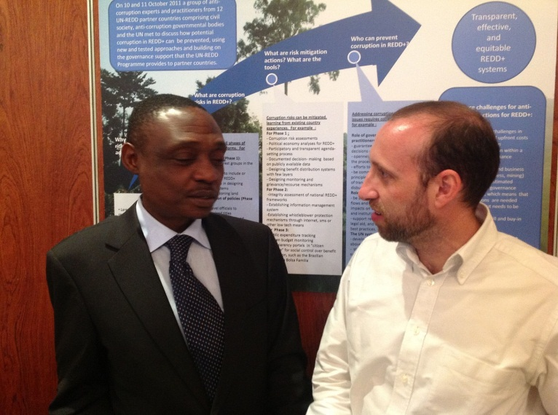
- Actors bribe public officials to register the carbon rights in the name of the corrupt actor
- Those responsible for managing REDD+ payments embezzle REDD+ revenues
- Project developers attempt to bribe public officials to falsify claimed emission reductions from projects and therefore to secure additional revenues
- Public actors intentionally distort information related to the distribution of benefits from REDD+ revenues
- Political elites exert undue influence to link carbon rights to State ownership of forests
The findings of the survey have also been disaggregated by country. Although there are similarities of risk rating and assessment, there remain peculiarities. There follows an exercise where participants, grouped by countries, discussed how to respond to corruption risks in REDD+ identified in a previously circulated online survey and proposed practical measures, based on existing actions when possible. As can be seen in the annex 2, these exercises produced a country by country summary identifying baselines, mitigation actions and stakeholder for the specific corruption risks prioritized.

Conclusion
REDD+ represents both enormous opportunities and challenges. In addition to direct benefits to preserving the forest ecology and reducing carbon emissions, successful implementation of REDD+ could potentially assist countries work towards expanding sustainable livelihood options and better economic opportunities to their citizens, and thereby contribute to the achievement of national development goals, including the MDGs. However, if the design and implementation of REDD+ do not fully ensure transparency, accountability and equity, it could undermine the very objective of the programme and might risk making the situation for forest-dependent communities even harder (for instance, if corrupt officials ignore the rights of communities to forest resources in order to obtain private gain from REDD+ wrongly). The underlying weakness in the forest governance and anti-corruption infrastructure remains one worrying sign in this regard.
Nevertheless, it is encouraging to see countries begin raising the challenges of corruption openly and taking firm actions to address it. Many of the REDD+ partner countries in Africa have put in place anti-corruption laws, instruments and tools. Judging from the global indicators on corruption incidence from available global indices, the lot remains to be done to make the fight against corruption effective. The recent move by UNDP and sister UN specialized agencies to take a sectoral approach to preventing corruption is a positive development. UNDP’s Global Anti-corruption Programme and UN REDD programmes collaboration in bringing in REDD+ experts and anti-corruption practitioners represent part of the shift to a sectoral approach to corruption. In preparing for the workshop, four countries worked on a join presentation by ministries of environment and anti-corruption commissions. This approach is already appreciated by representatives from partner countries as well as UNDP senior management.
During the event, a number of useful initiatives and tools to assess and measure corruption that can be applicable to REDD+ have been developed by international organizations. For instance, participating agencies shared such tools and approaches as the Participatory Governance Assessment, Governance Diagnostics Tool, and Integrity Assessment Methodology. An on-line survey on corruption risk assessment produced a risk map for the participating countries, resulting in a priority list. Based on the findings from the survey, group of countries went through an exercise of identifying baseline, potential mitigating action and list national actors.
At the end of the workshop, a joint statement of intention by all workshop participants, prepared and agreed upon during the workshop, was adopted. The workshop has initiated unprecedented dialogue between anti-corruption agencies and national REDD+ teams, which led to identifying and even drafting country action plans to examine prioritized corruption risks in REDD+. The findings of the workshop inform the focus, nature and delivery of UN-REDD Programme targeted support on anti-corruption for REDD+ in 2012 and onwards. Following the workshop, four countries (DRC, Kenya, Nigeria and Zambia) have begun working on country proposal for targeted support.

Annex 1 - Joint Statement by Workshop Participants
“ Participants in the Regional Workshop on Strengthening Transparency and Accountability for REDD+ in Africa, held in Lusaka, Zambia on 24-26 April 2012, acknowledge the importance of cross disciplinary work on anti-corruption for REDD+ in Africa, in view of the following facts and developments:
- the anticipated flows of climate finance;
- the growing political will of African societies and governments to address transparency and accountability in public matters;
- the need to enhance governance in the environment sector;
- the fact that international negotiations on climate change emphasize the importance of transparency in REDD+ processes and in climate finance in general; and
- the new opportunity created by the emerging national REDD+ institutions and systems to address anti-corruption, and the fact that corruption is best prevented if addressed from an early stage.
Discussions during the workshop led to the following findings and proposed recommendations:
- National REDD+ process and anti-corruption efforts are mutually reinforcing.
- The national REDD+ implementation framework requires adequate anti-corruption measures, while anti-corruption strategies need to permeate all sectors, traditional and new, such as climate policy and finance, and design and implementation of a REDD+ mechanism.
- Effective cooperation between anti-corruption agencies and ministries in charge of REDD+ can be achieved and strengthened through: (a) anti-corruption commissions designating/recruiting specialists on climate finance and/or REDD+; and (b) national REDD+ teams designating anti-corruption champions, or ideally recruiting specialists to lead such work stream.
- While civil society, anti-corruption agencies and REDD+ teams have a common responsibility on transparency & accountability, their roles are differentiated and complementary.
- Ensuring transparency and accountability needs concrete and autonomous structures monitoring climate & REDD+ governance, such as observatories and watchdog bodies. For these to function properly, governments have to enact and support enabling and conducive environments with adequate policies (e.g. freedom of information, whistleblower protection) whereas civil society has to engage in a solid manner (i.e. ensure fairness, verify information, report accurately).
- Timely access to relevant information is central to promoting transparency; feedback systems and responsive bodies that take action are equally indispensable to ensure that decision-makers and responsible parties are held accountable.
- The development of clear legal frameworks around REDD+ (including matters such as carbon rights and land use systems) will minimize the uncertainties that facilitate corruption, while providing guidance to assess transparency and accountability
- Modern information technologies represent a cost-effective means to strengthening transparency and should be utilized for creating, accessing and disseminating information, including the upgrading of monitoring mechanisms of projects and funds.
- The participatory nature of ongoing REDD+ processes is a first step towards promoting transparency and accountability, and needs to be replicated at all phases of the REDD+ process; existing participation and engagement structures are to be used for that purpose, and enhanced when required.
- Ongoing REDD+ management elements - such as the MRV and I systems, Free Prior and Informed Consent, the UN-REDD Social and Environmental Principles and Criteria, the World Bank’s Strategic Environmental and Social Assessment and Participatory Governance Assessments for REDD+- are entry points for transparency and accountability, but may not necessarily substitute for a specific monitoring system to track risks and cases of corruption or lack of transparency and accountability in REDD+, due to the complexities of REDD+ itself.
- A number of useful tools and initiatives to conduct in-depth assessments of corruption risks in REDD+ at the national level exist or are being developed; the key principles are that such assessments are nationally-owned, and conducted through multi-stakeholder platforms representing different interests and responding to the specific issues and risks of a given country.
- As these issues remain largely uncharted territories, the exchange of early experiences and lessons learned will be crucial.
In light of the above, participants:
- endorse the value and importance of cross-disciplinary work on climate finance and anti-corruption measures, which is likely to bring tangible results for both domains;
- commit themselves and their respective institutions to keep working on these issues in a collegial manner, and to keep exchanging experiences; and
- finally, request UNDP, the UN-REDD Programme, the Forest Carbon Partnership Facility and other development partners to work together to explore mechanisms to provide direct funding support to civil society organizations on the matter, and further provide technical advice and financial resources to develop capacities and carry on this new work that requires different expertise, as well as tools and support to share experiences and lessons learned.
Discussed and adopted in Lusaka on 26 April 2012”

Annex 2- Country specific corruption risk analyses
Corruption Risk Assessment – Zambia
Corruption risks (identified in survey) | Baseline (Actions already taken, for each risk) | Actions (for each risk or aggregated) | Actor (for each action)
BDSs are designed behind closed doors to the disadvantage of deserving beneficiaries | BDS is still at preparation stage. | Involve would be beneficiaries at formulation stage. | i. Government  ii. Civil Society  iii. Line Ministry  iv. Local Authorities  v. Traditional Leaders  vi. Communities  vii. Legal practitioners  viii. Governance institutions (e.g ACC)
 |  | Capacity building for communities in their own context.
 | The risks identified were assumptions based on past various experiences and observations. | The proportional distribution of resources to be pre-determined down to household level
 |  | Ensure communication of the beneficiary mechanism to the would be beneficiaries.
 |  | Designing and implementing the monitoring and M & E.
Powerful individuals influencing the design of the overall national REDD+ framework to benefit from it | i. Key stakeholders and key players have been mapped. | Review the mapped stakeholders to include some that may have been left out | As above
 | ii. Stakeholder assessment | Operationlaise the engagement plan
 | Engagement plan | Form a local multi-sectoral team to monitor progress in implementation.
Powerful actors exert undue influence to obtain fraudulent licenses, land titles or carbon rights | i. Available legislation and policies on various licenses and title to land. | i. Harmonisation of available policies | As above
 | ii. National land audit done in parts of the country | ii. Develop new policies and legislation where there are gaps (e.g. carbon rights)
Project developers bribe public officials to ensure that the land areas they own are allocated to, or excluded from, REDD+ plans | There are a lot of commercial farmers who own large pieces of land | Include more participants (stakeholders) in the verification exercises | As above
 | Integrated Land Use Assessment Done | Let there be public disclosure
 | Follow up LUA (LUA 2) is being initiated | On what land has been committed to REDD+
Political elites and the private sector agree to misrepresent national circumstances in a way that favours certain types of activities (such as plantations) | There has been past actions that have compromised the crop choices for plantations based on private sector collusion. | Multi-sectoral-Independent validate prior to adoption | As above

Corruption Risk Assessment – Nigeria

Corruption risk | Baseline (Actions already taken) | Actions | Actors
RISK NUMBER 1. political elites and the private sector agree to misrepresent national circumstances in a way that favours certain types of activities (such as plantations) | There is an existing legal framework but challenges exist with implementation enforcement and compliance. | Evaluation of assets and cost benefits analysis; enforcement of existing laws and sanctions; awareness creation among civil societies , forest communities and ordinary citizens. | UN REDD+; Civil society; private sector; Forestry commission; state ministry of lands and survey; Ministry of finance(office of the accountant general/ auditors general); UNDP; anti-corruption agencies(state due process office); Forest dependent communities.
RISK NUMBER 2. Powerful individuals influencing the design of the overall national REDD+ framework to benefit from it. | Policy makers are Not sufficiently aware of the benefits of REDD; inconsistency/constant changes in policies. | Same as above | Same as above
RISK NUMBER 3. Loggers exert undue influence to exclude large areas of high value timber from areas designated for conservation | Forest conservation laws exist; wildlife laws exist but there are capacity gaps and enforcement challenges. | Enforcement of all existing laws and sanctions; evaluation of assets and cost benefit analysis. | Same as above

Corruption Risk Assessment – Kenya

Corruption risks (identified in survey) | Baseline (Actions already taken, for each risk) | Actions (for each risk or aggregated) | Actor (for each action)
Powerful actors exert due influence and/or bribe public officials to create fraudulent licenses, land titles and carbon rights attributed to them instead of the appropriate rights holders | - Legal tools – Constitution, environmental and land court | - National policy on carbon investment and trading by June | - Min of Finance
 | - Awareness creation | - Strengthening institutions | - Various actors
 | - Integrity assurance officers/integrity champions in every ministry | - National REDD+ strategy (governance in forest sector) | - Min of Environment
 | - RPP | - Mainstream anticorruption in national REDD+ | - Ethics and Anti- corruption commission
 | - Governance assessment note | - SESA | - Thematic group
 | - National Anti-corruption plan | - Guidelines for investing in Carbon | - REDD+ focal point Actors
 | - Ethics and Anti-corruption commission | - REDD+ Registry | - Min of Forests
Actors exert undue influence and bribery of public officials who are responsible for implementing REDD+ to ignore breaches of REDD+ regulations | - Public officers and ethics Act | -SESA | - thematic group
 | - Criminal law | -Strong MRV systems | - REDD+ Actors incl communities
 |  | - EACC to designate a person on climate finance | - EACC
BDSs are designed behind closed doors to the disadvantage of deserving beneficiaries | - Lean from Nagoya Protocol on Access and Benefit sharing | - Ensure effective participation of deserving stakeholders in the BDS design phase | - REDD National office
 | - Lean from Nagoya Protocol on Access and Benefit sharing | - Oversight | - REDD National office
 | - Lean from Nagoya Protocol on Access and Benefit sharing | - Strengthen community based systems | - REDD National office

Corruption Risk Assessment – DRC
Corruption Risk | Baseline (Actions already taken) | Actions | Actors
Des compagnies puissantes d’exploitation du bois excercent une influence indue ou remettent des pots de vin pour exclure de vastes zones de | Forets classées, protégées et de protection permanente | · Plaidoyer auprès des députés nationaux, mais le problème c’est qu’ils ne s’intéressent plus aux problèmes communautaires/ | Société Civile et organes d’anti-corruption
 | Code Forestier | · En amont, bien documenter les choses : avoir les éléments sur la table => comprendre les acteurs qui sont impliqués ou non dedans (dans cas de corruption, identifier les acteurs du changements // situation de départ => nous permettra de mesurer // Première étape : identifier les types de corruption qui existent dans ce secteur => faire l’Etat des lieux sur la corruption dans le secteur forestier // | Tous les acteurs doivent être appliqués mais à différents niveaux :
 | Loi sur la Conservation | · Faustin ; a mené des enquêtes sur la transparence forestière // Greenpeace // L’arnaque // | 1er niveau : TDR faits société civile et gouvernement et exploitants
 |  | · Dissocier la corruption et l’exploitation illégale | 2eme niveau d’exécution : société civile seule
 | FORETS CLASSEES : | · OCEP : cas de fraude sur la foret // la personne est partie avant le Forum | Pour Cyril, la question de la participation se résout dans les consultations
 | 2002 : forets classées à 8% | · Organiser des débats à la TV, sensibiliser les médias | TDR doivent être faits par quelques-uns
 | 2006 : on est passé de 8 à 11% | · Devrait être faite par une organisation internationale, ex la BM (évaluation du | Mais après on fait la méthodo de travail (phase documentaire, phase de consultation, phase de terrain : aller sur les provinces)
 | 2009 : on a décidé de passer à 22% dans le document de l’Agenda Prioritaire | · Problème de participation dans cette étude pour garantir indépendance et le problème de l’appropriation des décideurs //
 | et now en 2012 : on est à 17% | · Fournir l’info différent de mener l’enquête
 | Forets protégées : | · Surveiller les textes sur la foresterie communautaire // Lobbying Haute Hiérarchie : PM ; car c’est le début du mandat
 | Catégorie par défaut
 | Société Civile : décret du PM sur la foresterie communautaire (procédure d’attribution) et arrêté sur le mode de gestion | · Surveiller l’AT
 | ð les entreprises et l’Etat bloquent cette réforme sur foresterie communautaire
 | Action supplémentaire sur les modes de répartition => zonage / aménagement du territoire | · Révision du Code Forestier pour prendre en compte les nouveaux enjeux
 | Il faut définir au préalable les blocs qui sont destinées aux communautés et celles aux exploitations | · Surveiller le moratoire jusqu’à ce que l’on n’ait pas fait le zonage // car le moratoire court encore ; normalement cela durait 3 ans => fin 2012
 | Mais pour faire l’AT, il faut résoudre la question de la décentralisation | Si le moratoire est levé, il faut absolument passer par des adjudications (passation de mrchés)// est ce qu’il y a un mécanisme de surveillance ? publication dans le journal officiel
 | Mais pour AT et décentralisation on a besoin des autres ministères => mines, hydrocarbure, foncier
 | Concession de Conservation : des entrepreneurs qui demandent des concessions de conservation sur
 | des concessions forestières désaffectées : transfert de titres
 | Il y a eu deux fois le moratoire : on ne peut pas donner des concessions tant que l’on n’a pas assaini le secteur
 | ð président à mis en place le processus de conversion des titres => a renforcé aussi le moratoire en 2005 => a couru jusquà la fin de la revue légale en 2009
 | On était à 25 M et on est arrivé à 10 M jugés convertibles
 | On avait 156 titres et on est arrivé à 80
Des responsables de projet de dvpt, des sociétés multinationales ou des agri-entrepreneurs puissants corrompent les agents publics pour que des zones soient exclues ou inclus des plans REDD+ | Concession de Mr Mozaba qui avait une grande superficie pour lui seul mais a fait travailler la société des exploitants d’AMEX Bois | Arrêté sur l’homologation + le Registre transparence | Sensibiliser les agents publics
 | Ex : un propriétaire terrien laisse des chinois pour faire des palmiers à huile et en même tps décide de valoriser le carbone | Comité technique de suivi sur l’arrêté: Renforcement des Capacité technique pour révision des projets carbone
 | Risques sur les projets sectoriels | Sensibiliser l’agent public pour dénoncer ce type de faude
 | Projet pilote au nord kivu avec CI : transformation des forets des CL en réserve naturelle (propriété de l’Etat) => Now discute avec Walt Disney | Respect des systèmes d’affectation des terres
 | (now études de biomasse pour prouver le carbon qu’il peut stocker => conflit | Surveiller les zones minières avec massifs forestiers
 | Dénonciation par la société civile pour que la typologie du code forestier soit respectée
 | Proposition de textes
 | Promulguer les nouveaux textes de la foresterie communautaire

Corruption Risk Assessment – Republic of Congo
Risques de corruption | Etat des lieux (actions déjà entreprises) | Actions à entreprendre pour corriger les risques | Acteurs pour chaque action
les systèmes de partage des bénéfices sont conçus de manières non transparente (derrière des portes closes) de maniere a desavantager les bénéficiaires qui y ont droit | 1- Etude diagnostique globale sur la gouvernance (Banque Mondiale) | mettre en place un mécanisme de transparence sur les fonds réservés à la gestion forestière | Point focal REED+
 | - Etat des lieux sur le manque de transparence | Plaidoyer pour l’adoption et la mise d’une loi sur l’accés a l’information | Le gouvernement ( ministères en charge des forets, économie)
 | - les fonds ordinaires ne sont pas redistribués au niveau régional et à la base | renforcer les capacités de l’environnement et de l’économie (formations spécialisées sur la cartes des ressources et l’intelligence economique) | Le parlement et les partis politiques
 | 2- Politique de décentralisation existe dans les textes mais n’est pas opérationnelle (difficiles à mettre en œuvre) | échanger des expériences au niveau régional et international sur les bonnes pratiques | Les autorités régionales ;
 | - Accès à l’information : cadre juridique inexistant et absence de motivations des bénéficiaires dans la recherche de l’information | élaborer une vision stratégique dans le secteur des forêts fondée sur une approche de coordination de toutes les actions, et des acteurs | les organisations de la societé civile
 | - Fragilité des bénéficiaires à la base |  | La commissions anti corruption
 | 3- carte des ressources existe mais non maitrisée par les acteurs (Souvent la carte est mieux connue par les acteurs qui ont besoin de ces ressources) |  | La cooperation internationale
 | - Equation de la maîtrise interne de l’intelligence économique |  | Les communautés de base
De puissants individus se servent pots de vin pour influencer les juges lors de la résolution des conflits liés aux questions foncières coutumières, aux droits de carbone et aux partage des bénéfices | 1- Législations non adaptées sur le foncier et sur les forets | Reformer l’arsenal juridique et l’adaptée aux nouvelles exigences du mécanisme ( besoins croissants des populations et impératif de protection des ressources forestières) | Juges
 | 2- Le secteur de la justice fragilisé par la puissance de l’argent (rapport de la commission anti-corruption) | Renforcer les capacités des juges (formation orientée sur les risques liés à la gestions des des forets) | Des parlementaires
 | - Augmentation des revenus et salaires des magistrats qui effectifs | Sensibiliser les acteurs sur les nouvelles législations sur le foncier et la forets | Les OSC ;
 | - La moralité douteuse des certains juges face à des dossiers qui leur sont transmis |  | les communutés de base
 | - Présence d’investisseurs véreux ( activités criminelles ; blanchissement d’argent , etc) |  | point focal UNREED + le gouvernement
Les élites politiques et le secteur privé s'engagent à dénaturer les circonstances nationales d'une manière qui favorise certains types d'activités (telles que les plantations) ou socio-économique et environnementaux à leur propre profit | 1- Accaparemments des terres dans les domaines forestiers par des investisseurs étrangers et nationaux dans un environnement fragile (lois ; institutions) | Voir action la legislation | Les membres des commissions forestières
 | 2- Exploitations superposées des ressources forestières, minières (pollution ; destructions des forets, biodiversité menacée) | Former des acteurs ( chefs traditionnels, propriétaires fonciers, agents des forets, membres des commissions forestières) | Les populations a la base
 |  | Sensibiliser des acteurs politique sur les dangers d’une mauvaise des questions | Les organes de la décentralisation
 |  | Réadatpter le plan d’action gouvernance et la lutte corruption pour prendre en compte ce nouveaux défis | Le ministère du commerce , finances ,

Annex 3 - Workshop Evaluation Survey Results
The scale used by participant to rate the various aspects of the meeting was from 1 (deficient) to 5 (excellent).
How do you rate the meeting in terms of the following?
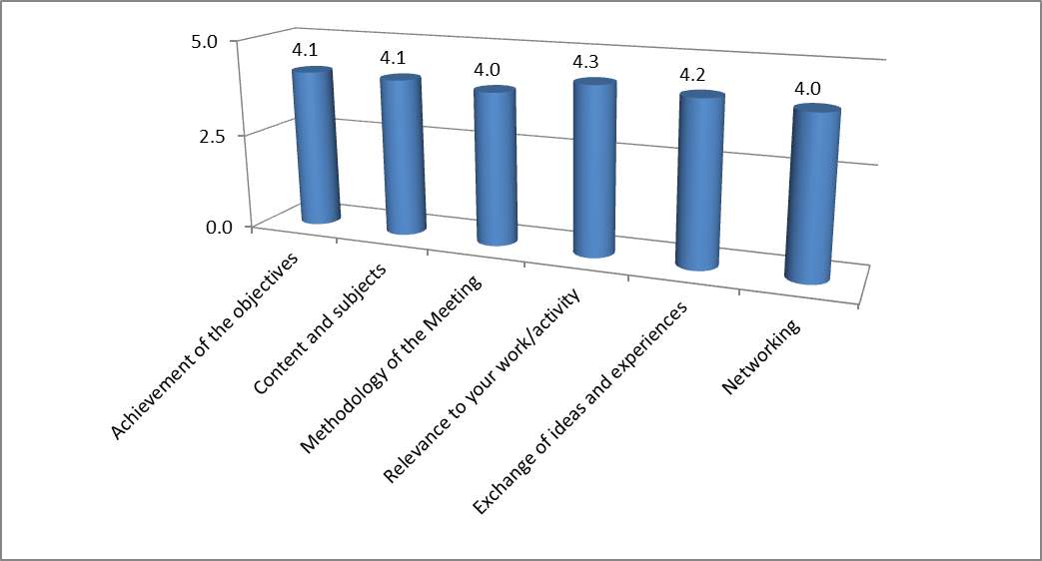

How do you rate the meeting contributed to the following aspects?
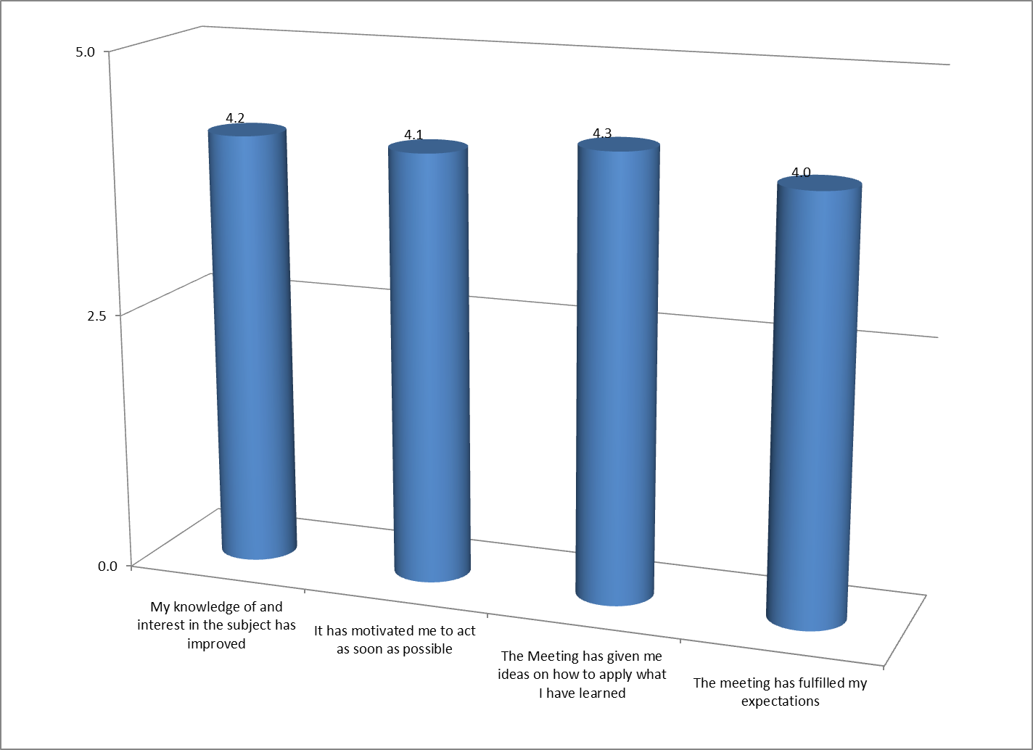
What is your rating of the following?
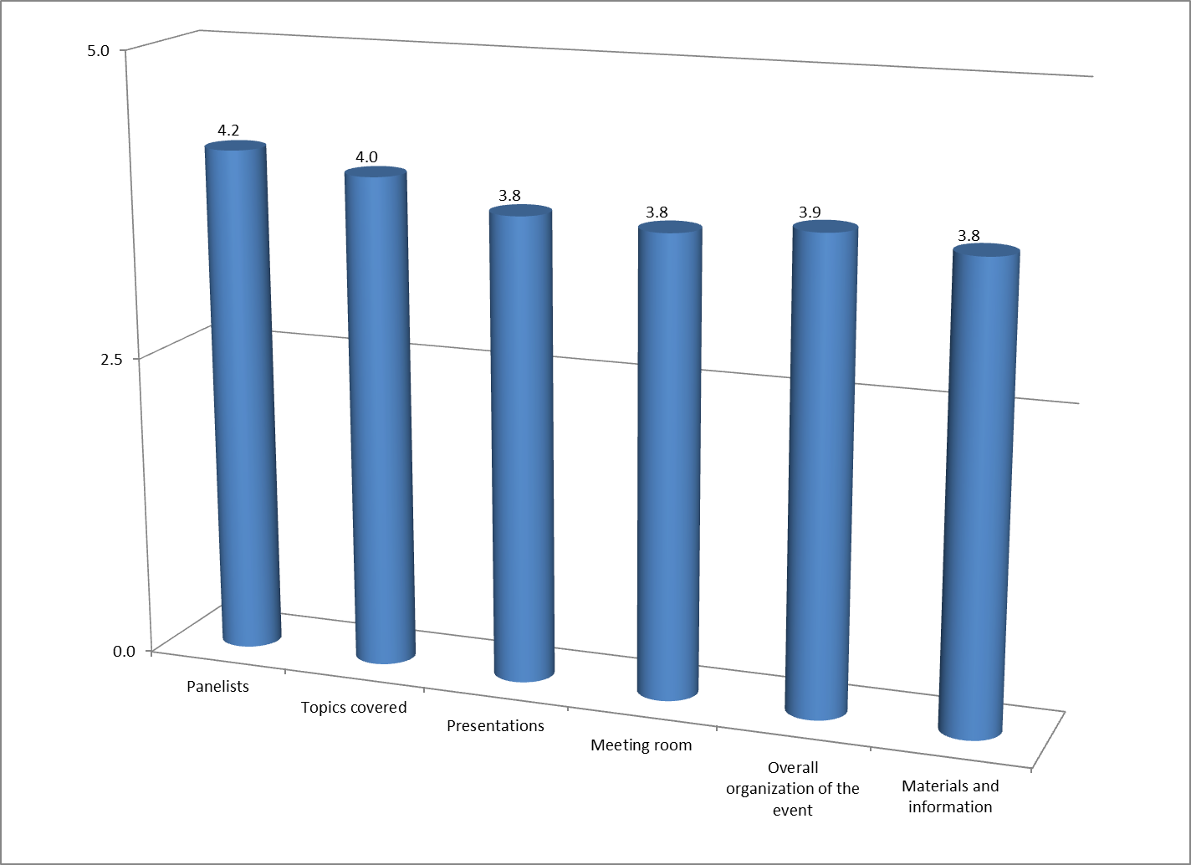
How would you rate the different sessions?
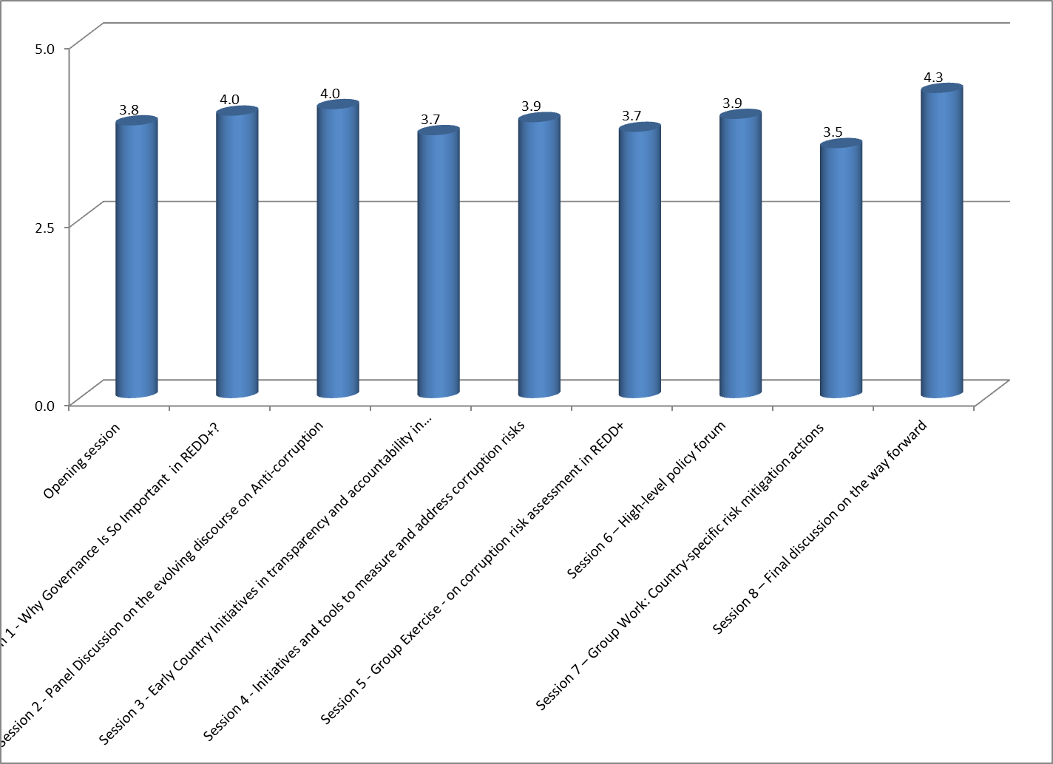
Responses to the open ended questions:
Some of the specific aspects that have contributed to enhance participants’ understanding of the subject of the Meeting were:
- Group work and country reports and exchanges
- tools to enhance stakeholder participation, transparency and accountbaility
- the cross-disciplinary approach of the workshop has been valuable to increase my understanding of the issues
- the inclusion of anti-corruption and governance in the REDD+
New insights that participants gained during the meeting include:
- the use of a project register (Congo DRC) as a tool for monitoring/transparency
- the need for cooperation and collaboration with other agencies who deal with economic crimes
- the full view of information flow on REDD+ and the experiences from other countries
- multi-agency effort is very preferable
Suggested topics and areas that need to be explored more in the future:
- issues to do with benefits to communities during the design and implementation phases
- international crimes in forestry sector and their potential risks to REDD+
- the role of anti-corruption watchdog as an important player in the execution of the REDD+
- customization of existing tools to assess corruption to fit in to the national context
Participants indicated to take the outcome of the meeting forward to their work:
- get the communities and networks involved more from the outset of the discussion
- take this learning to country and community level
- increased understanding and investigations of corruption in the forest sector
Additional suggestions
- transport allowance should have been alloted for participants Zambia
- members of IP should have been included

Annex 4 - List of Participants

A. Masinja, Ministry of Lands, Natural Resources and Environmental Protection, Zambia
Ad Spijkers, FAO, Zambia
Alfred Gichu, REDD+ focal point, Kenya
André Standing,U4 CMI, Kenya
Ayang Vincent Akam, Young People Initiative, Nigeria
Brhanu Kifetew, Ethics Infrastructure Coordinating Directorate, Federal Ethics and Anti-Corruption Commission, Ethiopia
Chancey Maroy Birimwirag, Dynamique UNESCO REDD, DRC
Charles Meshack, Tanzania Forest Conservation Group and consortium of CSO to the National REDD Task Force, Tanzania
Chiko Halwiindi, Anti-Corruption Commission, Zambia
Christopher Chibanku, Anti-Corruption Commission, Zambia
Clement Chansa, Anti-Corruption Commission, Zambia
Cyrille Adebu Liginda,OCEAN, DRC
David Gitahiga, UNDP, Kenya
David Ngwenyama, Zambia Civil Society Climate Change network, Zambia
Davies Kashol, Ministry of Lands, Natural Resources and Environmental Protection, Zambia
Deuteronomy Kasaro, Ministry of Lands, Natural Resources and Environmental Protection, Zambia
Estelle Fach, UNDP UN-REDD, Switzerland
Evans Bwalya, BELISOLAR LTD, Zambia
Faustin Bushashire Ngulu, Réseau CREF, DRC
Festus Chipungu, Anti-Corruption Commission, Zambia
Folake Oluoku, UNDP, Nigeria
Gertrude Lyatuu, UNDP, Tanzania
Ilitongo Kaywala, Ministry of Mines, Energy and Water Development, Zambia
Inonge Milupi, Anti-Corruption Commission, Zambia
Ireen Lamba, Anti-Corruption Commission, Zambia
Isidore Dianzinga, UNDP,R Congo
Jacob Makanbwe, African Youth Initiative Network (AYINET), Zambia
Jean Claude Kessous, UNDP, DRC
Josep Gari,UNDP UN-REDD, Kenya
Judy Ndichu,Transparency International, Kenya
Julian Fox, FAO, Zambia
Juventus Baitu,The Prevention and Combating of Corruption Bureau, Tanzania
Kanyinke Sena, UNPFII,Kenya
Kelvin Siampwili,Anti-Corruption Commission, Zambia
Kelvin Siwale,Anti-Corruption Commission, Zambia
Lawrence Mpundu, Anti-Corruption Commission, Zambia
Leah Good,Transparency International, Germany
Leslie Ouarzazi, REDD+ National Coordination, DRC
Mary Katimbe, Human Settlement of Zambia, Zambia
Morgan Samanenga, CarboAfrika, Zambia
Moyongo Géry Frédy, Réseau national des peuples autochtones du Congo (RENAPAC),R Congo
Neeta Hooda, World Bank, USA
Nkouka Noël Merlin, Commission nationale de lutte contre la corruption (CNLC),R Congo
Odigha Odigha, Forestry Commission, Cross River State, Nigeria
Phil Matsheza, UNDP, USA
Pixie Yangailo, Human Rights Commission, Zambia
Prof St Augustin Mwabandali,OSEP - Anti corruption, DRC
Ricky Mapama Kalenge, COLLECTIF OSC, DRC
Sally Kabanda, Anti-Corruption Commission, Zambia
Shimeles Sima,Ministry of Agriculture, Ethiopia
Susan Kinyeki, Ethics and Anti-corruption Commission, Kenya
Sylvester Ibiang Obono, Due Process and Price Intelligence Office, Calabar, Nigeria
Trond Loval, Royal Embassy of Norway, Zambia
Tsegaye Lemma, UNDP, USA
Tuva Bugge, UNDP, South Africa
Veerle Vandeweerd, UNDP, USA
Webster Munsanje, Anti-Corruption Commission, Zambia
Wiseman Sangulube, Ministry of Lands, Natural Resources and Environmental Protection, Zambia
Youlouka (Luc) Damiba, UNDP, Senegal

