Extension workshop on Building Awareness and Support of REDD+ among the Forest-Dependent Communities in Siam Reap province

Accomplishment Report

February 27, 2014

Submitted by

Mr. Chann Sophal
Edward V. Maningo, Ph.D.

1.0 Introduction
From 24-28 February 2014, Extensionworkshop on Building Building awareness and support of REDD+ among forest-dependent communities in Siam Reap province was organized by the project team.
2.0 Participants
There were 104 participants attended in the workshop including: National staff, trainer of REDD+ from Department of Forest and Community Forestry of Forestry Administration, project consultant, Siam Reap Forestry Administration cantonment, Deputy chief of Administration office of Siam Reap provincial hall, Chief of Bonteay Srey district, Chief of Varin district, Chief of Sotnikum district, Chief of Chikraeng district, Chief and deputy chief of all five communial councils, head of target villages, target CFMCs, HURREDO and FFI ( as in attachment).
3.0 Objectives of the Workshop
The specific objectives of the Extensionworkshop is to set the direction of the activities which will be implemented by IRD team in order to provide awarenessto the target communities related to REDD+ . The workshop aims to:

- Organize the information dissemination activities in order to achieve a significant impact. This includes planning of the information dissemination works in the field;
- Organize (selection and compilation) of relevant information materials to be used in the extension work and the reproduction of these materials that are sanctioned by the REDD+ Taskforce Secretariat;
- Identify awareness raising activity that disseminates the information to the target beneficiary. This includes a lecture presentation by an experienced professional who is knowledgeable on REDD+, presentation of videos related to REDD+, distribution of reproduced information materials.

4.0 Methodology
This workshop is an Extensionworkshop related to information dissemination activity that targets the CF members and commune councils, and the NGOs working in the area. The NGOs, especially those that are involved in REDD+, were invited to join the workshop with two reasons:
- To enrich their knowledge from the lecturer
- To share their experiences with the community
The participation from the local authorities (Provincial, District and Commune Council) in the awareness raising is to generate support to REDD+ and to increase their awareness on the contribution of human activities to GHG, for example: indiscriminate use of nitrogen-based fertilizers, land conversions, burning, etc. at the same time. The session workshop was separately conducted to the following groups:
- Community-level meeting: In this session, the target participants were chief, vice chief and members from target CFs. The meeting was conducted in CF only.
- Provincial, district, commune, village and NGOs level meetings: Representatives from provincial government, chief and deputy chief of the four districts, chief and deputy chief of the five commune council, head of the five villages, and NGOs working in the target areas and local forestry administration play an important role in the implementation of REDD+ in Siam Reap province.
5.0 Activities and Expected outcome of the Extension workshop
The Extension workshop is to expect positive result for the awareness raising/extension activities to increase the awareness of REDD+to the target beneficiaries. The workshop was conducted for 2 days with important topics and consultation as in the following:
- February 27, 2014: The workshop was conducted for CFs level
- February 28, 2014: The workshop was conducted for local forestry administration, provincial, district, commune, village and NGOs and other stakeholders.

6.0 Proceedings of the Workshop

The speech opened by Mr. Tea Kimsot, Chief of Siam Reap FA cantonment focused on the ensuring cooperation between the government and development partners with the distribution to achieve National Development Goal to insure sustainable forest management and livelihood improvement of local people. REDD+ is an important mechanism for distribution to the government to insure sustainable forest management. REDD+ is known as a new task in recent years, but it is an old task that was included in forestry, fishery and natural protected area laws.

REDD+ is a necessary mechanism for the distribution with the government to insure sustainable forest management, safety and welfare, and poverty reduction of people, especially people who live near the forests. Climate Change has affected to social and environment, especially the live of community in urban area, because the communities do not have ability to climate change adaptation. There are many issues that can cause to climate change such as transportation, industry sector, factory and enterprise, chemical use in agriculture sector, forest fire, deforestation and forest degradation. Climate change can cause global warming, changing rainfall regime, storm, Tsunami, and increasing sea level etc. These factors can affect to local community such as drought, irregular raining, lack of underground and ground water, human and livestock health by occurring some diseases. Cambodia is an agriculture country that is the most vulnerable to climate change, and agriculture sector that plays an important role depends on rainfall, Mekong and Tonle Sap regime.

Moreover, the workshop was also included presentation conducted by speakers from national and international that is representatives from government, civil society and other team works to share experiences in REDD+ implementation in Cambodia. There are some topics as in below:
- The evaluation sheet was used before the workshop start in order to get baseline data to measure knowledge on REDD+ so that REDD+ secretariat can effort awareness to target people who need this.

- Overview of climate change by Dr. Edward V. Maningo such as:
1. What is climate change?
2. The effects of global warming
3. What is needed to do to mitigate global warming?
- Basic science of climate change presented by Mr. Yeum Heng:
- Abbreviation
- Green house affects
- Issues of water used in the world
- Introduction to REDD+
- Climate change
- REDD+ and how to do?
- Presentation and discussion on forests and climate change by Mr. Long Ratanakkoma
- Advantages of forests
- Deforestation and forest degradation
- Emission to the atmosphere
- Carbon
- Carbon and forests
- Forest carbon stock
- Carbon absorption from the atmosphere
- The effects of climate change to forests
- Function of forests in adaptation
- Function of forests in climate change mitigation
- Presentation and discussion on Carbon credit project in CF in Oddar Meanchey
- Forest cover change in Cambodia
- Policy and legislation supports
- Information on the project
- Why choose Oddar Meanchey?
- Project structure
- Factors of deforestation and forest degradation
- Process of the project
- Benefit sharing
- Challenges
- The evaluation sheet was used before the workshop start in order to get baseline data to measure knowledge on REDD+ after extension workshop
- Participants attended in the workshop will get knowledge and experiences on REDD+. The level of knowledge on REDD+ will be remeasured by using KAP that is a tool to measure baseline data
- Suitable statistic test will be used to measure the level of CF knowledge to compare to base line data. It is expected that the awareness on REDD+ to CFs will motivate CFs to include REDD+ into their CFMP.
- The motivation of the community on REDD+ can be discerned from their ideas of incorporating REDD+ in their CFMP
- During the community meeting, a discussion will be conducted to determine which activities communities can engage that will help reduce emissions or enhance removals of greenhouse gasses from forests and whether this includes some costs which should be taken into consideration when discussing benefit sharing.
- All stakeholders who participated in the workshop are including: local forestry administration, local authorities, CFs, NGOs and international NGOs, and expressed their ideas and concepts on REDD+ in Siam Reap province
- Understanding on role in the process of project implementation on Awareness and supports of REDD+ among CFs
- Getting some concepts and recommendation from the workshop to implement the project on Awareness and supports of REDD+ among CFs in Siam Reap province

7.0 Outcome of the Training

An evaluation was conducted to measure the level of knowledge and attitudes of the participants. An evaluation questionnaire prepared by UN-REDD Secretariat. Before the training, the participants were required to fill up the questionnaire. The same sets of questions were asked after the training to measure the changes of the knowledge.

7.1 Changes in Knowledge

The result of the evaluationrevealed that before the training, there are about 37% participants who have low level of knowledge on REDD+ (and 63% have high level). After the training, it can be noticed that the participants who have low level of knowledge has reduced from 37% to 14% (Figure 1). The 23% increase is also shown in Figure 2. It can be observed in Figure 2 however that there are some aspects of REDD+ where the participants are still limited. This is on themeasurement of the changes on forest cover, involvement on REDD+, impacts on biodiversity and a few areas.

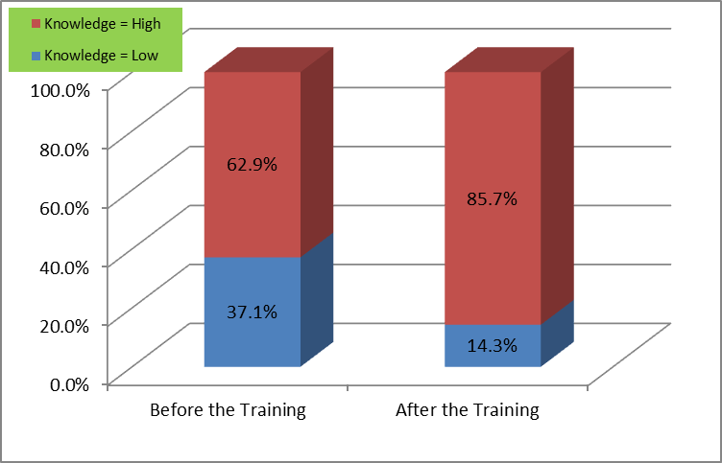
Figure 1. Change on the Level of Knowledgeamong the Participants of the Training

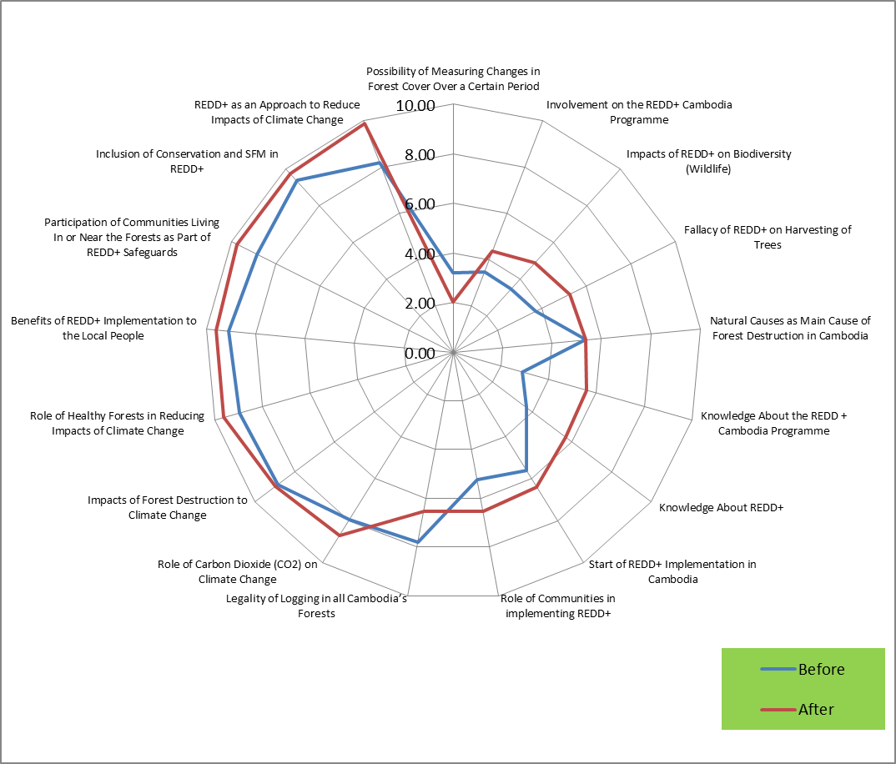

Figure 2. Extent by which the participants have improved their knowledge

7.2 Changes in Attitudes

The outcome of the training on the attitudes of theparticipants was further validated. Based on the tool, the participantsbelieve that REDD+ will provide opportunities to the CF. the responses mostly came from those participants who acquired high knowledge from the training (Figure 3).

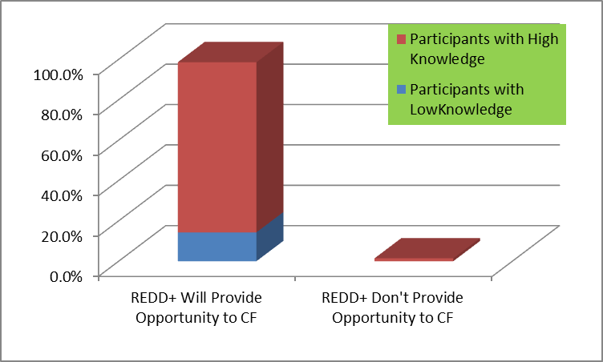
Figure 3. Perception of the participants on the Opportunities that REDD+ can provided to CF

One of the practices that need to be transformed is the farming practices of the community members. Before the training, 76% of those participants who farms indicated that they practice burning the agricultural wastes. But after the training, there is marked change of their attitudes. From 76%, this went down to 24% or a reduction of 52%. This remarkable change in attitude could indicate the success of the awareness raising activity. Despite the significant change, 24% of those who have farms indicated that they will still continue to burn theagricultural wastes (Figure 4). They cited the reason that it will improve the fertility of the soil. This information will indicate the need to strengthen the awareness raising on sustainableagriculture and on the adverse effect on the burning of wastes.

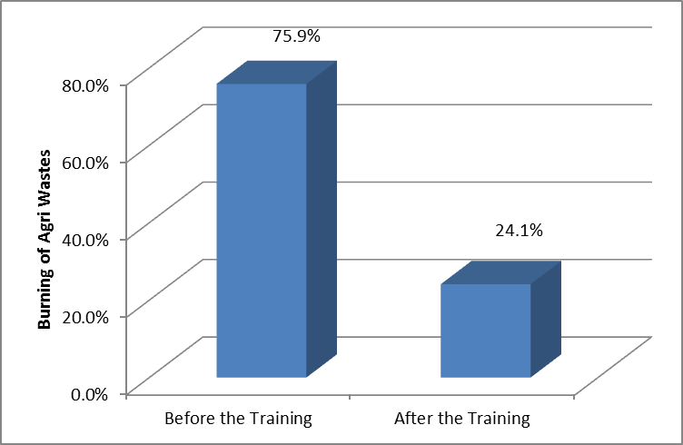
Figure 4. Attitudes towards burning of agricultural wastes

The changes in the attitudes could be driven from the motivations of theparticipants of the training. Specifically, the expected benefits from REDD+ may have affected their attitudes. The result of the evaluation indicated that the community members’ primary motivations are the expected income and other benefits that the CF and HHs can get from REDD+ (Figure 5). Understandably, the community expects monetarybenefits from REDD+ due to poverty.

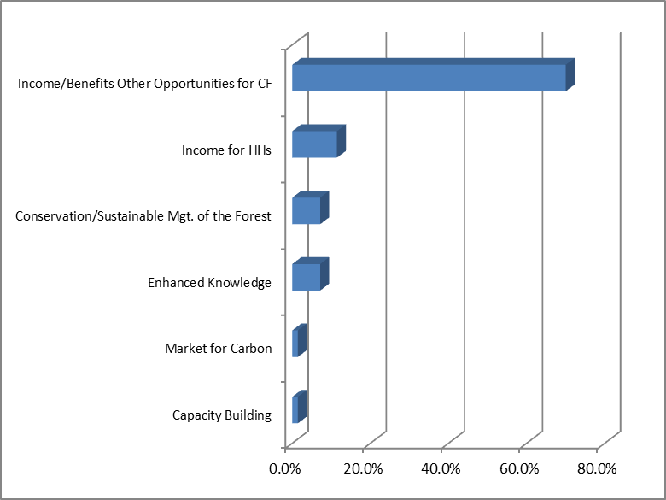
Figure 5. Expected Benefits from REDD+

7.3 Suggestion on How to Effectively Implement the Program

The participants provided some recommendations of effective implementation of the program. These include among others the capacity building and training of the community, providing wider informationdissemination and and simply, implementingtheprogramproperly (Figure 6).

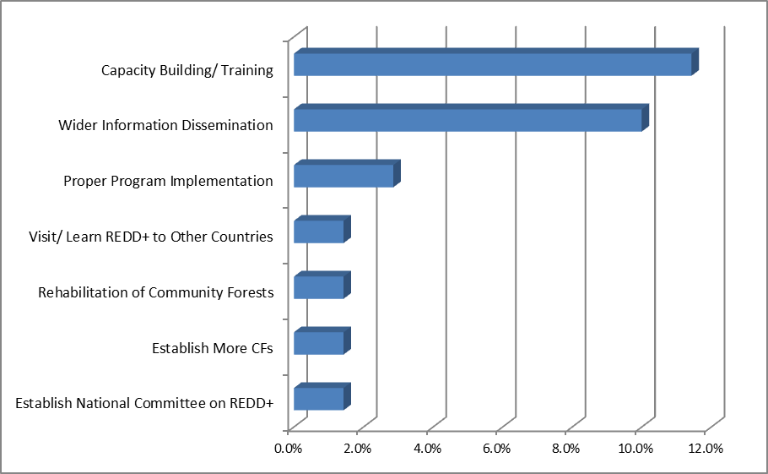
Figure 6. Suggestions from the Participants How to Effectively Implement the Program
6. Lessons Learned

The extension workshop on Building Building awareness and support of REDD+ among forest-dependent communities in Siam Reap province is an effective means of sharing sharing knowledge related to REDD mechanism and REDD+. It also provided an oportunity to interact with the stakeholders of REDD+. The pre and post workshop evaluation shows the improvement on knowledge and awarness of the participants on REDD+. Although the resource person is a veteran lecturer, the sheer complexity of REDD+ and climate change is still too complex to comprehend by the community members who generally do have limited education. There are still a few respondents who believe that burning of agricultural wastes will increase soil fertility.

7. Recommendations

Extension of REDD+ to the different stakeholders needs to be continued. In any community fora, it is important that REDD+ and climate change has to be included. The mass media, which is an effective means of conveying the message on the impacts of climate change. Lastly, sustainable agriculture will play an important component of any development activites and to transform the farming practices of the community.

Annex 1. Proceedings of the Extension workshop on “Building the Awareness and Support of REDD+ Among the Forest-Dependent Communitiesin Siem Reap” last 27 February 2014

List of Participants
No | CF Name | Numbers
1 | Project Team | 07
2 | Siem Reap Cantonment | 05
3 | Bos Thom Community Forestry | 11
4 | Prey KbalTuek Community Forestry | 10
5 | Prey Tamouv Community Forestry | 10
6 | Phum O Community Forestry | 10
7 | Chub ChreyKhangKaeut CF | 09
TOTAL |  | 62

Proceedings

1. The workshop on “Building the Awareness and Support of REDD+ among the Forest-Dependent Communities in Siem Reap” was opened by Mr. Tea Kimsot, Chief of Siam Reap Forestry Administration cantonment and was arranged by FA under the supports from REDD+ Secretariat. REDD+ provides a good opportunity to the communities to get benefit through Payment Environmental Services for their forest protection with necessary participation among CF and other stakeholders.

2. The evaluation and investigation are to get the baseline data that is the basic for measuring to measure knowledge on REDD+ so that REDD+ secretariat can effort awareness to target people who need this knowledge by using questionnaires before the workshop starts.

3. The presentation of REDD+ in Cambodia, joining as a member of REDD, Readiness for REDD, Supports to REDD and REDD progress nowadays.

4. The presentation on general background on Climate Change by Dr. Edward V. Maningo :
- What is climate change?
- The effects of global warming
- What is needed to do to mitigate global warming?

5. Basic science of climate change presented by Mr. Long Ratanakoma and Mr. Yim Heng:
- Concept of REDD+
- Forest and Climate Change
- Water crisis in the world

6. Overview of REDD+ in Cambodia
- Reducing Emission from Deforestation and Forest degradation
- Community forestry and REDD+
- REDD+ and how to do?
- REDD+ pilot project

This session aims to show problem occurred and experiences of REDD+ implementation in Oddar Meanchey province for the case study.

- Overall discussion

The discussion is to give the opportunity to the participants to understand clearly about REDD+ and brainstorm on how the lectures have improved their knowledge/awareness.

7. Discussion question on how to get and send the evaluation information and workshop facilitation.

8. Question about the communities:
- Question from Bos Thom CF: Where is Green House established? Can it be exist in CF?
- Answer: There is enough sun light so we do not need Green House for any crop planting.

- Presentation and discussion about forest and Climate Change by Mr. Long Ratanakoma

- Advantages of forests
- Deforestation and forest degradation
- Emission to the atmosphere
- Carbon
- Carbon and forests
- Forest carbon stock
- Carbon absorption from the atmosphere
- The effects of climate change to forests
- Function of forests in adaptation
- Function of forests in climate change mitigation

- Question and Answer

- Q: If forest are clear and when the tree are planted, can it absorb carbon?
- Answer by Mr. Mao Nha Chief of Kbal Teuk CF: After the tree is planted, it can absorb carbon.
- Answer by Mr. Long Ratanakoma: After the forests are cleared, carbon emits to the atmosphere. If we replant the tree it takes long time and spend a lot of money until the tree is mature and absorb carbon.
- Q: Can grass and small plants absorb carbon?
- Answer: All kind of plants can absorb carbon and much or less depending on type of plant.

- Reducing Emission from Deforestation and Forest Degradation
- Definition of REDD+
- History of REDD+ development
- Why need REDD+?
- Concept of REDD+

- Question and Answer
- Q: When we have community forest, what do we have to do to get money from REDD+ to our CF?
- Answer: Money is from the supports from government and international, and from carbon selling from the forests.
- Why are developed and developing countries interested in REDD+?
- Basic requirement and technical for REDD+
- Law and management unit
- Technical:
- Reference emission
- Measurement Reporting and Verification
- Protection
- Carbon credit trade

- Question: No

- CF and REDD+

- CF regulation
- Participation and Decision making
- Benefit sharing and benefit receiving
- Institutional arrangement
- Protection and Forest conservation
- Ownership
- Question and answer
- Q: Mr. Nok Sy (Tbaeng lech): How many percentage that the benefit from REDD+ will be shared the CFs?
- Answer: In principle, stakeholders in REDD+ will get benefit and direct practitioner will get more but it is still not sure as it is in the progress of preparing.
- Q: Can private forest be integrated into REDD+?
- Answer: Private forest can be integrated into REDD+ in case it has clear agreement.
- Q: If we participate in REDD+, can we collect forest products?
- A: CF can use forest as in traditional purpose in order to sustain the uses of forests. Timber cutting for selling can be done for the tree that is mature or old enough in order to sustain forest and carbon stock in CF.

- Presentation and discussion on carbon credit project in CF in Oddar Meanchey province
- Forest cover change
- Policy and legislation supports
- Information on the project
- Why choose Oddar Meanchey?
- Project structure
- Factors of deforestation and forest degradation
- Process of the project
- Benefit sharing
- Challenges

- Question and answer

- Q: How is the progress of the project in Oddar Meanchey?
- A: The carbon project in Oddar Meanchey has been successful and we are waiting for carbon buyer.
- Q: There is good protection in CF but there are people outside the CF come to cut timber in community forest, do the CF agree?
- A: This case is needed to protect to avoid the loss of forests.
- Q: The progress in Oddar Meanchey have finished, when CF in Siam Reap is started?
- A: FFI have been starting some researches in CFs of Siam Reap.

Annex 2. Proceedings of the Extension workshop on “Building the Awareness and Support of REDD+ Among the Forest-Dependent Communitiesin Siem Reap” last 28 February 2014

Lists of Participants

No | CF Name | Numbers
1 | Project Team | 07
2 | Siem Reap Cantonment | 13
3 | Siem Reap Government Officer | 01
4 | District of Siem Reap Province | 04
5 | Commune of Siem Reap | 10
6 | Village of Siem Reap | 05
7 | NGOs | 02
TOTAL |  | 42

1. The workshop on “Building the Awareness and Support of REDD+ among the Forest-Dependent Communities in Siem Reap” was opened by Mr. Tea Kimsot, Chief of Siam Reap Forestry Administration cantonment and was arranged by FA under the supports from REDD+ Secretariat. REDD+ provides a good opportunity to the communities to get benefit through Payment Environmental Services for their forest protection with necessary participation among CF and other stakeholders.

2. The evaluation and investigation are to get the baseline data that is the basic for measuring to measure knowledge on REDD+ so that REDD+ secretariat can effort awareness to target people who need this knowledge by using questionnaires before the workshop starts.

3. The presentation of REDD+ in Cambodia, joining as a member of REDD, Readiness for REDD, Supports to REDD and REDD progress nowadays.

4. The presentation on general background on Climate Change by Dr. Edward V. Maningo:
- What is climate change?
- The effects of global warming
- What is needed to do to mitigate global warming?

5. Basic science of climate change presented by Mr. Long Ratanakoma and Mr. Yim Heng:
- Concept of REDD+
- Green House effects
- Water crisis in the world

6. Forest and Climate change
- Climate Change
- Cambodia REDD+
- REDD+ and how to do?

- Reducing Emission from Deforestation and forest degradation
- CF and REDD+: present about potential of REDD+ in CFs with sustainable development and success of REDD+ implementation and show about responsibility of CFs in REDD+ distribution , recent issues in REDD+ implementation.

- REDD+ Pilot project
- The potential of CFs in REDD+
- Advantages and responsibility of CFs in REDD+

7. The evaluation and investigation are to get the baseline data that is the basic for measuring to measure knowledge on REDD+ so that REDD+ secretariat can effort awareness to target people who need this knowledge by using questionnaires before the workshop starts.

8. Discussion question in this session will give opportunity to participants to understand clearly about REDD+.

9. This session aims to collect idea from participants on how lectures have improved their knowledge/ awareness? At the end of the presentation, there is a session to estimate about how impacts to participants? The participants are given a questionnaire to complete to measure their interests in the session. Moreover, all participants are asked and shared their knowledge on how the lectures are and their experiences.
- Question FFI: What the cloud occur from?
- Answer: The cloud occurs from evaporation from water and forests.

- Presentation and discussion about forest and Climate Change by Mr. Long Ratanakomar and Mr. Yim Heng

- Advantages of forests
- Deforestation and forest degradation
- Emission to the atmosphere
- Carbon
- Carbon and forests
- Forest carbon stock
- Carbon absorption from the atmosphere
- The effects of climate change to forests
- Function of forests in adaptation
- Function of forests in climate change mitigation

- Question and Answer
- Q: If forest are clear and when the tree are planted, can it absorb carbon?
- Answer by Mr. Long Ratanakoma: After the forests are cleared, carbon emits to the atmosphere. If we replant the tree it takes long time and spend a lot of money until the tree is mature and absorb carbon.
- Q from FFI : What can CF receive after REDD+ has been developed?
- Answer by Mr. Koma: REDD+ mechanism implementation is needed the participation from endogenous people and CFs forest dependent and all decision makings are made by local communities and indigenous people.

- Reducing Emission from Deforestation and Forest Degradation
- Definition of REDD+
- History of REDD+ development
- Why need REDD+?
- Concept of REDD+

- Question and Answer
- Q: When we have community forest, what do we have to do to get money from REDD+ to our CF?
- Answer: Money is from the supports from government and international, and from carbon selling from the forests.

- Why are developed and developing countries interested in REDD+?

- Basic requirement and technical for REDD+
- Law and management unit
- Technical:
- Reference emission
- Measurement Reporting and Verification
- Protection
- Carbon credit trade

- Question: No

- CF and REDD+

- CF regulation
- Participation and Decision making
- Benefit sharing and benefit receiving
- Institutional arrangement
- Protection and Forest conservation
- Ownership
- Question and answer
- Q by representative from provincial government: What are issues in REDD+ implementation?
- Answer: There are 4 main challenges:
- Measurement to calculate carbon stock in the forests that is needed high accuracy in that area
- Payment: Donor countries are asking about payment benefit to local people
- Responsibility on how to ensure carbon payment to distribute to sustainable forest management.
- Fund raising: Do developed countries have to make fund raising in order to encourage the countries that reduce emission of GHGs from deforestation and forest degradation?
- Q: Can private forest be integrated into REDD+?
- Answer: Private forest can be integrated into REDD+ in case it has clear agreement.
- Q: If we participate in REDD+, can we collect forest products?
- A: CF can use forest as in traditional purpose in order to sustain the uses of forests. Timber cutting for selling can be done for the tree that is mature or old enough in order to sustain forest and carbon stock in CF.

- Presentation and discussion on carbon credit project in CF in Oddar Meanchey province
- Forest cover change
- Policy and legislation supports
- Information on the project
- Why choose Oddar Meanchey?
- Project structure
- Factors of deforestation and forest degradation
- Process of the project
- Benefit sharing
- Challenges

- Question and answer

- Q: How is the progress of the project in Oddar Meanchey?
- A: The carbon project in Oddar Meanchey has been successful and we are waiting for carbon buyer.
- Q: There is good protection in CF but there are people outside the CF come to cut timber in community forest, do the CF agree?
- A: This case is needed to protect to avoid the loss of forests.
- Q by representative from FA cantonment: How much money to spend for REDD+ implementation?
- A: According to the report by Mr. Stern about economics of climate change shows that to reduce GHGs emission from a half from deforestation before 2030, it is needed about 17-33 billion dollars every year.

Annex 3. Photo Galleries of the Workshop

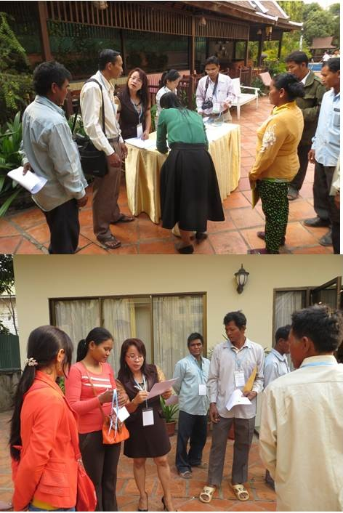
Training Staffs registering and providing instructions to the participants

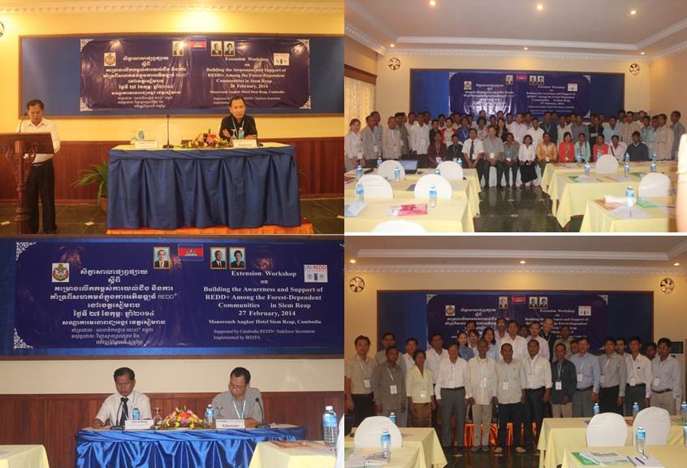
The Participants of the Workshop

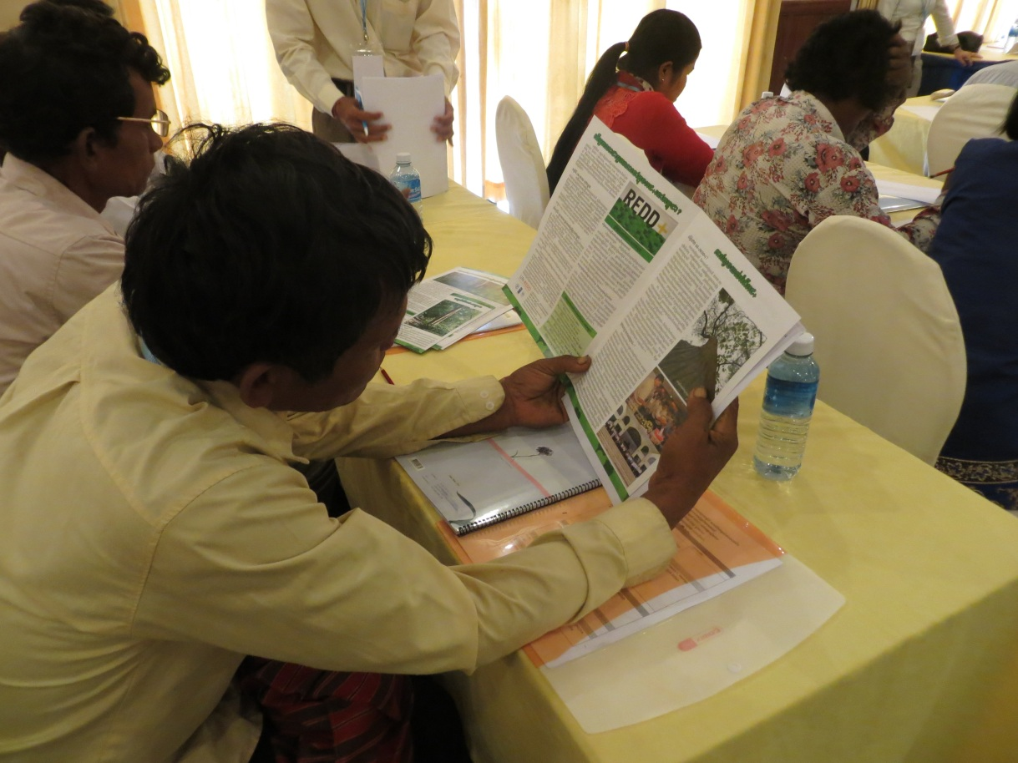
Participant reading the distributed REDD+ information materials

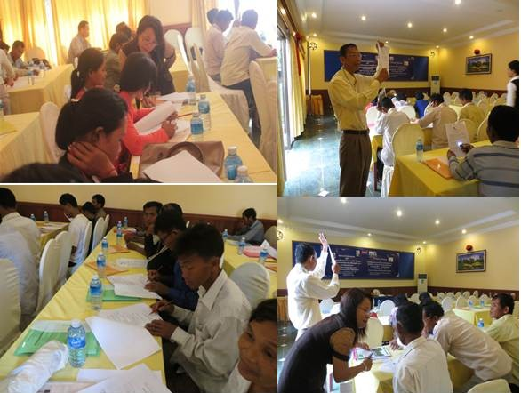
Training Staffs giving assistance on how to complete the training evaluation tool

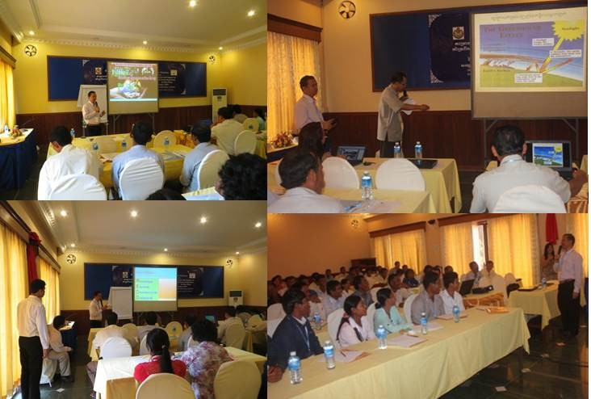
Lecture presentation

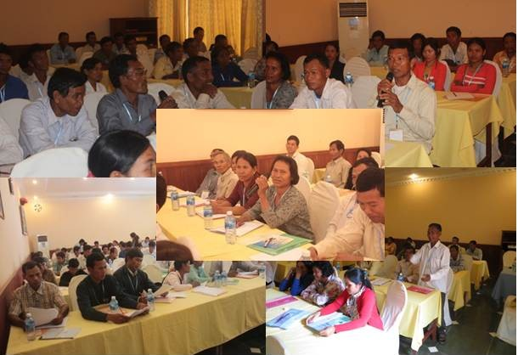
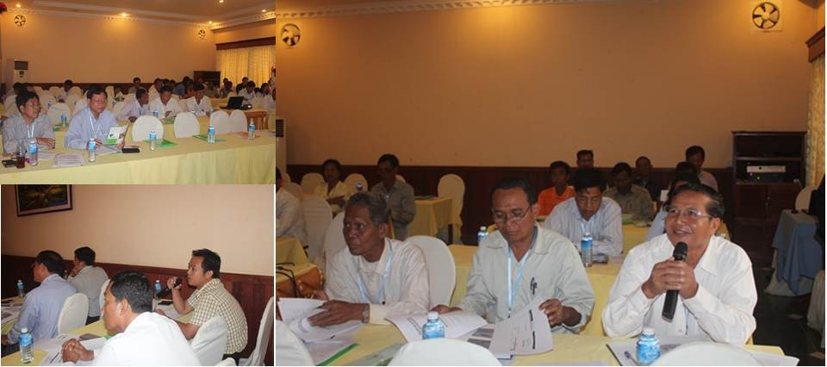
Participants interacting with the presentation and open forum

