Solomon Island National REDD+ Programme - MRV Practical
Guidelines - Draft

Purpose
The purpose of this document is to provide a suite of practical guidelines for conducting the MRV portion of the National Forest Monitoring System. This report is submitted as part of deliverable #6 for the Monitoring & MRV expert portion for the UN-REDD Initial National Programme in the Solomon Islands. This document is to be used as general guidelines only, with further and more in-depth review on a case by case basis. Some of this material is presented in the REDD+ Readiness Roadmap (Cowling et al. 2013) and is repeated here as a stand-alone document.

Introduction & Background
In 2013, the Solomon Islands had the unique opportunity to explore and enter into the UN-REDD Programme while implementing a key component of REDD+ readiness, the development of a National Forest Monitoring System (NFMS). During the second half of 2013, stakeholders within the Solomon Islands were navigating through the political mechanisms associated with participating in REDD+ and also taking advantage of existing funding, national enthusiasm, and critical needs to produce a prototype national forest inventory design and implementation for the sub-national region of Choiseul Province.

Typically, increasing REDD+ Readiness at the country scale involves (among many other things) a pathway to building a NFMS, inclusive of trainings and capacity building designed to launch a country to form a national strategy for forest monitoring and measurement, reporting, and eventual verification (MRV) of forest carbon stocks, GHG emissions and removals, and the reference emissions levels associated with those stocks (REL) and changes of those stocks in the form of emissions factors (EF) with land use/ land cover change (activity data, AD). In the case of the Solomon Islands, a "learn by doing" approach was implemented in mid-2013 to both inform the REDD+ Readiness process, and to identify and fill key data gaps to bring the country into readiness concurrent with the launch of the REDD+ Readiness Roadmap.

Through this unique approach, a prototype NMFS has been created concurrent with the REDD+ Readiness Roadmap. This document outlines the major guidelines to conducting future forest inventory to add to the NMFS under the current trajectory conducted thus far, and outlined in the Roadmap. This document is subject to annual review and change as methods and priorities are refined.

National Forest Monitoring System: Monitoring & Measurement Components
In brief terms, the NFMS is formed through the union of two major approaches (Figure 1). The first is a monitoring approach, where land use and land cover is mapped and updated on a regular basis (e.g. annual or as actions occur). Mapped features include native forest, plantations, agriculture, logging concessions, mining, infrastructure/ development, conservation areas, etc. The purpose of the monitoring effort is to spatially document the current and historic conditions on the landscape, and identify change into the future. These provide the essential elements for the spatial orientation of land use/ land cover for the country, province, or project area, and the methods to perpetually monitor outcomes of REDD+ activities.

Measurement is the process of defining a suite of ecosystem values to a given land use/ land cover type. While the monitoring aspect defines what type exists in a given current (or historic) condition, the measurement is what is required to calculate the carbon stocks and changes for a given land cover use and land use change, and how that land use type either performs as a source or a sink of greenhouse gasses (GHG) to the atmosphere--key factors that affect climate change. How a given land cover use changes determines if it acts to increase (a source) or decrease (a sink) atmospheric GHG. Combining these values with the monitoring spatial database yields a national-level GHG inventory. Hence it is important to measure what the carbon stocks are to quantify how a given land use acts as either a source or a sink when undergoing change.

Measurement of carbon stocks requires field-based measures to accurately measure all of the ecosystem components, or the aboveground, belowground, and soil organic matter associated with a given land cover type. Because REDD+ focuses on reducing net country emissions of GHG from forests and the human-caused (anthropogenic) changes associated with forests (logging, degradation, conservation, reforestation), the land use change measurements will focus on forests and converted forest environments, and how they change through time. Measurement requires several factors to increase accuracy of the estimate, including sampling of as much detail in vegetation types (e.g. species assemblages or basic forest types) as the country is able to monitor, as well as maintaining a good statistical sample to ensure the carbon stocks are accurate within a given type.

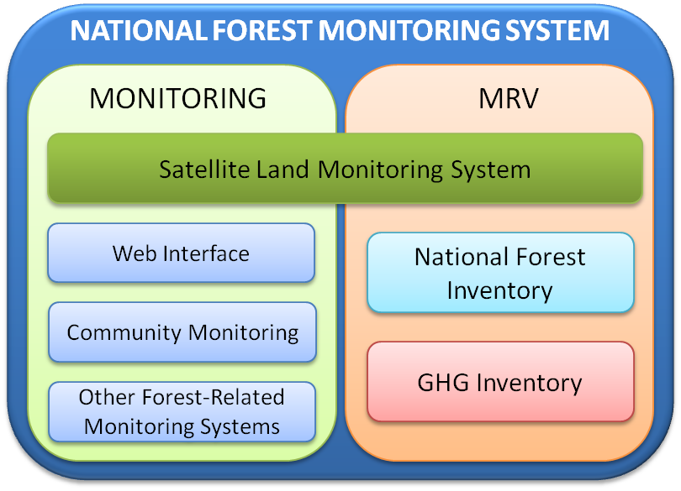
Figure 1. Conceptual diagram for a National Forest Monitoring System (NFMS) outlining the different aspects of Monitoring & MRV.

Core Elements of the NFMS
The NFMS extends beyond just the use of a single Ministry in planning purposes for REDD+. The ideal structure of an NFMS under REDD+ is used to monitor change for any user, from people within the country, as well as from third-party verifiers that may be internationally based or arriving to review methods and procedures used to generate the country level REL/RL and GHG inventories. To be effective and to fully participate in REDD+, the NFMS and methodologies used must contain the following key elements:

- Transparency. Assumptions and methodologies are clearly explained to facilitate replication and assessment of the inventory by users, including those decision makers within the country and third-party reviewers in a role as independent verifiers.
- Accuracy. This defines the degree of closeness of a measured value to its actual (true) value. Carbon stock and change measurement requires sampling to some degree, and the sampling protocol must contain enough samples to be statistically robust to represent the closest value to what is being claimed. For remote sensing data, there must be feedback and some degree of ground truth analysis to ensure classifications are correct.
- Consistency. This refers to methodologies used to ensure that they are internally consistent throughout the years. Methods can be refined, but there must be enough consistency so that prior years are comparable.
- Completeness. The forest inventory must cover all sources and sinks (including all gases for national GHG inventories) in the existing and relevant source/sink categories. In forestry, this considers all ecosystem components in the inventory (e.g. above- and belowground).
- Comparability. Estimates of emissions and removals by Parties should be comparable among all Parties. Forestry activities and emissions such should follow similar methodology and reporting guidelines so that results are comparable on a global scale.
Incorporating these key elements will ensure clarity and open participation in REDD+ and forms as the core guidelines for conducting for monitoring and MRV.

Required Capacity
A separate, more detailed Capacity Assessment Report has been prepared as part of the UN-REDD Programme in the Solomon Islands. Several highlights have been made regarding the entire discovery process of developing the prototype NFMS in the Solomon Islands, including current outcomes of training and future work to ensure long-term capacity. Brief highlights include the following:

- Computing Resources. Reliable power supply and IT support are inhibiting progress for capacity to conduct Monitoring & MRV. Simple solutions exist. Computers are lacking along with common GIS software resources (MapInfo vs ESRI ArcMap and open source such as Q-GIS and GRASS). Focus in this area will increase overall capacity for Monitoring as well as MRV data analysis and reporting criteria.
- Mapping Products. Current mapping products are a beginning to a national forest inventory program. Consider investment in ready-made digital imagery products from commercial providers to achieve basic product outputs, rather than build capacity in highly technical procedures. Working with regional partners is the best approach. Additional training required to conduct mapping for Monitoring & MRV activities.
- Project Leadership & Organization. Overall project management and logistics demonstrate outstanding capacity to initiate and execute a project virtually anywhere in the Country. Team Leaders learned a wide range of valuable skills and require additional practice to improve their ability to organize teams for field measurements. Upland forest leadership is much more refined than mangroves--mostly due to the focus of the workshop. Additional training is recommended to generate more practical experience.
- Technical Skills Required. Most in-field skills were developed at the time of the August 2013 workshop. Some recurring issues with sampling methodologies will require additional practice. An important data gap is in identifying tree species. Additional training within MoFR just to identify major tree species is required to fully outfit three teams for upland forest inventory sampling. Additional training in mangroves, secondary growth, and other ecosystems will also be needed to better capture the range of environments in Solomon Islands.
- Data Analysis & Reporting. A total of 20 participants with no prior database experience constructed the first national forest inventory database to analyze the current carbon stocks for sites measured in Choiseul. Sub-national reference Level (RL) carbon stocks were calculated as carbon dioxide equivalents (CO₂e) and the database allows for additional data to be readily imported and queries were established to produce results as additional sites are entered. Participants have a good introductory capacity to relational databases, and much enthusiasm was observed to further this type of training.
- Women as Environmental Professionals. There is a need to increase women's roles and responsibilities in all aspects of the REDD+ process. At the local level, women professionals can engage with women in the communities to better understand the particular constraints of a village or tribe, then communicate these concerns to the National REDD+ Implementation Unit. At broader scales, women within the National REDD+ programmes play vital roles in the overall direction of the REDD+ policy and implementation. Furthermore, there is a need for men to recognize and support their women colleagues in this effort so that REDD+ is indeed representing the national interests of both men and women.
- International Capacity & Collaboration. There was wide acceptance and enthusiasm associated with including four experienced Forestry Officers from Fiji to assist with the training event. This helped to build a larger team of qualified Officers that will be able to assist each other, as well as other countries in the region with forest inventory and MRV practices. This capacity also included similar methodologies to ensure consistency as part of the core elements of the NFMS. Additional training in this regard should be considered at every given opportunity.

Overall the Roadmap outlines next steps to continue with the capacity building and ensure an institutional development of an NFMS in the Solomon Islands to be housed with the National REDD+ Implementation Unit (MoFR) with collaboration from the National REDD+ Focal Point (MECDM).

NFMS: Monitoring & MRV Outline of Procedures
This section defines in more detail the process by which MRV is conducted, and the general outline of events required to build and populate the NFMS. A Primer Manual is a noted data gap that is required to further outline all procedures outlined here in more detail.

A broad outline of the process is shown in Figure 2. Activity data are effectively the land use changes in the current condition expressed as a classification (following IPCC land use categories) and size of area (ha). Emission Factors are the estimate of the emissions associated with changing from one land use type to another, expressed as the basis of emissions in carbon dioxide equivalents (CO₂e) per unit area (ha). The Emission Estimate is the product of these two values to estimate the total emissions due to land use change from/to forests (as is the case with NFMS) and also the change associated with other GHG emissions (e.g. transportation, manufacturing, other sectors).

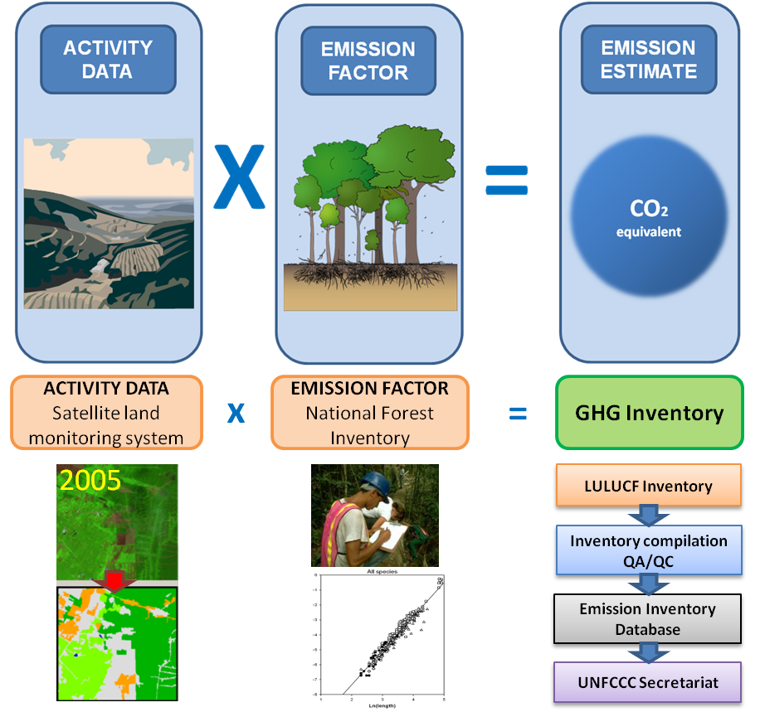
Figure 2. Methodological approach to calculate anthropogenic GHG emissions related to forest land (IPCC).

Activity Data
Activity data represent the most basic land use data, where the current status of the land is documented on a map and then tracked as the status of that land changes through time. Activity data requires the understanding of the current condition in a map at the national level, keeping in mind that a stepwise solution of building sub-national units is an acceptable approach to ensure "learn by doing" improves on the technique and methods.

This step requires capacity for GIS and mapping skills, with also a critical element of evaluating change through time (monitoring). For example, in 2012 a standing native forest is within a logging concession and is harvested in 2013. The activity data for that site would be a change from native forest to post-logged forest. However, it is first important to know that a given area was in forest, and then to monitor that area for change through time and marking the map with the change in activity. Further, if that site is then later replanted, then it would become equally important to note the activity now involves restoration.

One critical path to building an activity layer at the onset of REDD+ Readiness is to conduct a Historic Trend Analysis (see Roadmap). This analysis involves gathering all historical activities for all provinces (or beginning at the sub-national level) and creating a trend assessment and map of how activities changed through time--this includes historical logging concessions and their utilization, conservation/ protected areas, reforestation, areas of degradation, etc.

For REDD+, monitoring and updating of Activity Data as well as the national GHG inventory should occur every two years with a final reporting every four years. However, maintaining active communication with other ministries and departments within each, and through good coordination through the National REDD+ Implementation Unit and National REDD+ Focal Point, this process can be ongoing and readily updated as new actions occur.

Stratification of the Landscape
With a map of the current conditions and activities, it is possible to identify the areas in need of additional MRV forest inventory, and appropriately select sites to measure on the ground to provide the information on ecosystem carbon stocks and changes for a given forest type or activity. Stratification is the process by which a given strata, or homogeneous forest type/ population, is sampled on the landscape to capture the mean, range and variability of the carbon stocks, so that these values can be "scaled up" to the appropriate level (island, subnational, national).

The primary tools for this procedure are generally remote sensing and GIS based: aerial/ satellite imagery, current activity layers, distribution of forest types, elevational gradients, and any other information that would potentially need to be included in order to increase accuracy of the stratification (climate/rainfall, land status, access, etc.).

Stratification can be done in a hierarchical fashion, where forests can be further delineated into different types of forests (for example: low, medium, high elevation), different ages, different compositions, etc., or may just be on a systematic grid. The primary need is to provide flexibility and be consistent when conducting the future measures so that the data are comparable and transparent. Stratification may change through time, as both more information about the forest composition and structure becomes known, and as national level monitoring becomes more mature. However, the core elements of the NFMS are the most important to maintain for quality control and assurance (see Core Elements of the NFMS beginning on page 3).

With a stratification scheme that is transparent and in place, then permanent sample plots can be located on the ground for future field measurement.

Measurement of Carbon Stocks & Emissions Factors
Measurement of carbon stocks and the calculation of emissions factors (measured as CO₂e) occur with completing forest field inventory by following the sampling design of the stratification scheme selected (see above), and analyzing the data for carbon stocks and changes.

In general, sampling occurs in replicates of aboveground components (trees, shrubs, vines, ground cover plants), dead trees (standing and lying on the ground), belowground plant biomass (roots), and soil organic carbon. Many of these components can be measured directly, or estimated using published allometric models (i.e. roots are estimated from live tree allometry). For mangroves, it is critical to obtain samples from the marine sediments as well as depth of the sediment to the coral sands, as the majority of the ecosystem carbon lies in this strata of the forest.

A primary data gap with Solomon Islands is a full Protocol for sampling of both mangroves and upland native forest, along with protocols for sampling plantations, converted lands, second growth and other features that can be attributed to forestry-related anthropogenic sources or sinks of GHG. Methodologies were selected as part of the MRV prototype project in South Choiseul, though these methods need to be formalized and worked with other Regional partners (e.g. Fiji, Vanuatu, PNG) to ensure they are comparable methods. Early work on this was completed prior to the Choiseul field mission.

Following data collection, allometric models are well established to estimate total ecosystem biomass of the forest, which can then be quantified as carbon stocks (approximately 50% of the biomass is carbon); likewise carbon stocks can be conservatively converted to CO₂e (as carbon dioxide, 3.67 times carbon content). Averages of these carbon stocks form reference levels (RL) for the particular forest type sampled. Change in emissions occurs using the difference between RL for the change in type. For example, a primary lowland forest converted to post-logged forests would have an emissions factor of the difference in reference CO₂e between the two types (a loss to the atmosphere). Conversely, a conservation area may have an "avoided conversion" of the opposite if the forest is guaranteed to not be harvested.

Creating GHG Inventory (Forestry Activities)
As stated above, using the reference emissions levels (REL) and forest reference carbon stocks (RL) are calculated, emissions factors are calculated for a given change on the landscape. Using the Activity Data, housed as a GIS monitoring layer database, the emissions factors can be applied to each land cover type to quantify the mean, range and variability of the total GHG emissions due to change from one time period to the next. It is important to describe these with the levels of uncertainty clearly defined, as well as identify uncertainties and data gaps associated with the Activity Data. These uncertainties are to be very clearly outlined as part of the transparency guideline of the NFMS.

A full accounting of the GHG inventory from forestry activities can be completed by the National REDD+ Implementation Unit and then passed to the National REDD+ Focal Point in the MECDM, who will add to the GHG inventory for other sectors.

The capacity to accomplish these goals, along with required skills, experience and infrastructure are reported in the Capacity Assessment Report (Heider 2013).

Reporting
Key elements of the reporting process follow the same guidelines of the NFMS, described in the Core Elements of the NFMS section beginning on page 3. Reporting serves as the base by which full transparency and comparability can be observed for both internal (national and sub-national) review as well as for the international community (e.g. UNFCCC).

Reporting can (and is recommended to) be done during the natural iterative steps of developing the national RL/REL, through the stepwise approach of sub-national sampling. As field work is completed and new RL/REL are developed, reporting can take place to reflect those emissions during the given time step. Reporting should take place every two years -- through a Biennia Update Report (BUR) -- for estimating change. This BUR is the mechanism by which changes in forest activities or "trajectories" of land use can be updated along with the national GHG inventory. Full reporting is conducted through a national level communication every four years. This could mean that the Country reports at a two year frequency, but sampling and internal reporting happens every year.

Reporting is also a way of connecting and quantifying the links with the National Drivers of Deforestation to better understand the trends as the country moves forward with REDD+ Implementation. Market changes, legislation, safeguards, and other factors may very well change the Drivers of Deforestation into a different allocation of activities that may need closer tracking. Reporting serves as a "feedback loop" with the National REDD+ Task Force and the National REDD+ Implementation Unit and National REDD+ Focal Point to better design response and need for monitoring, MRV, and project design.

Technology transfer also occurs during the reporting phase, with updates to the transparent web-based monitoring system in the NFMS as well as transfer of data to Provincial Government and other key stakeholders. This was information that was requested in the Choiseul prototype MRV training so that the community could monitor their contributions to climate change and better understand decisions in that context. Outreach is one key aspect of reporting.

Verification
Once REL/RLs are established, the national GHG inventory (with details of methods, data sources and uncertainties) can be submitted to the UNFCCC for review. Verification occurs only in Phase 3 of REDD+ Implementation, and protocols are not yet finalized for REDD+. Under the voluntary carbon market, verification protocols are in place for the establishment of Verified Carbon Standard when evaluating how carbon credits are quantified. Additional guidance from UNFCCC is anticipated in the coming years.

Despite the unknown specifics, a key factor with any verification involves the "Chain of Custody" diligence that demonstrates (in a clear and transparent way) that the methodology is valid and follows the Core Elements (see page 3), that the inventory can be repeated within reasonable bounds of accuracy, and that the assumptions used are valid. Due diligence by verifiers is profoundly less complicated if the NFMS is well designed. Opportunities exist to work with international partners (e.g. current partnership with Fiji) in "self-check" verification services to train on improving transparency and comparability among regional neighbors and participants.

Defining Demonstration Areas
The final REDD+ Readiness Roadmap and the Capacity Assessment Report both outline a suite of criteria by which the National REDD+ Task Force and partners make decisions for future MRV trainings and forest inventory, as well as define areas that may be suitable for potential REDD+ projects. This is an ongoing process that is better discussed in the roadmap and added to these guidelines as the process repeats itself into the next MRV implementation work scheduled for 2014.

In general, the following should be considered in selecting demonstration sites in the near-term in the Solomon Islands:
- Clarity of the land/resource ownership
- Existing levels of local capacity (resource owners, supporting NGOs)
- Rates or current threats of deforestation or forest degradation
- Forest area/ size
- Logistical feasibility: accessibility to the sites and costs of the operation
- Potential to deliver multiple benefits
- Interest and capacity for Provincial Government to engage in project
- Demonstration has significant co-benefits that could be generated

Once sites are identified, a prioritization structure can be developed (see Capacity Assessment Report for an example) to begin measurements of the REL/RLs in a given sub-national area(s). Refinement of these criteria is iterative with the REDD+ Task Force and advisory from the rest of the team. Priorities include:

- Status of Mapping Resources
- Status of Historical Trends
- Magnitude and Timing of Threats
- Stakeholder Willingness
- Fiscal & Logistical Concerns
- Active Concessions/ Legal & Contractual Considerations

Additional guidance is provided in the REDD+ Readiness Roadmap for consideration of future areas for both REDD+ Demonstration, but also for first developing the REL/RL through the MRV process.

MRV Prototype Methodology
Following the general guidelines above, the National REDD+ Implementation Unit along with the National REDD+ Focal Point and partners initiated an intensive field training in Southern Choiseul Province (Lauru Island). The workshops were conducted to train approximately 30 people for to stratify and sample forest biomass in 18 upland and mangrove sites, and to conduct data analysis to quantify the mean carbon stocks associated with native forest.

Methods
Methodology was kept consistent with ongoing efforts currently underway by the SPC-GIZ funded REDD+ programme in Fiji. These methods were initially selected to maintain a comparable sampling protocol, and to maintain consistency with past efforts by the Solomon Islands MoFR in their permanent sample plot (PSP) network.

Stratification using remote sensing imagery for Choiseul was generally not of high quality or resolution to parse different forest types. Data available from the Shuttle Radar Topography Mission (SRTM) allowed for stratification based on elevation. Intact forest sites were selected along an elevational gradient of low, medium, and high elevations, and replicated in different areas of the Demonstration Area. Three sites that had been recently logged were also measured as second growth forest stands.
Mangroves were selected on the basis of major type (Bruguiera-dominant, Rhizophora-dominant, or mixed species types).

Field Sampling
Field sampling for upland forests followed a modified approach to those used by both Solomon Islands MoFR and Fiji Department of Forestry for their PSP design (Figure 3). Design changes were largely modifications to the number of subplots used (four instead of two) to sample mid-strata tree diameters (10 - 25cm dbh) and for all plants <10 cm dbh. In addition, a total of 8 planar intercept transects were established to measure all dead wood lying on the ground. Biomass of herbaceous materials and litter and duff were not measured or accounted for in the carbon inventory because this component had a relatively high cost in both labor and laboratory work for a relatively low amount of carbon relative to the rest of the ecosystem. In addition, the remote conditions did not adequately allow for full drying of litter samples to accurately account for biomass.

Figure 3. Plot diagram used for measuring upland primary forest.

For upland forests, all trees ≥25 cm dbh were identified for species and measured for both dbh and height in the entire 50 x 50 m plot. Trees >10 cm and <25 cm were likewise measured for dbh and height in the four 20 x 20 m plots. All plants <10 cm dbh were identified and measured for dbh. For plants <1.3 m in height, all plants were tallied by species. Originating at the inside edge of each 20 x 20 plot, 12 m transects were established to sample downed wood material (see bottom graphic in Figure 4) for 12 m along the edge of the plot (total of 8 per site).

Mangrove sampling followed methods described in Kauffman & Donato (2012), which has been implemented throughout the world, and most recently in Fiji by the Pacific Mangroves Initiative (Heider et al. 2013). In each mangrove site, a linear transect (125 m) with six plots were established at regular intervals (25 m apart). Trees ≥5 cm dbh were identified and measured within each of six, 7 m radius plots. For trees <5 cm, dbh trees were likewise measured in a 2 m radius circular plot within the 7 m radius plot. Down wood transects were sampled (4 per plot, 24 total per site) originating at the center of the plot. Because the majority of the carbon pools are located in the marine sediments (soils), a soil auger was used in each plot to sample fixed volumes of soils at five different depths: 0-15, 15-30, 30-50, 50-100 and >100 cm. The depth of the soils was also measured using a soil probe (three times per plot) to calculate the mean depth to the coral sands.

Figure 4. Plot diagram for mangroves (top) and for the downed wood transects (bottom). Source: Kauffman & Donato 2012.

Data Analysis
For upland forests, allometric equations for moist forest stands that utilized dbh, height, and wood density were selected, using an average wood density values for tropical moist forests (0.58 g/cm³) (Chave et al. 2004). Training for wood density sampling by species was conducted in Choiseul and is in the process of being linked to a species specific database. Mangrove models utilized diameter-based measures developed in Micronesia (Kauffman and Donato 2012. Genus-level models were used following major growth form where species models were not available. Belowground root biomass for mangrove trees was calculated using the formula presented by Komiyama et al (2005). Tree carbon was calculated by multiplying by a factor of 0.48 for aboveground and 0.39 for belowground biomass (Kauffman and Donato 2012). Standing dead trees were likewise measured for biomass and carbon, assigned by decay class; dead trees were present but a rare fraction of the total ecosystem pool. Downed wood was sampled using the planar intercept technique (Van Wagner 1968).

Core samples of each soil depth were dried and weighed to calculate bulk density. Carbon concentrations are determined using the dry combustion method (induction furnace) with a Leco CNS-2000 Macro Analyzer. Bulk density and carbon concentrations were combined with plot-specific soil depths to determine the total C stocks.

Data analysis was conducted during a two day training in Honiara, where participants developed a specialized database to import data collected in the field and calculate average biomass and carbon pools for all plots within each site. Not all sites were entered and available for this training, though the process involved making a series of fixed queries that followed the following general steps:

- Enter site name, plot type and number, species, dbh, height, and count into a working spreadsheet
- Import the spreadsheet into the Access Database
- Review and "clean" the data to ensure it is not duplicated and all site names are entered correctly
- Create or append a site list by name, with categories based on the stratification scheme (e.g. low, med, high elevation sites)
- Create or append a species list that can be populated with wood density values
- Calculate biomass and carbon for all trees, downed wood, and soils, in metric tonnes (Mg)
- Express biomass and carbon in terms of metric tonnes per hectare (Mg/ha) based on the plot size used
- Calculate the total sub-plot carbon pools for each plot type in each site (Mg/ha)
- Average all of the sub-plots for each site (Mg/ha)
- Sum all of the averaged values for each plot type for each site to calculate total ecosystem carbon for each site (Mg/ha)
- Calculate tonnes of carbon dioxide equivalents for each site (tCO₂e/ha) by multiplying carbon mass by 3.67
- Average the total carbon pools for each site type (e.g. low, mid, high elevation or Rhizophora, Bruguiera, mixed mangroves) and calculate confidence intervals
- Report both carbon pools (MgC/ ha) and carbon dioxide equivalents (tCO₂e/ha) with the confidence intervals to quantify the reference level (RL) for the stratified forest or activity data type
- Multiply the amount of land area (ha) by the carbon pools and CO₂e to create an inventory of standing stocks
- Apply different emissions factors for different land use changes (e.g. low elevation forest to a logged forest) to calculate forestry-related GHG emissions.
There is a need to develop a fully refined protocol that is specific to the Pacific Countries regional considerations for REDD+. This formal protocol should include all of the steps associated with MRV, and considerations for sampling format and design as well as collaboration with other regional partners that are also engaged with REDD+.

References

Heider, C., et. al. 2013. MESCAL Carbon Assessment: Rewa Delta Mangrove Reference Levels & Emissions Due to Conversion. Pacific Mangroves Initiative. 27p.

Kauffman, J.B. and D.C. Donato. 2012. Protocols for the measurement, monitoring, and 4 reporting of structure, biomass and carbon stocks in mangrove forests. Working Paper 86. 5 Center for International Forest Research. 40p.

Komiyama, A., S. Poungparn, and S. Kato. 2005. Common allometric equations for estimating 16 the tree weight of mangroves. Journal of Tropical Ecology. 21:471-477.

Van Wagner, C.E. 1968. The line intersect method in forest fuel sampling. Forest Science 24: 469-483.

See Heider C. Capacity Assessment Final Report. Watershed Professionals Network. Submitted to UNDP UN-REDD Programme, Honiara, Solomon Islands. November 2013.
See C. Heider "Lessons Learned" documentation. Submitted to UNDP November 2013.
As per recommended in the REDD+ Readiness Roadmap with a stepwise solution beginning at subnational scales.
See Heider, C. Solomon Islands MRV Capacity Assessment Report, UN-REDD Programme, November 2013.
A full methodology and primer is a key data gap identified in the REDD+ Readiness Roadmap
See Heider, C. Solomon Islands MRV Capacity Assessment Report, UN-REDD Programme, November 2013.
http://srtm.usgs.gov/index.php
diameter at breast height, 1.3 m
Approximately 50% of the biomass is carbon.

