Monitoring systems for illegal land encroachment at the Seima Protection Forest REDD + Demonstration site

Tony Lynam, Tom Evans, Pet Phaktra and Phien Sayon
Wildlife Conservation Society Cambodia Program and Forestry Administration
October 2013
Contents

Executive summary 1
1. Introduction 5
2. Encroachment threats at Seima 6
3. Patrol-based deforestation monitoring 10
4. Additional encroachment monitoring systems 13
5. Conclusions and recommendations 19
Annex 1: Methodology for use of Landsat 7 imagery in near-real-time monitoring of deforestation threats. 21
Annex 2: Case study of use of Landsat 7 to identify deforestation hotspots in Labake areas, SPF 29
Annex 3: Methodology for use of FIRMS active data to identify suspected deforestation hotspots in evergreen forest 31

Executive summary

Background and objectives
A site-based carbon offset project is being developed in the Core Area of the Seima Protection Forest (SPF) under the Reduced Emissions through avoided Deforestation and Degradation (REDD) framework. This report describes one activity under a grant funded by the UN-REDD programme of support for Cambodia’s National REDD Readiness process. The objective was to document improvements to land encroachment monitoring systems across the project site, and to draw lessons for approaches under the national system.
Success of REDD in the SPF (and elsewhere in Cambodia) is dependent in part on controlling illegal land-use by local communities and in-migrants in accordance with the Forestry and Land Laws. Where deforestation is rapid, boundaries poorly demarcated, and governance systems remain weak this presents a major practical challenge. Effective, timely monitoring enables a rapid response to deforestation while it is underway, minimising the area lost and increasing the possibility that cleared areas can be restored to forest before other uses become too firmly established.
Technical approaches tested
This report describes an integrated system of four approaches to monitoring which is likely to have wide applicability in Cambodia as it relies on affordable technology and readily available technical skills. All four are more effective when applied together with existing knowledge of the site, in particular the distribution of forest types, access routes, socio-economic conditions and the location and drivers of recent deforestation and degradation.
- Patrol-based monitoring
The primary form of field-based monitoring is via ranger teams, who collect and record geo-located observations whilst conducting law enforcement patrols. Patrols are targeted by patrol supervisors through daily oversight and monthly and quarterly review sessions. The key innovation relevant to this report is a user-friendly data management system that enables the results of recent patrols to be quickly mapped, analysed and reported to enable adaptive targeting by patrol supervisors. Free but proprietary software (MIST; Management Information System) has been used and Seima is now transitioning to the improved and fully open source version called SMART (Spatial Monitoring and Reporting Tool). The data stored in a MIST or SMART database is also useful for external reporting (e.g. to higher levels of government or to civil society). It provides excellent documentation of the intensity, distribution and results (e.g. arrests) of patrolling effort that can be aggregated across sites, regions or nationally.
Requirements: The system runs on almost any normal computer with printer; a GPS unit is needed for each patrol team. Routine data management (data entry and outputting) can be conducted by anybody with basic computer literacy and good attention to detail. A computer technician with moderate database skills is needed for some trouble-shooting tasks and more skilled support is needed to set the system up and periodically review it. The patrol supervisor must be comfortable reading and analysing simple maps and tabulated data.
- Routine inspection of satellite imagery
Given low patrol staffing levels and the dispersed nature of the threat, effective surveillance systems are required so that routine enforcement can focus in a few key places and rapid responses can be organized when incidents occur elsewhere. Systematic national and site based deforestation mapping happens too infrequently to enable timely enforcement responses so a rapid monitoring system has also been established at Seima, and could be more widely applied.
Images from Landsat sensors (currently Landsat 8) acquired on a 16-day cycle are freely available for download for Cambodia and can be used for rapid identification of significant new areas of clearance, without the need for elaborate analysis. Each scene can be directly compared with scenes from the same or earlier seasons by overlaying them. The human eye is very good at detecting small changes between otherwise similar images, and such changes can then be inspected more closely to decide whether they are likely to represent clearance or seasonal changes like flooding. This becomes easy with a little practice and some field experience. When areas of recent change are identified the image are be sent to the law enforcement team, together with the relevant coordinates, for field inspection and follow up. The sequential images are also useful for reports, presentations and communication with other stakeholders.
Requirements: The system works on a typical desktop computer with appropriate software (e.g. ERDAS Imagine plus ArcGIS). A reasonably fast internet connection is required to download the chosen images. The computer operator needs to be able to interpret the images being inspected, which requires some training and field experience, but does not require elaborate computing skills.
Note: several automated systems for detecting deforestation are under development globally. They may soon become the preferred approach due to their expected simplicity, accuracy and broad scale of operation. The development of these systems should be monitored closely.
- Fire hotspots revealed by FIRMS data products
NASA’s FIRMS (Fire Information for Resource Management System) integrates remote sensing and GIS technologies to deliver pre-processed, freely downloadable daily hotspot/active fire location datasets. In Seima these data are reviewed approximately every two weeks. A cluster of fire locations in an evergreen or semi-evergreen forest area is taken as an indicator that fire is being used to burn woody material during forest clearance and we share the location and a map of the area with the law enforcement teams who can then go to make an inspection. Fires in or close to deciduous forest (according to the FA’s national forest map) in the dry season are excluded (since they are a common and necessary feature of the ecology of such forests).
Requirements: The system works on a typical desktop computer which needs to have software for handling and viewing the dataset (e.g. ArcGIS). Internet downloads are small and easy on most connections. The computer operator needs to be able to interpret the data which requires some training and field experience, but does not require elaborate computing skills.
- Monitoring of data on land and mining concessions
Most economic land concessions, hotel projects, mines and so on require a decision by the Council of Ministers (typically a Subdecree). These are usually recorded in full in a cheap, publicly available legal gazette (the ‘Royal Book’). Other sources include the Open Development website, and companies’ own information (e.g. signs, press releases etc). In the Seima example these data are compiled in a geographical information system (GIS) and overlaid on the reserve boundaries. Concessions that fall within the reserve, or are immediately adjacent, are mapped and the exact locations passed to field teams who can them make regular inspections to ensure that the legal boundaries are being respected, and can use the data when people encountered wrongly claim that their activities are legal.
Requirements: The system works on a typical desktop computer which needs to have software for handling and viewing the dataset (e.g. ArcGIS). Internet downloads are small and easy to achieve. The computer operator needs to be able to communicate the data clearly to the field teams, but does not require computing skills other than basic GIS.
Relevance to the national system
All four of the methods described here are recommended for wider application. These approaches are useful for detecting deforestation caused by small holders or large companies, and also for certain kinds of degradation (especially logging the involves the construction of new roads and large fires in forest types that do not usually burn). They are not useful for detecting low intensity forms of degradation (e.g. firewood collection, highly selective logging, or the gradual effects of over-burning in deciduous forest).
The core of the system is to conduct regular field patrols at a high standard with clearly defined strategic priorities, using local informant networks to help guide activities. It is also essential that data on patrol activity and results are analysed (using MIST, SMART or some other system) to enable effective management oversight of staff performance, patrol targeting and threat levels. The three supplementary surveillance methods are also highly recommended, especially the first – frequent inspection and comparison of Landsat images. MODIS fire hotspot data are useful in vegetation types that are not normally prone to fire, and frequent monitoring of land concession data is also useful given the rapid issuance of such concessions in recent years in most Cambodian forest landscapes.
The four-part system described above is best implemented at the level of an individual forest management unit (for instance a Protected Forest) so that the participants are familiar with the site and so that there is a direct, rapid connection between those doing the monitoring and those responding. Many other management activities naturally take place at this level and the monitoring functions should be integrated with those. However, the approach is readily replicable between sites, and scalable to provincial and national levels (when setting up the system and aggregating the results). Some of the technical support functions could be centralised to achieve economies of scale. For instance, a single monitoring officer could inspect satellite imagery and FIRMS data for all the community forests or protected forests in a given region, and MIST data management support could also be shared, while a national team could support the setting up of the system at new sites, aggregated reporting, and system maintenance/improvements.

1. Introduction

A site-based carbon offset project is being developed in the Core Area of the Seima Protection Forest (SPF) under the Reduced Emissions through avoided Deforestation and Degradation (REDD) framework. The site is managed by the Forestry Administration (FA) with long-term technical support from the Wildlife Conservation Society Cambodia Program (WCS). The Royal Government of Cambodia is developing a national REDD readiness framework, and in 2011 SPF was designated as one of a small number of demonstration sites for this process.
In order to mobilize funds for forest protection, REDD credits from SPF will be sold on the voluntary carbon market after being validated against the two leading voluntary market standards. There are significant co-benefits expected as the site has high biodiversity and livelihood values. REDD approaches can be implemented rapidly and efficiently at the site because of the presence of a well-established NGO/government collaboration with existing facilities, core staffing, legal mandate and community engagement program on which to build. This makes it an ideal place to test and refine the approach without lengthy start-up investments. Management at the site already emphasises the formalisation of indigenous land rights (most people in the Core Area are from indigenous ethnic groups) and this will help to guarantee that existing rights are taken into account.
The preparation of this report was funded by UNDP under Micro-Capital Agreement Project Number D0078446. It is the result of Activity 2.1.1 (Integrate field patrol reporting systems, community liaison meetings and satellite imagery inspection to improve rapid response systems for land encroachment) and documents how the project has sought to achieve Output 2.1 (Improvements to land encroachment monitoring systems across the project site). This work forms an element of the UN-REDD programme of support for Cambodia’s National REDD Readiness process.
Success of REDD in the SPF (and elsewhere in Cambodia) is dependent in part on controlling illegal land-use by local communities and in-migrants in accordance with the Forestry and Land Laws. Where deforestation is rapid, boundaries poorly demarcated, and governance systems remain weak this presents a major practical challenge. The south-west border of the SPF Core Area is such an area of rapid clearance, associated with the presence of many recently arrived migrant Khmer families, good road access, attractive soils and various other factors. Over a number of years various strategies have been tried to stabilise the forest boundary in this area, but problems continue and a more concerted, systematic effort was planned for 2012, as a testing ground for work elsewhere in the reserve. The project team is employing a variety of approaches including better rapid response to new cases of clearance (as documented in this report) and other, longer term actions to demarcate vulnerable areas, support the FA in applying available legal sanctions to the best effect and enhance the effectiveness of existing community-based strategies.

2. Encroachment threats at Seima

Encroachment has emerged as a serious threat to the integrity of forested lands inside and around the Seima Protection Forest (SPF) in the last ten years (2002 - 2011). Prior to 2002, the area was part of an active logging concession leased by the Samling International company from Malaysia with the oversight of the Ministry of Agriculture, Forests and Fisheries. The main access routes into the area were from Snoul in Kratie Province via a poor unsealed road built by the company, and the even more poorly maintained national road Route 131. The existence of these roads attracted limited encroachment, but this was discouraged by active private security hired by the company and infringements were rare.
By 2002 the concession had become inactive and the Seima Biodiversity Conservation Area was established through a Ministerial declaration. A multiagency enforcement team led by the FA was formed to combat threats to the reserve (Lynam, 2004). Subsequently, in 2009 the level of legal protection was further increased with the declaration of the Seima Protection Forest through a Prime Ministerial subdecree. During this period there were successive improvements to the road network, many of them financed by the Chinese government, so that by the end of 2010 the main road through SPF to Sen Monorom town was a wide, metalled, all-weather route. Road access also improved to the western, north-western and north-eastern borders of the reserve.

In parallel with this improving access, together with increasing local populations, reduced insecurity, changes in national, regional and global economies, and other factors, deforestation rates have increased in SPF. Levels of protection have failed to keep pace with this growing pressure due to limitations of funding, human resources and a difficult governance situation. The best deforestation figures available to date are from unpublished analyses by the WCS/FA project team for the REDD project (Table 1).

Table 1 Observed annual deforestation rates
 | 1998-2002 | 2002-2008 | 2008-2010 | 2010-2012
Whole SPF | 0.04% | 0.27% | 0.61% | 0.49%
Core Area | 0.03% | 0.16% | 0.30% | 0.25%

The recent rate of 0.25% equates to 472ha of forest cleared per year in the Core Area and 0.49% equates to 1446ha for the whole SPF. Since 2002, 3822ha have been cleared in total in the Core Area and 11,137ha in SPF overall.

The draft project document (PD) for the REDD project analyses the agents of deforestation in SPF and a broader reference region of similar forest management units. Two main groups of agents are identified (Table 2) and classified as planned or unplanned deforestation, according to categories in use by the Verified Carbon Standard (www.v-c-s.org).

Table 2 Summary of the main agents of deforestation in the SPF and reference region
Agent group | Type of deforestation | Occurs in SPF Core Area | Comments
Smallholder farmers | Unplanned | Yes | Active throughout the historical reference period (1998-present)
Economic Land Concessions | Planned | No | Very limited prior to 2008; greatly increased through 2008-2012

Unplanned deforestation in the reference area during the historical reference period has been overwhelmingly dominated by one main agent group, smallholder farmers. As defined here smallholder farmers are a broad group comprising people of any ethnicity (including Khmer, Cham and various indigenous groups) who plant annual or perennial crops for consumption or sale on a family scale (that is, on holdings of typically <20 ha, often <5 ha but occasionally up to 50 ha and using either family labour or a small number of hired labourers). This takes place widely in SPF and the rest of the reference region (Figure 1 and 2).
The remainder of deforestation in the reference region is attributable to planned deforestation conducted by large agro-industrial concessions. Such concessions are generically called Economic Land Concessions (ELCs) and most are governed by the Subdecree on Economic Land Concessions (#146, 2005). They can be issued to domestic or foreign companies and can legally be of any size up to 10,000 ha. In practice they are typically larger than 1000 ha. One of the key differences between smallholders and ELCS, which may grow the same crops, is that the smallholder farmers typically require no permits from central government, and so their expansion is consistent with the VCS concept of ‘unplanned deforestation’. No ELCs have been issued in the SPF Core Area, but they do exist in the SPF buffer zone and widely elsewhere in the reference region. Some of them abut the Core Area and have the potential to encroach beyond their permitted concession boundaries.
The conservation program at SPF seeks to deal with both groups of agents of deforestation, and some of the driving factors behind them, through a broad strategy including high-level work on land-use planning and sustainable financing, support to law enforcement activities, a broad community engagement program focused on land-titling and demarcation.

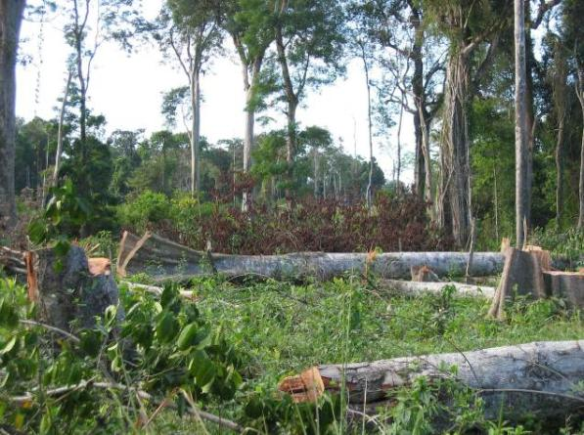
Fig. 1. New deforestation in O Am, March 2011
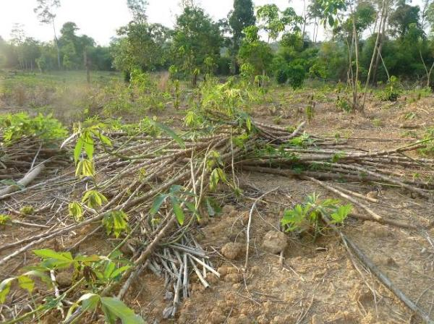
Fig. 2. Land under cassava cropping in O Am, May 2011

Since staffing levels are low and encroachment is happening on a number of geographically dispersed fronts that are often tens of kilometres apart, patrol teams do not have the resources to visit every place on a regular basis, especially due to the remoteness of some locations from guard stations. Effective surveillance and monitoring systems are required so that routine enforcement can focus in a few key places that are known encroachment areas and so that rapid responses can be organized when incidents occur elsewhere.

Critical to the identification of the hotspots has been deforestation mapping. The best national datasets are produced by the Forestry Administration through their 4-yearly Forest Cover Assessments (2002, 2006, 2010). These are of good quality for national overview purposes, but are too infrequent, have too coarse a mapping scale (c.25 ha) and are too difficult to obtain to be sufficient for monitoring individual sites. As such they are only able to give a very general appraisal of rates of forest loss (Lynam and Soriyun, 2004).

To supplement national datasets, the project has conducted higher resolution (1 ha) analyses of deforestation for the site and surroundings using Landsat 5 images, recently at two-year intervals (Table 2). The resulting maps enable us to identify the main recent hotspots of clearance where enforcement should focus (i.e. the red and pink areas on Figure 3).

The mapped pattern of forest loss from smallholders in SPF is complex. Particularly heavy clearance takes place along the reserve boundary in Sre Khtum commune and southern Sre Preah commune near the HQ (notably O Am, O Rona, Sre Levi, Sre Preah and Pu Char villages), plus along new roads accessing the southwest, northeast and northwest of the reserve in Khsim and Romonea communes. There is also scattered small-scale clearance around remote villages in the reserve interior, part of which is legal as it falls within areas eligible for land title but part of which is likely to be illegal, especially where it involves expansion to new areas of mature forest or land-grabbing by outsiders. The large rectilinear areas of planned deforestation by ELCs are clearly visible on Figure 3 just outside the SPF boundary.

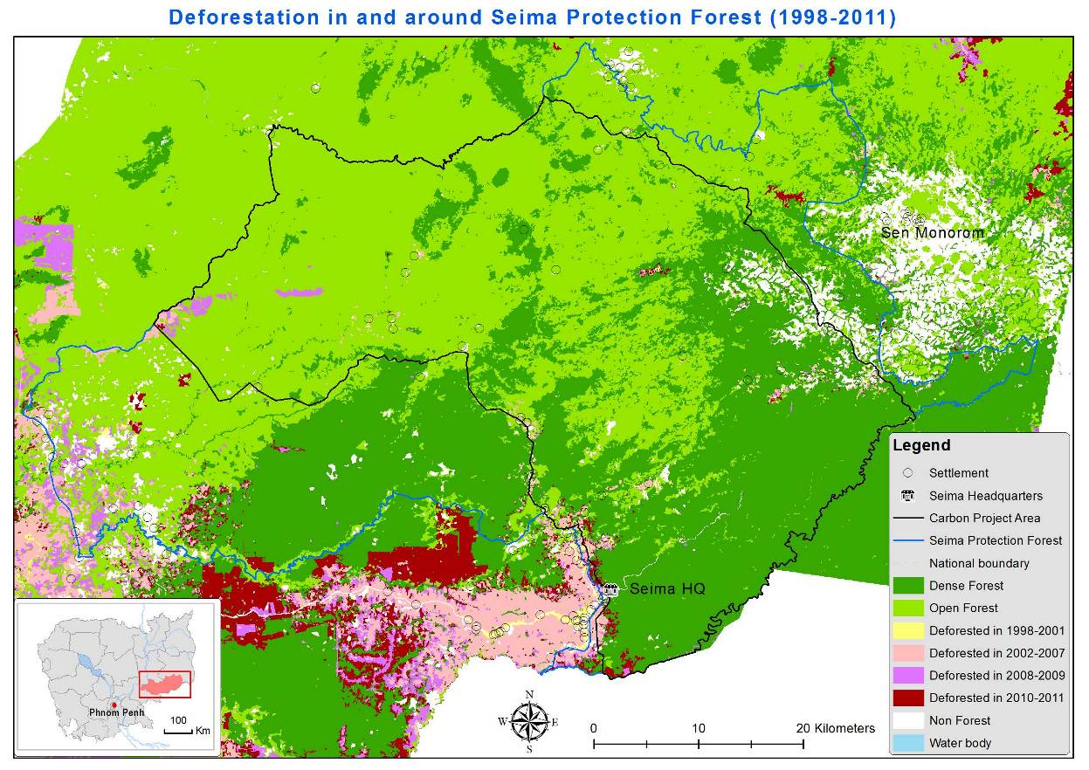
Fig. 3. Deforestation in and around Seima Protection Forest (1998 – 2012)

In addition to deforestation mapping, a system has been developed to track changes in the human population of the many settlements in or adjacent to SPF. Areas with rapidly growing populations indicate a likely increase in deforestation pressures and many other threats. Government statistics are collected annually but have not been released since 2010 and are only at the village level, which means that in the SPF context they aggregate many scattered sub-villages with different population trends, limiting their value for targeting our work. Therefore the project team conducts its own survey every 2-3 years by visiting every settlement and conducting a short interview with the relevant official (for example the village chief or sub-village chief). Surveys were conducted in 2004 (Evans and Delattre 2005), 2006 (Evans 2007), 2008 (Pollard and Evans 2009) and 2010 (Evans in prep.) and are next planned for 2013.

Analysis of this kind is essential but is still too infrequent and time consuming to allow the timely detection of deforestation events that are underway. Therefore it has been necessary to set up of various rapid response monitoring methods, which will be described in following sections. Section 3 describes direct monitoring through field patrols. Section 4 then describes a variety of important supplementary techniques using other data sources.

3. Patrol-based deforestation monitoring

Background

The primary form of field-based monitoring is ranger patrols. In 2002 the first enforcement teams were recruited to patrol the reserve. From the beginning, a multiagency approach was taken, with teams consisting of local police, military, Forest Administration staff, and guides from local communities (Lynam, 2004). Up until 2004 the focus of enforcement operations was anti-poaching, the key threat to the reserve at the time being from poaching and illegal wildlife trade (Lynam and Soriyun, 2004). Patrols were deployed by 4WD vehicle along the then unsealed access road linking Keo Seima and O Reang Districts. Patrols were foot based and focussed on the core of the reserve where poaching of tiger, wild cattle, sambar, muntjac, pigs, pangolins and pheasants for commercial trade was a problem. After 2004 deforestation increased (Evans et al., 2009) as did logging (e.g. WCS/FA 2010) and patrols were adapted to address these major additional threats to the reserve.

Team organization and staffing

Since a major restructuring in late 2009 the project has worked primarily with FA patrol teams leaders and alongside Phnom Penh-based military police. Currently the project supports 23 military police who have received basic training in wildlife protection concepts, and practical techniques for patrolling, along with four Forestry Administration patrol leaders and the FA Enforcement Supervisor. The team is advised on a full-time basis by an expatriate law enforcement field advisor, and on a part-time basis by a WCS regional law enforcement monitoring advisor and trainer. Patrol staff, including FA officers, are frequently rotated between sectors and their performance is closely monitored. They are removed from the team if their integrity becomes compromised and/or they cease to be effective at their jobs.

Due to the dispersed nature of forest crimes across the reserve, a 7-member mobile patrol team provides flexibility for rapid response to reports of illegal activity. The mobile team also provides backup to teams at guard posts across the southern half of Core Area which conduct patrols mainly in their areas of responsibility.

Strategy

The law enforcement strategy for land clearance mostly involves day patrols or short patrols (1 – 4 days) to targeted locations. Broad strategic targets are set for each year, identifying expected hotspots for the coming year where major reductions in threat levels must be achieved and where cold-searching for land clearance should be attempted regularly. Two kinds of information are then used to refine the patrol strategy from day to day. Firstly, surveillance is done by patrol staff and advisors who collect information on new and ongoing deforestation hotspots, identify people involved, and either follow suspects or wait for them at vantage points along roads and take photographs of their activities. Using this approach valuable information on movements of suspects has been accumulated. Secondly, indirect information on illegal activity is obtained from informants in the communities surrounding the reserve. This network has been carefully cultivated by senior project staff over many years. Information comes from the various well-established community committees and from other concerned individuals. Information on the movements of suspected loggers, timber traders, and land clearers coming through this network has led to the arrest of many suspects.

Transportation

Patrol teams use motorcycles and a 4WD vehicle for conducting patrols. Between June 2011 and May 2012 SPF patrol teams travelled a total of 30,594km on patrol, 65% of which were patrols done by motorcycle, 33% vehicle patrols, and 2% foot patrols. Many of the threats are concentrated near to access roads and these are also often the most efficient locations at which to break illegal trade chains. Due to the heavy reliance on motorcycles, a significant portion of the budget goes towards gasoline, and maintaining and repairing motorcycles.

Law enforcement monitoring

The effectiveness of the patrol-based deforestation reduction strategy is monitored through the use of ranger-based data collection procedures. Patrols are documented in the field by team leaders using standardized forms and GPS waypoint records of significant observations. The Khmer language forms have evolved with the increasing requirements for detail. The current set of forms includes an authorization form, a movements form for documenting patrol routes, an observation form for documenting threats that are encountered and interventions made by the patrol teams, and a carcass form for recording natural deaths and poaching of key wildlife species.

As the spatial distribution and intensity of deforestation has increased, the site manager has had an increasing requirement for up-to-date information on problem hotspots. The MIST (Management Information SysTems) database is a tool for organizing ranger-based data. MIST was originally designed for use in the Ugandan protected areas system has been developed and adapted for use across our global conservation sites. Seima Protection Forest was one of the first sites in Asia where MIST was introduced, tested and refined, from 2004 onwards.

Patrol data are entered from paper forms onto the database by the MIST officer. Summaries of patrol efforts and maps showing locations of illegal activities detected, and key wildlife species, are produced at the end of each month. These reports are evaluated by the law enforcement team who then interpret the deforestation situation from the information contained in them, allowing them to make informed decisions about where to place enforcement effort. Figure 4 shows an example of a MIST map.

Figure 4 Example of a MIST database report for land clearance cases in SPF, February 2012

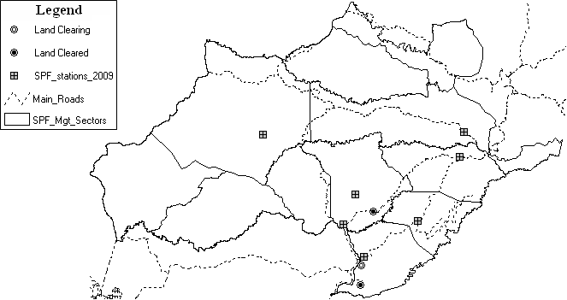

More than 50 protected areas across Southeast Asia now employ MIST as a primary database for law enforcement monitoring and park management. WCS is now cooperating with other organizations to develop a new and improved law enforcement monitoring tool called SMART (Spatial Monitoring and Reporting Tool). The new tool will provide greater functionality and allow greater flexibility in the way patrol data can be arranged and analysed. Seima Protection Forest is one of a handful of demonstration sites for SMART across Asia, Africa and Latin America.

Technical requirements: The system runs on almost any normal computer with printer; a GPS unit is needed for each patrol team. Routine data management (data entry and outputting) can be conducted by anybody with basic computer literacy and good attention to detail. A computer technician with moderate database skills is needed for some trouble-shooting tasks and more skilled support is needed to set the system up and periodically review it. The patrol supervisor must be comfortable analysing simple maps and tabulated data.

4. Additional encroachment monitoring systems

Three additional data sources supplement the direct evidence from field patrolling and informant networks – Landsat imagery, FIRMS Active Fire data and a regular review of land concessions that have been issued.

a) Use of Landsat imagery

The Landsat satellites are operated by the US government. Images from successive Landsat missions (currently Landsat 8) are freely available for download for Cambodia and can be used for rapid identification of significant new areas of clearance, without the need for elaborate analysis. Landsat 8 has a fixed orbit and acquires the same scene every 16-day repeat cycle. Not every scene is posted on the website (e.g. due to excessive cloud cover), and some that are posted still have areas obscured by clouds. Lansat 7 was the key sensor up to 2012 but, due to a sensor malfunction each scene has some defects, with narrow data-free stripes running across the image. Luckily these defects vary in position, so by, underlaying a second image from a nearby date the gaps can be filled sufficiently to allow visual interpretation. See Annex 1 for details.

The SPF project downloads and processes Landsat images in this way several times (depending on how cloudy the scenes are) during each dry season. Each scene can then be directly compared with scenes from the same or earlier seasons using ‘toggle’ or ‘swipe’ visualisation methods in a GIS or even between jpeg images. The human eye is very good at detecting changes between similar images, and such changes can then be inspected more closely to decide whether they are likely to represent clearance or seasonal changes like flooding. This becomes easy with a little practice and some field experience. When areas of recent change are identified the image can be sent to the law enforcement team, together with the relevant coordinates, to enable field inspection and follow up to be conducted.

The maps are also useful for reports and presentations, as a time sequence of images can give a vivid and immediate impression of the location and rate of change.

Technical Requirements: The system works on a typical desktop computer which needs to have software for handling and viewing the imagery (e.g. ERDAS Imagine plus ArcGIS). A reasonably fast internet connection is required to download the chosen images. The computer operator needs to be able to interpret the images being inspected, which requires some training and field experience, but does not require elaborate computing skills.
Note: several automated systems for detecting deforestation are under development, all using advanced computing techniques to make the comparisons done here by eye. These systems are currently less suitable for the Cambodian context than the methods presented here for various reasons, but they are rapidly improving and may soon be the preferred approach due to their expected simplicity, accuracy and broad scale of operation. The development of these systems should be monitored closely.
Examples of Landsat in action

1a) Deforestation at Labake, O Am and O Rona (Sre Khtum commune) became a topic of renewed concern in 2010 when it was realized there had been substantial fresh encroachment into the Core Zone. Regular inspection of Landsat imagery has since been conducted regularly to guide foot patrols to areas of fresh clearance, and to provide an overview of the scale and pattern of change without the need for exhausting mapping on foot. Among other positive results this process identified a new cluster of fields deep in the forest some km to the east that is associated with a border police outpost and accessed from a road on the Vietnamese side, and so had been overlooked by patrol teams. The sequence of images is shown in Annex 2. If viewing on a computer screen one can easily toggle between pages in this Annex and see how easily the human eye detects changes.

1b) In April 2012, inspection of Landsat 7 images detected an apparent patch of fresh clearance just inside SPF in the Sre Roneam area, adjacent to the inactive Taynam rubber concession which lies just outside SPF. A patrol team sent to the area encountered a group of workers who had recently cleared up to 60ha of grassland inside the reserve boundary. A tractor was impounded and the activity stopped (Figs 5, 6, 7, 8).

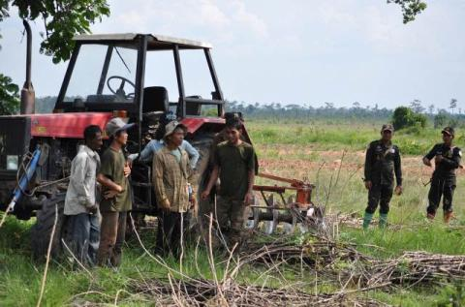
Fig 5. Tractor and workers engaged in clearing grassland at Sre Roneam

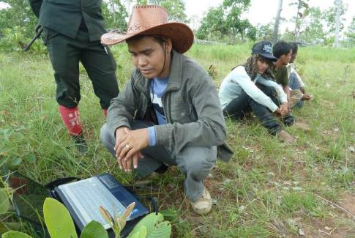
Fig 6. GIS specialist confirms the location of new clearance identified from Landsat 7 data

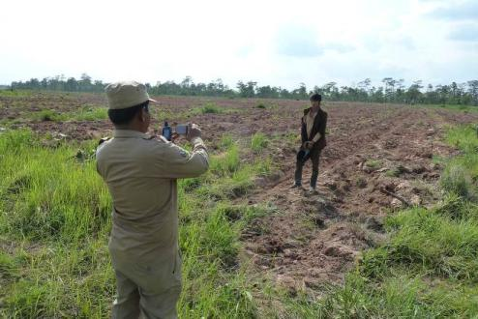
Fig 7. FA patrol leader documents the extent of the new clearance at Sre Roneam

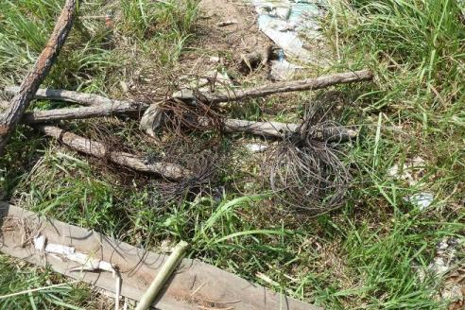
Fig 8. Other illegal activity associated with the land clearance – snares found at a workers camp near the clearance area.

b) Use of FIRMS data

Dry season fires are a common and necessary feature of the ecology of Cambodia’s deciduous forests, but very rare in denser evergreen and semi-evergreen forests. Therefore a cluster of fire locations in a dense forest area is likely to indicate fire being used to burn woody material during forest clearance.

FIRMS (Fire Information for Resource Management System) integrates remote sensing and GIS technologies to deliver global MODIS hotspot/active fire locations to natural resource managers and other stakeholders around the World. MODIS stands for MODerate Resolution Imaging Spectroradiometer. The MODIS instrument is on board NASA’s Earth Observing System (EOS) Terra (EOS AM) and Aqua (EOS PM) satellites. The orbit of the Terra satellite goes from north to south across the equator in the morning and Aqua passes south to north over the equator in the afternoon resulting in global coverage every 1 to 2 days. The EOS satellites have a ±55 degree scanning pattern and orbit at 705 km with a 2,330 km swath width. Therefore there are at least 4 daily MODIS observations for almost every area on the equator – with the number of overpasses increasing (due to overlapping orbits) the closer an area is to the poles. It takes approximately 2 – 4 hours after satellite overpass for MODIS Rapid Response to process the data, and for FIRMS to update the website. Occasionally, hardware errors mean that it takes longer than 2-4 hours to process the data. In SPF these data are downloaded and then queried so that fire locations are only shown within the areas we have previously mapped as dense forest, and at least 500 meters from the nearest area of open forest or non-forest (to allow for the low data resolution). We then inspect these data to identify clusters of fires in the interior of dense forest, and if these seem likely to be significant, we share the location and a map of the area with the law enforcement teams who can then go to make an inspection. Annex 3 provides details of the method.

Requirements: The system works on a typical desktop computer which needs to have software for handling and viewing the dataset (e.g. ArcGIS). Internet downloads are small and easy to achieve. The computer operator needs to be able to interpret the data which requires some training and field experience, but does not require elaborate computing skills.
Example – MODIS in action

In February 2012, FIRMS Active Fires Data indicated the presence of fires in an area of the buffer zone west of Pu Char (Fig. 9). These were clearly associated with a huge area of legally sanctioned forest clearance within a land concession in Snoul Wildlife Sanctuary. A patrol team deployed to the area found fresh clearance near the points detected by MODIS right up to the border of the buffer zone but not inside, and also detected people illegally cutting timber inside the buffer zone. Chainsaws and a logging vehicle were impounded, and three individuals were arrested and sent to court.
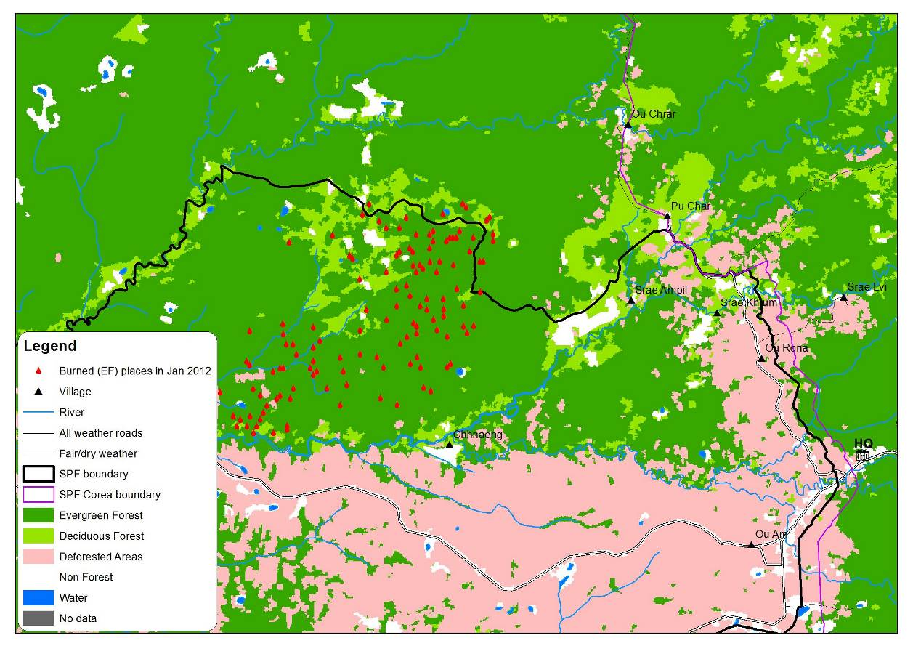
Fig. 9. MODIS imagery detected fires in areas mapped as dense forest the buffer zone west of Pu Char (red triangles in the centre of the map north of the SPF boundary).

c) Regular monitoring of data on land and mining concessions

Most economic land concessions, hotel projects, mines and so on require a decision by the Council of Ministers (typically a Subdecree). These are often recorded in full in the publicly available ‘Royal Book’, a legal gazette. The project subscribes to the paper copy of this gazette (which is published c.4-8 times per month) and has also purchased the past 4 years of back issues on CD-ROM. Each entry has been checked and any decision relevant to the SPF or a broad area around it has been extracted and reviewed in detail. The documents often contain either a list of boundary points or a map with a grid from which points can be extracted. These data are compiled in a geographical information system (GIS) and overlaid on the SPF boundaries. Concession that fall within the reserve, or are immediately adjacent, are mapped and the exact locations passed to field teams who can them make regular inspections to ensure that the legal boundaries are being respected.

The project also regularly downloads data from the Open Development Cambodia website. These also reflect official, publicly available data, collated and shared by an NGO, and so they partly duplicate what is available in the Royal Book, but they also contain older concessions, and a selection of new concessions that have only been reported in other locations.

Several concession boundaries have also come to the project direct from the companies themselves, either as a result of meetings, in press releases or, occasionally, roadside signboards. These are all incorporated into the same GIS.

The Royal Gazette or Royal Book (in Khmer—Reach-jeak-kech) is a legal gazette which contains decrees, royal decrees, sub decrees, decisions, circulars and declarations which the Council of Ministers received from the Royal Palace Cabinet and other institutions of the Royal Government. The Book is issued by the General Department of the Royal Book and Computer Service (Council of Ministers) every few days, about up to eight books per month. One can purchase these whenever needed or make a prepaid order with several options: each a book is 5000 KH Riels or 1.25 US Dollars, for a month the cost is 40000 KHR, for three months is 120000KHR, for six months is 240000KHR and for one year is 480000KHR. The General Department compiles these books in to PC CD-ROM every quarter, five CDs per year, which cost 10 US Dollars for each. Therefore, we could purchase even the old royal book which issued in the first year in 2001 until now 12th year. The General Department is located in house number 216-218 Eo, St. Kampuchea Krom, Phnom Penh or contact at 023 725 960.

Requirements: The system works on a typical desktop computer which needs to have software for handling and viewing the dataset (e.g. ArcGIS). Internet downloads are small and easy to achieve. The computer operator needs to be able to communicate the data clearly to the field teams, which does not require elaborate computing skills.

5. Conclusions and recommendations

All elements of the system presented here are considered to be replicable at other locations and transferable to other scales, both larger and smaller, although below a certain size it will not be financially feasible for a project or organisation to maintain a GIS officer or MIST patrol database officer. There are potential economies of scale in sharing costs on several of the processes between clusters of nearby sites, or even nationally, and this would also enable groups of smaller projects/sites to be able to reach the minimum threshold to make the costs affordable.

The core of the system is to conduct regular field patrols at a high standard with clearly defined strategic priorities, using local informant networks to help guide activities. It is also essential that data on patrol activity and results are analysed (using the MIST system, SMART or some other similar system) to enable effective management oversight of staff performance, patrol targeting and threat levels. The three supplementary surveillance methods are also highly recommended, especially the first – frequent inspection and comparison of Landsat images. MODIS fire hotspot data are useful in vegetation types that are not normally prone to fire, and frequent monitoring of land concession data is also essential given the rapid issuance of such concessions in recent years in most Cambodian forest landscapes.

These approaches are useful for detecting deforestation caused by small holders or large companies, and also for certain kinds of degradation (especially logging the involves the construction of new roads and large fires in forest types that do not usually burn). They are not useful for detecting low intensity forms of degradation (e.g. firewood collection, highly selective logging, or the gradual effects of over-burning in deciduous forest).

6. References

Evans, T and E. Delattre (2005). Human populations and land-use in the Seima Biodiversity Conservation Area, Mondulkiri and Kratie Provinces, Cambodia in late 2004. WCS Cambodia Program, Phnom Penh.
Evans, T D, (2007). A survey of communities in and around the Seima Biodiversity Conservation area in 2006. Wildlife Conservation Society – Cambodia Program. Phnom Penh
Evans, T. Heng Bauran, and E Delattre (2009). Deforestation rates in and around the Seima Biodiversity Conservation Area, Cambodia, 2001-2007. WCS Cambodia Program. Phnom Penh
Evans, T. (in prep) A survey of communities in and around the Seima Biodiversity Conservation area in 2010. Wildlife Conservation Society – Cambodia Program. Phnom Penh
WCS/FA (2010) Seima Biodiversity Conservation Project. Annual report 2008-2009. Forestry Administration and Wildlife Conservation Society Cambodia Program, Phnom Penh.
Lynam, A. J. (2004) Band of Brothers. Wildlife Conservation, 107, 22-27.
Lynam, A. J. & Men Soriyun (2004) A conservation management strategy for the Seima Biodiversity Conservation Area, southern Mondulkiri: guidelines for law enforcement and administrative structure. Wildlife Conservation Society Cambodia Program.
Pollard, E. H. B and Evans T D (2009). A survey of communities in and around the Seima Biodiversity Conservation area in 2008. Wildlife Conservation Society – Cambodia Program. Phnom Penh.

Annex 1: Methodology for use of Landsat 7 imagery in near-real-time monitoring of deforestation threats.

Free, high quality multispectral satellite imagery, updated 16-day repeat cycle, is available online for the whole of Cambodia from the Landsat 7 sensor operated by the US Government. It has been shown to be feasible to set up a system in Cambodia that can rapidly process these images and disseminate them in a format where they can be used by protected area managers to identify and deal with new clearance hotspots. The imagery also has several other potential applications, as outlined below.

Landsat 7 imagery is of medium resolution (30 m x 30 m pixels) and hence is sufficiently detailed to show all but the smallest patches of deforestation or other habitat change. For law enforcement purposes it is not necessary to conduct any elaborate analysis. All that is needed are two images from different time points (ideally quite close together, either within one season or within one year). By showing the two images on screen and switching repeatedly between them a computer operator can visually identify areas of change. With some training, the operator can pick out changes due to deforestation, as opposed to seasonal changes such as leaf fall, grass fires or flooding. The operator can then highlight those suspected deforestation areas on a map, produce a list of grid reference points and pass them on to a protected area manager who can arrange a response. At the end of each year, the images, hotspots and documented responses could form part of the annual reporting for the site.

To illustrate this process, the following two pages show Landsat 7 images one year apart from an area of eastern Cambodia centred on Snoul Wildlife Sanctuary. By using page up/page down in this document the reader can get a sense of how the visual change detection works, although it is best done in other software which allows the comparison to be made more easily. The main areas of change are highlighted with red boxes - these include irregular patches of smallholder clearance and rectangular blocks due to company activities. As can be seen they are mostly obvious, and so should be detectable by most observers.

This method of interpretation is less rigorous than the use of automated classification techniques, and does not replace them. However, it has the enormous advantage of being quick and cheap to implement - automated methods require expensive consultants, extensive ground-truthing and tend to involve delays of at least 6-12 months - by which time the information is already out of date and deforestation has progressed further. Rapid visualisation of Landsat 7 images is an excellent complement to more sophisticated techniques, providing information that is cheap, timely and of sufficient quality to inform action on the ground.

The satellite carrying this sensor passes over Cambodia every two weeks. Not all images it acquires are placed on the public archive, and some have too much cloud to be useful, but nonetheless one can usually find a usable image for the area of interest at least every 4-6 weeks. The images have a defect, with some blank stripes across them, but this can usually be dealt with by filling the no value-gaps using a slightly older image (e.g. previous month), as has been done on the images below.

Landsat 7 ETM+, false colour (RGB-453), two scenes: 125-052 and 125-052 which each scene acquired on 19 February 2010 (put on top) and 11 February 2010 (lower layer)

Landsat 7 ETM+, false colour (RGB-453), two scenes: 125-052 and 125-052 which each scene acquired on 12 April 2011 (put on top) and 10 March 2011 (lower layer). The red outlines show new deforested areas (by human eyes) in early 2011 compared to Feb 2010.

Landsat 7 ETM+, false colour (RGB-453), two scenes: 125-052 and 125-052 which each scene acquired on 9 Feb 2012 (put on top), 25 Feb 2012 (lower layer) and 24 Jan 2012 (at the bottom) The red outlines show new deforested areas in early 2012 compared to the same season in 2011.

To obtain Landsat 7 ETM+ for free of charge, just following the screenshot below:

- Run your web browser and type http://glovis.usgs.gov in its address bar. If your computer does not have Java Platform installed, it will ask you then you just follow it.
- Navigate to your area of interest by moving a red spot in map navigator or type Path-Row of Landsat scene, or put Latitude-Longitude of the place where you need
- Choose your maximum Cloud Coverage
- Choose the date of imagery acquired
- Add your selected scene and send to card to download or delete to remove from your card

The following screenshots show how we overlay the Landsat7 layers to hide gaps of striplines in Landsat 7 ETM+ before we use swipe tool to detected new clearance by human eyes.

Add the latest image into map viewer,

This image acquired on 31 May 2012, with 82% cloud coverage, that we used to find newly deforestation. The white stripes are the data gaps.

To fill the gaps, we make them transparent and then add another (sometimes more than one) layer which acquired just before it to put underneath in the GIS viewer. The combined image can then be compared with others using the swipe tool or exported as a jpeg.

Annex 2: Case study of use of Landsat 7 to identify deforestation hotspots in Labake areas, SPF

The Labake area is in the south-western part of the core area of Seima Protection Forest not far from Cambodia-Vietnam international boundary, near the village of O Am.

The following satellite maps show the deforestation that happened from 2010 to 2012 in comparison to a forest boundary demarcation line that was agreed in writing with all local stakeholders. Further enforcement efforts are taking place to try to prevent use of any land beyond the demarcated boundary, and the satellite images are helpful in identifying those areas.

Annex 3: Methodology for use of FIRMS active data to identify suspected deforestation hotspots in evergreen forest

FIRMS (Fire Information for Resource Management System) integrates remote sensing and GIS technologies to deliver global MODIS hotspot/active fire locations to natural resource managers and other stakeholders around the World. FIRMS was developed by the University of Maryland with funds from NASA. FIRMS is currently being transitioned to an operational system at the United Nations Food and Agriculture Organization (UN FAO). Each hotspot/active fire location represents the center of a 1km pixel (approximately) flagged as containing one or more actively burning hotspots/fires within that pixel. The hotspots/fires are detected using data from the MODIS instrument, using a specific fire detection algorithm that makes use of the thermal band detection characteristics of the sensor. MODIS stands for MODerate Resolution Imaging Spectroradiometer. The MODIS instrument is on board NASA’s Earth Observing System (EOS) Terra (EOS AM) and Aqua (EOS PM) satellites. The orbit of the Terra satellite goes from north to south across the equator in the morning and Aqua passes south to north over the equator in the afternoon resulting in global coverage every 1 to 2 days. The EOS satellites have a ±55 degree scanning pattern and orbit at 705 km with a 2,330 km swath width. Therefore there are at least 4 daily MODIS observations for almost every area on the equator – with the number of overpasses increasing (due to overlapping orbits) the closer an area is to the poles. It takes approximately 2 – 4 hours after satellite overpass for MODIS Rapid Response to process the data, and for FIRMS to update the website. Occasionally, hardware errors mean that it takes longer the 2-4 hours to process the data.

To obtain active fire data, just go to http://earthdata.nasa.gov/data/nrt-data/firms/active-fire-data and register with your email address if you want to request for the data which is older than seven days. Within the last seven days of near-real-time fire data, you can download immediately, without requesting or waiting—by several extensions such as ESRI shapefiles (.shp), Google Earth file (.kml), Web Map Service file (.WMS) or text file (.txt). There you can choose active fire data in last 24h, 48h or last seven days.

Once we got the data, we could add it into the map viewer application to identify where they are in our landscape.

We acknowledge the many other donors who have contributed to the development of the systems described here, and the staff of WCS and the FA who participate in the conservation project at SPF.
http://www.maff.gov.kh/elc/laws/subdecree.html [downloaded 18/2/2011]
The first analysis (Delattre et al. 2009) has been superseded by unpublished analyses with higher precision but very similar findings conducted for the PD.
http://db.ncdd.gov.kh/cdbonline/home/index.castle
e.g. CLASLite http://claslite.stanford.edu/en/ and Global Forest Watch 2.0 http://www.gfw-beta.org/ and the Mongabay Deforestation Tracker http://rainforests.mongabay.com/deforestation-tracker/
http://maps.geog.umd.edu/firms/firedata.htm [28 June 2012]
www.opendevelopmentcambodia.net
http://maps.geog.umd.edu/firms/faq.htm#MRRMODAPS [28 June 2012]

