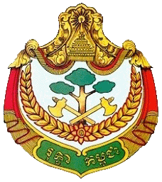
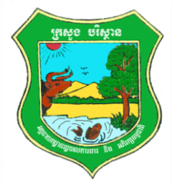
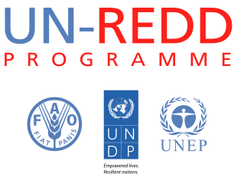

Cambodia REDD+ Activity Cover Page

Title of Activity:
Development of a Consultation Group workplan and information sharing mechanism

Related Activities UN-REDD Workplan:
1.3 Stakeholders are engaged in the REDD+ Readiness process (1.3b: Support to CF, CPA and CFI networks; 1.3c: Support to civil society groups to engage on specific technical areas)

Objectives of Activity:
To ensure effective operation of the Consultation Group by developing a viable workplan and effective methods for information sharing.

Brief Description:
The selection of representatives for the Consultation Group (CG) was considered an important step in stakeholder coordination. In order to establish the Consultation Group, the REDD+ Taskforce Secretariat began facilitating the selection process in November 2012. The process built in part upon the lessons from the experience selecting civil society and Indigenous Peoples’ representatives for the UN-REDD Programme Executive Board, which was initiated in May and completed in September 2012. Representatives to the CG were selected in August, 2013. In order to operate effectively, the CG needs to have a viable workplan and effective system for information dissemination. These activities wil estalbish these two pre-requisites for effective operation of the CG.

Key Outputs:
- A viable workplan which ensures that the CG is in a position to provide comprehensive and accurate information on stakeholders’ views to the Taskforce and RTS.
- Systems of information sharing and dissemination for each stakeholder group represented in the CG to ensure effective information sharing and dissemination.

 | Signature | Name and Function | Date
Developed by: |  | Thy Heang, Communications Officer
Implemented by: |  | REDD+ Taskforce Secretariat
Approved by: |  | UN-REDD Programme Director

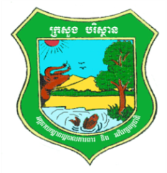

Cambodia REDD+ National Programme
UNDP PROJECT No. 00078446

(#40, Preah Norodom Blvd, Khan Daun Penh, Phnom Penh, Kingdom of Cambodia, 3rd Floor)

CONCEPT PAPER
Development of a Consultation Group workplan and information sharing mechanism

- Background
The selection of representatives for the Consultation Group (CG) was considered an important step in stakeholder coordination. In order to establish the Consultation Group, the REDD+ Taskforce Secretariat began facilitating the selection process in November 2012. The process built in part upon the lessons from the experience selecting civil society and Indigenous Peoples’ representatives for the UN-REDD Programme Executive Board, which was initiated in May and completed in September 2012. Representatives to the CG were selected in August, 2013.

While NGO networks exist in Cambodia that can be used to distribute information, reaching out to stakeholders at provincial and community levels remains a significant challenge. Some stakeholders such as CF, CFi, and CPA groups do not yet have a forum to find their collective voice, which made it difficult to find a sizable number of stakeholders from these groups. The geographical distance between these communities and the capital city, and problems with Internet access were amongst added challenges for the VFC.

However, a significant effort was made for IP groups who underwent a parallel process to select their representatives from 15 provinces prior to the Consultation Group selection. Through these representatives, the communication line to the IP groups was established.

The function of the REDD+ Consultation Group is to provide comments to the REDD+ Taskforce on the REDD+ Readiness process and provide a forum to represent the views of local stakeholders, especially civil society and NGOs.

The REDD+ Consultation Group members are responsible for (inter alia):
- Collecting, summarising and collating comments on, draft reports and proposed decisions of the REDD+ Taskforce from their respective constituencies. The Taskforce is required to send these documents to the Consultation Group and to respond to any comments raised on timely basis. Representatives must share this information with their constituents,
- Sharing information on developments relating to REDD+ within their constituencies with the REDD+ Taskforce, REDD+ Taskforce Secretariat and other members of the consultation group,
- Coordinating with and providing information to their respective constituencies. This might require regular meetings of each group.

In order to deliver on these responsibilities and others, the CG needs to develop a workplan and a process for efficeint and effective sharing of information with constituents. Initial inputs on a workplan and information sharing system have been generated by the CG itself. However, further work is required to be led by the RTS in order to finalize these proposals into systems that will be efficient and effective.

- Objective
To ensure effective operation of the Consultation Group by developing a viable workplan and effective methods for information sharing.

- Expectation
A fully operational Consultation Group ensures that the views of all stakeholders inform the development of REDD+ policy in Cambodia and the contents of the National REDD+ Strategy.

- Activities
- Compilation of ideas for workplan and information sharing mechanisms:
The RTS staff will compile all ideas generated to date by CG members and others on a workplan for the CG and systems for exchange of information.

- Analysis of workplan proposals in respect to Taskforce workplan:
Since one of the main functions of the CT, as noted above, is to support the Taskforce by providing the Taskforce with views from CG constituents, it is esserntial that the CG workplan be aligned with the Taskforce workplan. Therefore, the RTS staff, in collaboration with the Technical advisor, will review the elements of proposals for a CG workplan with those of the Taskforce workplan. This will enable superfluous workplan elements to be removed, and missing elements to be added.

- Analysis of information sharing proposals in relation to characteristics of CG stakeholder groups:
Since the CG is made up of disparate stakeholder groups, it is inevitable that information sharing mechanisms will vary across groups. It is necessary to identify systems that will be both effective and efficient for each group. For example, for those groups whose members have 100% email connectivity, it seems likely that email will constitute the major element of an information sharing system, supplemented by annual or more frequent meetings, if necessary. Conversely, groups with lower email connectivity will require a different information sharing system. The RTS staff will review lists of constituents of each CG stakeholder group, taking account of work being undertaken by RECOFTC, and identify those groups with 100% email connectivity. For those groups with lower connectivity, the RTS staff will develop proposals for information sharing in collaboration with the Technical advisor and Regional Stakeholder Engagement Specialist (UNDP).

- Consultation on proposals:
RTS staff will consult, individually and/or collectively with CG members on emerging proposals for the workplan and information sharing systems, leading up to a proposal to be tabled at the first available CG meeting. When endorsed by the CG, the proposal will be presented to the Taskforce.

- Outputs:
- A viable workplan which ensures that the CG is in a position to provide comprehensive and accurate information on stakeholders’ views to the Taskforce and RTS.
- Systems of information sharing and dissemination for each stakeholder group represented in the CG to ensure effective information sharing and dissemination.

- Roles and Responsibilities
The REDD+ Taskforce Secretariat will:
- Manage the compilation and review process,
- Discuss and agree on proposals for the workplan and information sharing systems with the Technical Advisor and Regional Stakeholder Engagement Specialist,
- Consult with CG members,
- Table a proposal for endorsement by the CG, and
- Present the endorsed proposal to the Taskforce.

- Budget
Activity | Budget
Consultations with CG members | 500
Miscellaneous | 200
Total | 700

Cost is in USD

- Time frame
Activity | Estimated duration to complete | Time period
Compilation of ideas | 5 days | 14 Mar 2014
Analysis and development of proposals | 10 days | 24 Mar 2014
Consultation with CG members | 15 days | 8 Apr 2014
Presentation to CG meeting | 1 day | tbd
Presentation to Taskforce | 1 day | tbd
Total | 32 days (not continuous)

