BIOGRAPHIES OF CANDIDATES
Biography for Election to the Cambodia REDD+ Consultation Group
Academic Institutions:

Candidate A:  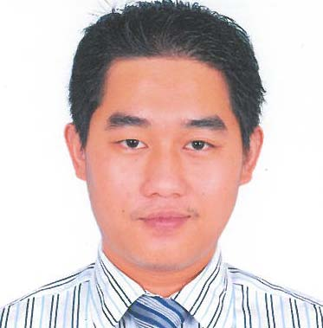 | Name: Nguon Pheakkdey
 | Organization: Royal University
 | Biography: Mr Nguon Pheakkdey is a Lecturer and Coordinator of the Department of International Studies at the Royal University of Phnom Penh. These roles enabled him not only to teach various environmental related classes, but also to mentor some of the brightest Cambodian students. At Clark University, where he is currently pursuing his PhD, funded by a two-year Fulbright Fellowship, he has volunteered as a research assistant to Prof. Ronald Eastman to learn the science of carbon measurements through the use of GIS and remote sensing. His recent academic research on REDD+ and stakeholders’ participation was through a manuscript submitted for participation at the 2012 Young Scientists Summer Program, sponsored by the International Institute for Applied Systems Analysis, in Austria. Finally, he has published a peer reviewed article on the design of the World Bank’s REDD+ projects at Environmental Science and Policy and an entry in Black et al. (2013) Climate Change: an Encyclopedia of Science and History.
Candidate B:  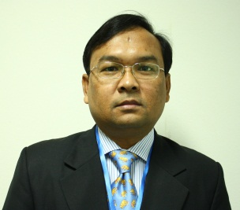 | Name: Seak Sophat
 | Organization: Royal University of Phnom Penh (RUPP)
 | Biography: Dr. Seak Sophat is a biodiversity conservation and natural resource management specialist with more than 15 years’ experience with teaching, and researching and evaluating natural resource management and biodiversity conservation programming in Cambodia, especially in the Mekong, Tonle Sap Lake region and Coastal area. As the Senior Lecturer and Deputy Head of the Department of Environmental Science at the Royal University of Phnom Penh, Cambodia, Dr. Seak Sophat has designed courses and collaborated with numerous projects throughout Cambodia to develop relevant programming for both university-level students and natural resource management professionals. He has taught and supervised students in the Biodiversity Conservation and Development Studies Masters Programmes at RUPP. He has a strong background in research pertinent to natural resource management, biodiversity conservation and assessment; and has worked throughout the country with numerous organizations and donors including Danida, Sida, DFID, CIDA, AusAID, ADB, WB, ICCO, UNDP, FAO, MRC, Oxfam, Henrich Boll Foundation, CDRI, and numerous local NGOs. His current research interests focus on participatory biodiversity monitoring linking to management interventions, REDD+ issues, hydropower development and climate change adaptation in the Mekong region with emphasis on conservation and livelihood improvement of rural communities.

Candidate C:  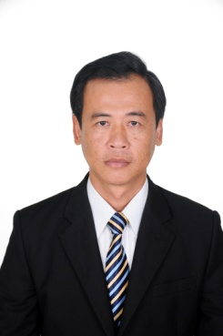 | Name: Kim Soben
 | Organization: RUA
 | Biography: Mr. Soben is Head of the Centre for Agricultural and Environmental Studies and MSc programme coordinator of the Graduate School of the Royal University of Agriculture. He has over 15 years of research and teaching experience in natural resource management. He is the country coordinator of the university network on wetland ecology in the lower Mekong basin. He has served as a climate change project coordinator in RUA, and been involved as a trainer in programs related to ‘Research Methods in Assessing Climate Change Impacts and Adaptation Strategies’, and ‘Wetland Ecology and Management in the Lower Mekong Basin’. He holds a Masters of Life and Environmental Science from Tsukubar University, Japan and a Masters of Renewable Natural Resource Management from RUA, Cambodia.

National NGOs:

Candidate A:  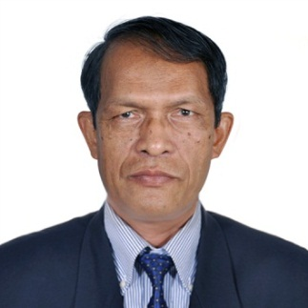 | Name: Va Moeurn
 | Organization: Mlup Baitong
 | Biography: Mr. Va Moeurn was born in 1956 in Prey Veng province. After the end of the Khmer Rouge regime, among a handful of well-educated survivors of the genocide, Mr. Va Moeurn helped reopen a teacher training center and several high schools in Prey Veng. He went on to become a respected high school principal in 1990. In 1996, after coming back from three-month training in Malaysia, Mr. Va Moeurn was appointed by the Ministry of Education, Youth and Sport to work in its Department of Planning. In 1998, he received a scholarship to undertake ten-months of professional training at the International Institute of Educational Planning of UNESCO, in Paris. In 2002, after serving his country as a government officer for 23 years, Mr. Va Moeurn decided to join Mlup Baitong, an environmental organization, as its Executive Director. Since his appointment, Mr. Va Moeurn has transformed Mlup Baitong from a small organization with a dozen staff to a well-known and respected organization with over 70 staff and an annual budget of over 1,000,000USD. With project areas in 8 provinces, Mlup Baitong is among the largest environmental organization in Cambodia. In his capacity as the Executive Director, Mr. Va Moeurn’s responsibilities include institutional development, program development, fund-raising, and donor correspondence.

Candidate B:  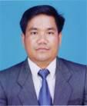 | Name: Chea Sarith
 | Organization: Women Organization for Modern Economy and Nursing
Biography: Mr Chea Sarith has worked with organizations which focus on helping communities to create a network to support community forestry and large natural water bodies in Prey Veng Province This involved mobilizing the communities to form up a forestry and lake conservation committee to manage and sustainably utilize natural resources from forests and lakes by preparing a sub decree, which was approved by the Ministry of Agriculture, Forestry and Fisheries to register community lakes and flooded forest areas with the Fisheries Administration.
Mr Sarith graduated from Royal University of Law and Economic majoring in Public Administration.

Candidate C:  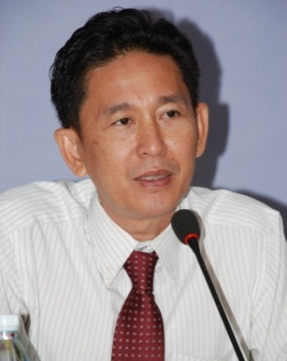 | Name: Chhith Sam Ath
 | Organization: NGO Forum on Cambodia
Biography: Chhith Sam Ath, the Executive Director of the NGO Forum on Cambodia since 2006, was the first Cambodian in this position, previously held by expatriate staff. His key responsibility is to lead and manage the NGO Forum on Cambodia to ensure it meets its goal. He has been working with NGOs in Cambodia for the last 21 years. In late 1991, he was a member of committed groups which formed the human rights group Cambodia Human Rights and Development Organization (ADHOC), one of first local NGOs in Cambodia. He holds a Master’s Degree in the field of Regional and Rural Development Planning from the School of Environment and Natural Resource Management at the Asian Institute of Technology, Thailand. Upon returning from Thailand, he was recruited by NGO Forum to fulfill the position of Development Issues Project Coordinator, a position he held from 1999 to 2001.

He then transferred to a senior position within the development NGO International Cooperation for Development and Solidarity (CIDSE), which became the Development and Partnership in Action (DPA). He has been involved in the the localization process of DPA and has extensive experience of NGO governance, providing training to local NGOs about the function of boards and their roles and responsibilities in organization governance. While working for CIDSE, he was also elected to the Management Committee of the NGO Forum, and worked as the Deputy Representative for one year before becoming Executive Director from the beginning of 2006.

Candidate D:  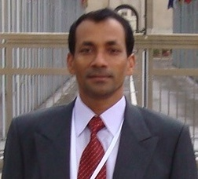 | Name: Akhteruzzaman Sano
 | Organization: Save the Earth Cambodia
 | Biography: Mr. Akhteruzzaman Sano, a Bangladeshi National, has been serving Cambodia since 2002. He is the founder of Save the Earth Cambodia. He has been working as the East and Southeast Asia Regional Coordinator of Initiative for Equality – a global network of activists and academics working on issues related to social, economic and political equality since 2013, and Southeast Asia Regional Coordinator of Global Network for Disaster Reduction that monitors the Hyogo Framework for Action since 2008. He has been providing technical services as an International Expert for the ADB, ADRRN, EU/DIPECHO, GNDR, UNDP, UNIDO, UNISDR, World Bank etc. supporting projects implemented by line ministries, institutions and CSOs in Cambodia. He is an elected member of Cambodian Climate Change Network, active member of ADRRN, Mekong CSO Environmental Network, CDKN, GDN, PCDN, GEF NGO Network, GS NGO supporter Network, NEXUS NGO Supporter Network and engaged in many international knowledge platforms. He was the technical expert in developing Outline of Master Plan on Gender and Climate Change for the RGC (PPCR Cambodia/2012), CSO Facility (PPCR Cambodia/2012), Established Emergency Coordination Center and Pandemic Preparedness Plan for NCDM (2011), developed REDD+ Advocacy Strategic Plan for NGO Forum (2012-2015), established Cambodia DRR Multi-stakeholder Platform Establishment (2011), and Cambodia GAR Report (2011). He was one of the technical experts of a UNIDO-supported project that resulted in Cambodia becoming a WTO member in 2005. He is an ISO 9001 Quality Management and ISO 14001 Environment System Expert. He holds a Masters of Geography and Environmental Science and he has been doing his Ph. D. in Climate Risk Financing for Enhancing Community Resilience.

International NGOs:

Candidate A:  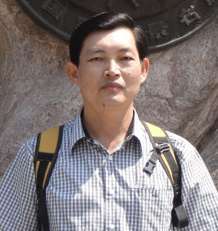 | Name: Hour Limchhun
 | Organization: Winrock International
Biography: Mr Hour Limchhun is Country Coordinator for Winrock International’s Lowering Emissions in Asia’s Forests (LEAF) Program that works across six countries in Southeast Asia to identify the most economical and effective ways to manage their land and forests. Chhun has over 20 years’ experience in forestry, natural resources and environmental management, sustainable livelihoods development, rural community development and climate change mitigation (REDD+).

Chhun holds an Engineering Degree in Forestry from the Royal University of Agriculture, Phnom Penh (1990) and Master's Degree in Environmental Forestry (Tropical) from the School of Agricultural and Forest Sciences at the University and College of North Wales, Bangor, UK (2000). He has worked for Department of Forestry and Wildlife, Mekong River Commission, DANIDA, UNDP and before joining LEAF, he was employed by the William J. Clinton Foundation or Clinton Climate Initiative as National Coordinator for Cambodia. Chhun also served as short term consultant for ITTO, assessing Criteria and Indicators for Sustainable Forest Management at National Level.
Candidate B:  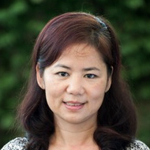 | Name: Hou Kalyan
 | Organization: RECOFTC
Biography: Ms. Kalyan has 17 years’ practical experience on community based natural resource management, working in capacity building and training through developing training manuals and delivering workshops and training courses to a wide range of audiences from the government, civil society, and local community.

Ms. Kalyan's expertise covers a wide range of issues such as sustainable forest and land management, livelihoods, governance and resource/land tenure, biodiversity conservation, including Cambodian and International laws and regulations that affect nature conservation. Her expertise also includes designing REDD+ Capacity Building Needs Assessment and Training Manual and Climate Change Training Manual in Khmer. Ms. Kalyan has delivered and facilitated aforementioned training to various stakeholders.

In regards to REDD+, Ms. Kalyan was actively involved in the consultative meetings and workshops on supporting discussions and sharing experiences and concerns on REDD and REDD+ roadmap development and its' implementation in Cambodia. More importantly, Ms. Kalyan was invited and involved in the drafting, preparation and development process of the Cambodia REDD+ Roadmap as an observer member of the Interim REDD National Task Force representing RECOFTC.

Candidate C:  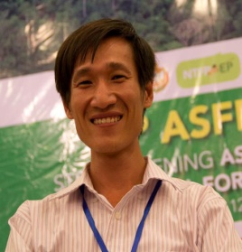 | Name: Yeang Donal
 | Organization: Fauna & Flora International (FFI)
 | Biography: Mr Yeang Donal is currently working as a National REDD+ Policy Adviser at FFI where he supports the development of national and sub-national REDD+ policies that strengthen the role of local government and communities in the Siem Reap Community Forestry REDD+ project under REDD+ Community Carbon Pools Programme in Cambodia. He used to work as a Senior Carbon Program Officer at Pact Cambodia where he used to be involved in planning and implementing biomass inventory, social assessments, and benefit sharing consultations for the Oddar Meanchey Community Forestry REDD+ project. Currently, he is also involved in a Legal Review of Carbon Rights in Cambodia with the University of Cambridge. Donal holds a double Masters degree in Forestry and Nature Conservation policy from Wageningen University (Netherlands) and the University of Eastern Finland.

Candidate D:  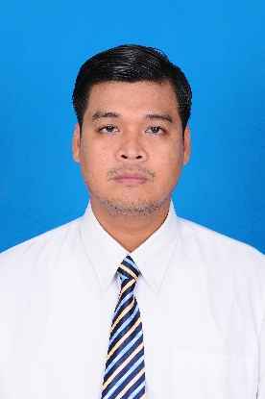 | Name: Sopha Sokun Narong
 | Organization: Wildlife Conservation Society (WCS)
 | Biography: Mr Sopha Sokun Narong is a Senior Programme Officer on REDD+ for the Wildlife Conservation Society (WCS). He is from Phnom Penh and has been working in the forest sector for more than six years with the Wildlife Conservation Society (WCS), working on sectoral project management, and specializing in grant management. He has worked as Programme Coordinator supporting the provision of grants to local NGOs in Mondulkiri province and directly supporting small grants provided to CBOs and local communities in the fields of forestry and livelihood-based development with WCS and other organizations. In addition to his main job, he has been active in networking, and has been selected to be a member of the core group of the CSO Cambodia REDD+, which was initiated by the NGO Forum on Cambodia. Mr Narong has completed a Masters Degree of Rural Development from the University of Cambodia (UC), Phnom Penh, Cambodia.

Civil Society Group:

Candidate A: | Name: Hok Sav
Candidate A: | Organization: My village (MVi)
Candidate A: | Biography: Mr Hok Sav graduated with a Bachelor’s degree in Agricultural and Agronomy Science at Prek Leap National School of Agriculture (PNSA). His studies covered community organization, research methodology, project planning and management, agri-business, leadership, agricultural extension and human resource management. He has completed computer word processing, communication and inter-personal skill, and community organization courses. Through his experience in Community Development, he gained a broad range of knowledge in coordinating, managing, and organizing training, facilitating the community, and organizing and monitoring the progress of project activities. He has extensive experience with budgeting and planning projects, M&E and management, climate change, forest management, NRM, business, facilitation, project design, micro-enterprise, and marketing.  My Village (MVi) is a Cambodian non-profit-non-governmental-organization which was founded in November 2006 and officially registered with the Ministry of Interior in 2007. MVi is operating in northeastern provinces of Cambodia, particularly Mondulkiri, Kratie and Stung Treng. MVi has become a recognized local NGO working for Indigenous Peoples' Rights. MVi promotes ownership by, and participation of indigenous peoples’ to protect their land and natural resources.

Candidate B: | Name: Ang Cheatlom
Candidate B: | Organization: Ponlok Khmer (PKH)
Candidate B: | Biography: Mr Ang Cheatlom’s forestry experiences have been gained from Buddhist study on environment and climate change and global warming. He has been involved as a social worker on forestry issues since 2002. In early 2005 he was heavily involved in community forestry in Preah Vihear province, talking with local communities and authorities on social forest issues, particularly on sustainable forest and land management, as well as climate change. From 2008, he has been involved in community forest resource livelihoods development, particularly on NTFPs and community based ecotourism, as an approach to encourage local communities to protect and conserve the forest, sustainably utilize forest resources, improve market linkage for the local communities, and promote fair trade of NTFPs in Cambodia, in compliance with government policies of one village one product.  He is currently engaged in national and regional consultation and exchanges on sustainable forest management and monitoring FAO guidelines on land tenure security implementation. He is also involved with a regional network on the Southeast Asia Sub-regional consultation on Development for Agricultural Investment, Voluntary Guidelines on Land Security Tenure (FAO), and other priorities of community forests.

Candidate C:  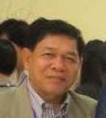 | Name: Rith Bunroeun
 | Organization: Action for Development (AFD )

Biography: Mr Rith Bunroeun is currently employed as the Executive Director of Action For Development (AFD), a non-profit organization and a provincial-based non-profit, non-religious organization that has no affiliation to any individual or political ideology. It was established in May 2004, and registered under the RGC’s Ministry of Interior in May 2006.

He is responsible for preparing an annual strategic plan and the national work plan, undertaking the monitoring and evaluation of projects, and producing relevant reports. He is also responsible for budget planning and financial and project management, organizing monthly meetings, planning workshops, as well as logistical arrangements. He used to work with various organizations and institutions, including MEDiCAM, Ministry of Social Affairs, Veterans and Youth rehabilitation (MOSVY), and Partners for Development International (PFD).

Candidate D:  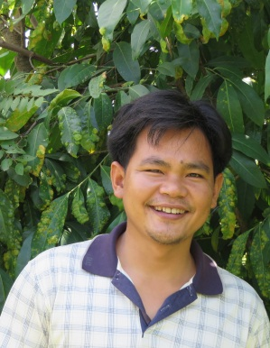 | Name: Smeun Boreyroth
 | Organization: Deputy of Executive Director
 | Biography: Mr Smeun Boreyroth is a Deputy Executive Director for CDA. He is originally a farmer and is an Indigenous Person (Kouy). He has worked in forestry for more than 15 years and with the pilot REDD+ project in Oddar Meanchey province for more than 6 years. He has been a consultant on the World Bank project on Community-Based REDD+ Consultation in Cambodia. He has worked in over 11 provinces and at the national level on Community-Based Natural Resource Management, including as a member of the national land and forest network that focused on implementation, consultation and policy. His work has also given him the opportunity to work directly with marginalized communities and IPs on community development, Natural Resource Management, human rights and climate change mitigation programmes, lately focusing specially on the implementation of the REDD+ framework in Oddar Meanchey and the National Forest Programme (NFP). He has completed the ToT on REDD+ and ToT in Nepal on enhancing stakeholder participation in national forest programs. Boreyroth holds a Master of Business Administration degree and a Bachelor of Economic Agriculture and Rural Development degree.

Candidate E:  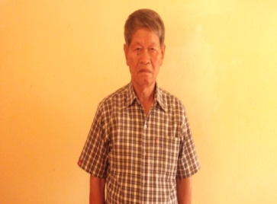 | Name: Kin Sim
 | Organization: AFHOD
Biography: Mr Sim Kin is Executive Director for AFHOD, which assists Khmer low income earners (earning less than $1.00 per day), improves food security, and conducts marketing research.

In the past 25 years has worked for the Department of Social and Health services in Washington State, USA as a social worker providing financial medical assistance and a food program and counseling for disabled persons to be self-sufficient.

He is particularly interested to learn how to protect forests, plan a forest environment programme, and about climate change.

