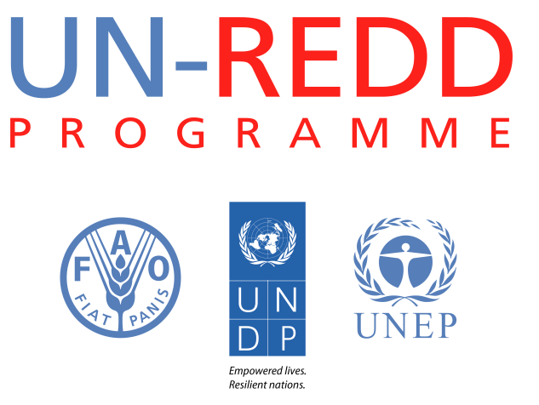
Briefing note : Anti-corruption in REDD+
UN-REDD Programme- July 2012
1. Why is it important to pay attention to corruption in REDD+ ?
Corruption in REDD+ may happen during the design of a national REDD+ strategy: powerful actors may seek to influence policies, through bribery, trafficking in influence and other corrupt means, in order to either skew the distribution of benefits in their favor, including through manipulating the design of land policies, or avoid having to alter their current practices, including illegal logging. Corruption risks in REDD+ could also take the form, during the implementation phase, of embezzlement of REDD+ benefits, and allowing laundering of REDD+ proceeds.
Corruption could undermine the effectiveness of REDD+ as a climate change mitigation instrument, because, with corruption, strategies to address the drivers of deforestation are likely to fail. It will reduce the efficiency with which emission reductions are achieved, as limited financial resources are lost to illegal activities. It will also result in inequitable sharing of benefits, and could pose risks to the human rights of local communities and indigenous stakeholders. Without effectiveness, efficiency and equity, the very sustainability of the REDD+ mechanism is at risk.
REDD+ countries also need to respond to the United Nations Framework Convention on Climate Change‘s "Cancun Agreements", where they have committed to REDD+ countries to promoting and supporting "transparent and effective national forest governance structures". Many countries also have commitments under relevant conventions such as United Nations Convention Against Corruption (UNCAC) and other regional anti-corruption agreements.
Pioneer work on anti-corruption in REDD+ could also potentially pave the way to promote transparency and accountability in other climate finance mechanisms.
2. What are the different risks – is categorizing them important?
UNDP and Transparency International have listed about 25 corruption risks that could occur in REDD+. Those related to the readiness phase (influencing policy design) and implementation of policies and performance payment phases are different. Ultimately, what matters is which ones are more relevant in a specific national context, and therefore which ones need to be tackled first.
3. Are countries acting on these risks?
Yes. For example :
- The Indonesia Participatory Governance Assessment has corruption as a cross-cutting issue, and data currently collected examines the existence and effectiveness of regulations, practices and actors that could prevent specific corruption risks in REDD+.Indicators for example include the number of advocacy initiatives to eradicate corruption in the forestry sector by environmental NGO activists or anti-corruption NGO activists, mechanisms to handle complaints, laws and policies regulating the accountability of institutions, implementation of law enforcement etc.
- Philippines, Bangladesh, Nepal, Peru, and Bhutan are planning to undertake Corruption in REDD+ risks assessments this year
- Viet Nam's phase 2 proposal contains a range of anti-corruption activities, including awareness raising, developing indicators to assess corruption risks, building on the BDS and FPIC work as a basis for a mechanism to handle complaints, designing and implementing measures to ensure open and effective access to information, identify legal ambiguities and loopholes that can create a space for corruption, and developing recommendations for modification to policies and measures related to forest management so as to provide improved incentives to avoid corruption.
- DRC's National Coordination has hired a staff to identify, in consultation with national stakeholders, entry points for anti-corruption measures for REDD+ aligned with the country's readiness process. Intervention will for example include mapping specific corruption risks, developing tools to register complaints, educating community stakeholders in pilot projects on corruption risks and on using these tools, addressing gaps or inconsistencies in legal frameworks conducive to corruption, to and training the judicial system.
In a 2012 poll of anti-corruption practitioners in Asia-Pacific, conducted by UNDP, over 75% of poll takers deemed that addressing corruption risks in REDD+ was either a priority or a top priority.
4. What the UN-REDD Programme does to support them
- Funding and policy & technical support
- Disseminate knowledge through publications and workshops
- Facilitate in-country conversations between, for example, the Anti Corruption Agencies and the national REDD+ teams, or civil society organizations working on REDD+ or dedicated to fighting corruption
- Linking this work to UNDP's support to the implementation of UNCAC and of national anti-corruption strategies
- Link to relevant support provided by the UN-REDD Programme, such as engagement of stakeholders and in particular civil society and indigenous peoples, FPIC, national level recourse mechanism, legal preparedness, safeguards and safeguards information systems and of course the ongoing participatory governance assessments.
5. Early lessons learned
- Governments in REDD+ countries increasingly recognize the pragmatic and reputational risks of not addressing corruption risks in REDD+
- Anti-corruption measures have already started through broader governance efforts, such as participation, and need to be complemented through specific, technical inputs to promote transparency and accountability in different elements of a national REDD+ strategy
- Using institutional and national comparative strengths, lessons learned and networks will be key

Prepared by Estelle Fach, UNDP, UN-REDD Programme
These risks are further detailed in Staying on Track : Tackling Corruption risk in Climate Change, UNDP, 2010, http://tinyurl.com/StayingonTrack-UNDP
Staying on Track : Tackling Corruption risk in Climate Change, UNDP, 2010, http://tinyurl.com/StayingonTrack-UNDP

