UNITED NATIONS DEVELOPMENT PROGRAMME  BDP/EEG - MISSION REPORT SUMMARY  Date: 12 July 2012 |  |  |  | 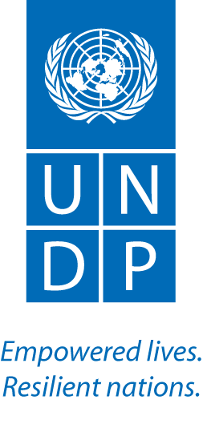
Name  Aki Kono, UN-REDD/GEF EBD |  | Tel No.
Approved Mission Itinerary:  Bangkok – Colombo – Bangkok |  | List of Annexes:  n/a
Inclusive Travel Dates: |  | Key counterpart(s) in each location:
17 July – 17 July 2012 |  | Location: Colombo, Sri Lanka  - Anura Sathurusinghe, Conservator of Forests, Dep of Forest, MoE  - Patrick Evans, FAO Country Represenative  - Ananda Mallawatantri, UNDP CO ARR  - Nalin Munasinghe, FAO CO Officer  - Anna Giovannini, UNV for UN-REDD  - Jinie and Sithara, Local Experts
Purpose/Objectives of Mission
Provide support for the revision of the R-PP and preparation of the National Programme Document for the (re)submission.

Context

Sri Lanka’s Natioanl Programme was approved by the UN-REDD Policy Board on the 27th of March this year. Since then, Sir Lanka has been given six months to fully address the official review comments and resubmit the RPP together with the National Programme Document (NPD) elaborating the UN-REDD Programme’s scope of support in the country as well as the UN agencies roles and responsibilities in implementing the Programme. Upon successful resubmission, the release of funds will take place, followed by the commencement of the Programme. On this basis, the country is expected to (re)submit a revised RPP along with a response matrix and the NPD before the end of September this year.
Summary of Mission Activities/ Findings

This short mission to Colombo was to assist the country team in finalizing the R-PP revision process and NPD preparation in order to ensure the Programme’s speedy transition into the implementation phase. Two full days were spent mainly on internal discussions to review responses and how and where in the R-PP to address outstanding review comments. Also, a brief meeting at the FAO Country Rep’s office was held to update and discuss immediate actions (e.g., PMU recruitment) with the country team (Govn’t, FAO, and UNDP).

Key points:
- Nearly all review comments on the R-PP have been addressed. There are still several outstanding comments which require inputs from the UN-REDD regional advisors and national institutions, and they are currently being addressed by the regional advisors and national focal points.
- The National Programme document (NPD) has been prepared. The document is about 80% complete. Specific areas that require inputs and advice from the UN-REDD regional advisors have been identified.
- The plan is to have the revised R-PP along with the response matrix and the NPD (re)submitted to the UN-REDD Sec by mid-August.
- FAO will be handling the establishment of PMU hence the recruitment of the PMU personnel. Based on the discussion during this mission, the general posts will be recruited through the special contracting modality of the Government to be in line with the national policy on development project management, while the recruitment of technical staff will be directly handled by the UN agencies. In all cases, formal approval from the Department of External Resources will be required.

Observation:

The NPD template introduces similar but different logframe and M&E framework tables from the R-PP. There should be a special consideration for non-Common Delivery Partner countries like Sri Lanka to have a more streamlined process, going from R-PP to NDP.

Follow up actions:  - UN-REDD regional advisors to provide technical assistance in addressing any outstanding comments.  - The country team to complete the revision of the R-PP and NPD to have them (re)submitted to the UN-REDD Sec by mid-August. |  |  | Distribution List:  - Tim Clairs, UN-REDD UNDP PTA  - Tim Boyle, UN-REDD AP  - Clea Paz, UN-REDD Secretariat  - Ananda Mallawatantri, UNDP CO ARR

