UNITED NATIONS DEVELOPMENT PROGRAMME  BDP/EEG - MISSION REPORT SUMMARY  Date: 12 July 2012 |  |  | 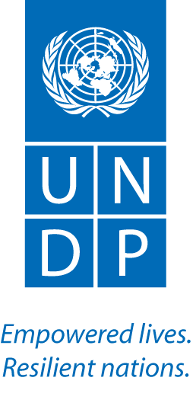
Name  Aki Kono, UN-REDD/GEF EBD | Tel No.
Approved Mission Itinerary:  Bangkok – Honiara – Bangkok | List of Annexes:  n/a
Inclusive Travel Dates: | Key counterpart(s) in each location:
21 July – 30 July 2012  Joint mission with Ben Vickers, FAO Regional Forestry Officer | Location: Honiara, Solomon Islands  Counterparts:  Chanel Iori, Acting Permanent Secretary, MECDM  Gordon Konairamo, Under Secretary, MOFR  PEB Mebmers including MoFR, NGOs, development partners (SPC/GIZ, JICA,etc.)  Akiko Suzaki, UNDP DRR  Fred Patison, PMU Manger  Gloria Suluia, UNDP Programme Officer  Deltina Solomon, UNDP Programme Associate  Jennifer Kuma Kilua, PMU Assistant
Purpose/Objectives of Mission:
Assist with the preparation for the first Programme Executive Board (PEB) meeting in the Solomon Islands, and provide guidance to the PMU to initiate stakeholder engagement and REDD+ Roadmap/guidelines development processes.
Context
The UN-REDD Initial Programme in the Solomon Islands has suffered setbacks during the past 11 months since the inception workshop due to political unrest and capacity constraints, especially high staff turnover at the UNDP CO and difficulty in recruiting the PMU personnel. After having applied an innovative approach and adaptive management, the PMU is now in place. The Programme’s first PEB meeting was held on July 27. The Initial Programme is establishing the national taskforce and expecting rapid progress in delivery of the Programme outcomes.
Summary of Mission Activities/ Findings
The key activities during the mission include the provision of:
- Induction training on the UN-REDD Programme and Initial National Programme in the Solomon Islands to the new PMU staff and CO Programme Officer;
- Technical assistance in the PEB meeting preparation – agenda setting, etc. and providing key information and recommendations during the PEB meeting when and where requested by the PEB members; and
- Technical guidance in activity and budget planning and initiating the establishment of a national REDD+ taskforce and process of developing a National REDD+ Roadmap/policy.
Key points:
- Considering the delays in implementation and capacity and resource constraints faced by the country, a multi-year budget was reviewed and revised to meet the current national circumstances. This has resulted in three key adjustments:
- By taking into account the 12 month delay in implementation and realistic delivery projection, the programme budget has been updated to extend till the first quarter of 2014, which will necessitate another no-cost extension. The PEB has agreed to send a request to the UN-REDD Sec at the end of this year so that such a request will be backed by the improved delivery and progress status.
- To provide continuous policy and technical guidance to address capacity constraints, an international policy advisor will be engaged on a part time basis. The cost will be shared across all Outputs and partly covered by the Tier 2 UNDP project ($50K)
- By considering the capacity and resource constraints, the PEB has agreed to narrow the focus of the Programme to the development of a national REDD+ roadmap with three policy guidelines on stakeholder engagement, safeguards and MRV. Demonstration activities will not be funded by the Programme, but through inclusive planning, the Government will encourage other development partners (Live&Learn, SPC/GIZ, JICA, GEF) to support the demonstration components.
- Multi-sectoral taskforce will be established to support the development of the national REDD+ Roadmap/policy. The members include the private sectors (extractive industries, tourism and financial sectors).
Follow up actions:  - Aki to follow up on the no-cost extension procedure with Clea Paz.  - Regional UN-REDD team to:  - support technical evaluation of candidates for the policy advisor position  - assist the PMU in providing technical guidance to the work of the taskforce  - The Government focal points, PMU, UNDP CO and UN-REDD regional team to work on increased coordination and collaboration with development partners in SI. |  | Distribution List:  - Tim Clairs, UN-REDD UNDP PTA  - Tim Boyle, UN-REDD AP Coordinator  - Fred Patison, PMU Manager  - Gloria Sula, UNDP CO Programme Officer  - Clea Paz, UN-REDD Secretariat

