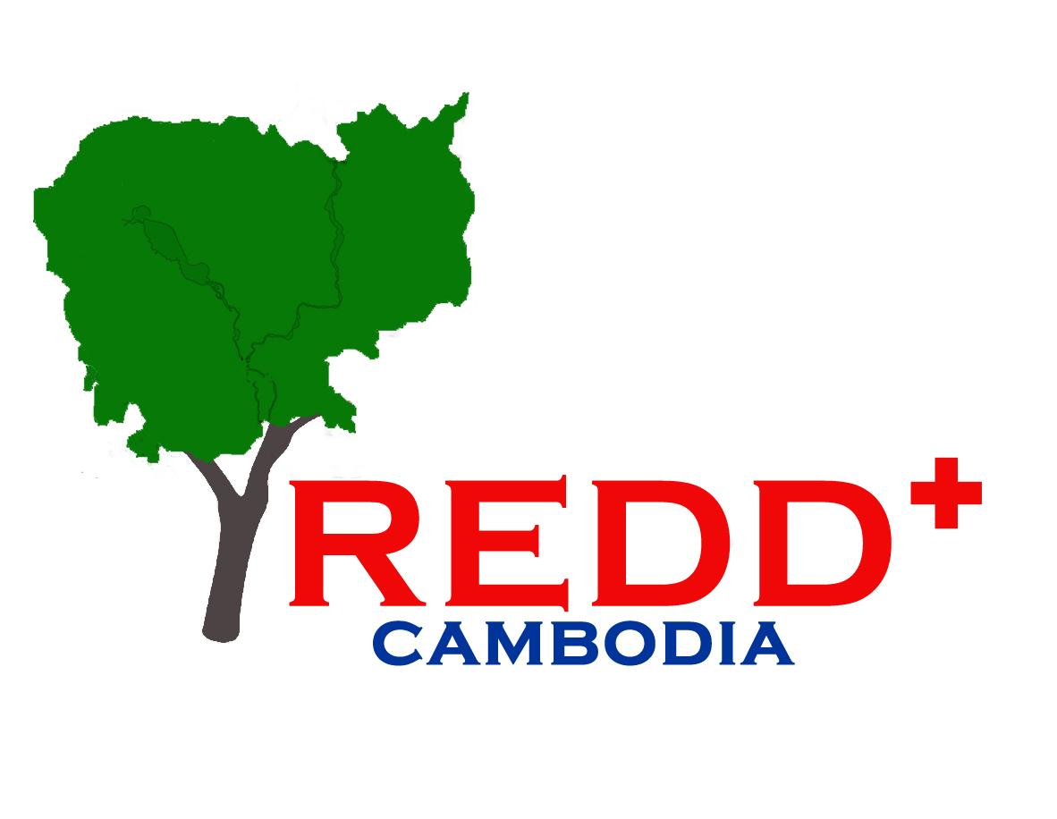 | CONCEPT PAPER
Title of activity | National meeting on assessment of existing fund mechanisms under Cambodia Law (activity 2.3e)
Outcome/output from Results Framework | Output 2.3: Establishing REDD+ Fund mechanisms and Revenue sharing
Anticipated timing | 9th January 2014
Duration | 0,5 Day

Objective of activity:
To present and discuss findings from the assessment of existing fund mechanisms under Cambodia Law including international experiences with regards to the establishment of national Funds targeted to REDD+.

Justification:
Output 2.3 of the UN-REDD National Programme include an activity to assess options in Cambodian Law for establishment of a REDD+ Fund.
Following UNFCCC COP19 REDD+ countries are invited to identify national entities (e.g. a REDD+ Fund) to receive international incentives for result-based actions. This meeting will provide an opportunity to present and discuss the findings from an assessment of existing fund mechanism in Cambodian Law.

Approach:
The consultancy team hired for the assessment of existing fund mechanisms under Cambodia Law will develop the agenda for the meeting, identify relevant stakeholders, relevant speakers and prepare a presentation to facilitate discussions in consultation with the REDD+ Taskforce Secretariat.
Besides key stakeholders in Cambodia including the REDD+ Taskforce members and other members from government and non-governmental organizations in total around30 people, the meeting will seek to invite other actors working on national fund mechanism either in Cambodia or neighbouring countries. All REDD+ countries are likely to begin considerations on how to establish a national REDD+ Fund, and while the national context between countries are likely to be different, there will also be opportunities to learn from each other. The conducted assessment will be presented by the consultant. National and international experts will be invited to participate and make presentations in order to provide for a rich discussion.

Key Outputs:
The outputs of the activity will be:
- Provide further input to the assessment of existing fund mechanisms under Cambodia Law and identify possible next steps for providing the necessary documentation for taking a decision on the establishment of a national Fund to receive international incentives for results-based actions.
The benefits of the activity will include:
- Increased awareness on the possibilities and requirements for a national REDD+ Fund.

Agenda:
Time | Topic | Speaker/Presenter
08.00-08.30 | Registration
08.30-09.00 | Opening Ceremony  - Announcement of Program  - National Anthem  - Opening speech | H E Chea Sam Ang, Chair of the REDD+ Taskforce
09.00-09.20 | Setting the context and introducing the activity | Mr. Khun Vathana, Head of the REDD+ Taskforce Secretariat
09:20-09:50 | Presentation on Assessment of Mechanisms for REDD+ National Fund | Gillian Duggin
09:50-10:10 | Q&A
10:10-10:30 | Coffee break
10:30-10:45 | Presentation by stakeholder – experiences with a national Fund  - Commune/Sangkat Fund | Government official from Commune/Sangkat Fund
10:45-11:00 | Presentation by stakeholder – project based Fund  - Seima pilot projects | NGO representative from Seima pilot projects
11:00-11:15 | Presentation by international speaker – international experience developing National REDD+ Fund  - Vietnam experiences | Representative of LEAF on VietNam experiences?
11:15-12:00 | Panel Q&A and Discussion; Recommendations/Outcomes | Facilitated by UN-REDD Programme team
12.00 | Lunch

Suggested participants: 35 people
 | Members of REDD+ Taskforce | (09 people)
01 | H.E Chea Sam Ang | Chair of Taskforce | FA
02 | Mr. Kim Nong | Vice chair of Taskforce | GDANCP
03 | H.E Cheam Pe A | Member of Taskforce | MoI
04 | H.E Net Mony | Member of Taskforce | MEF
05 | Ms. Pov Voreleak | Member of Taskforce | MIME
06 | Mr. Ouk Vibol | Member of Taskforce | FiA
07 | Mr. Dok Doma | Member of Taskforce | MRD
08 | Mr. Keo Omaliss | Member of Taskforce | FA
09 | Mr. Sao Vary | Member of Taskforce | MLUMC
 | Consultation Group | (05 people)
01 | Ms. Hou Kalyan | Consultation Group | INGO
02 | Ms. Teng Rithiny | Consultation Group | NGO Forum
03 | Mr. Va Moeun | Consultation Group | Mlop Baitong
04 | Mr. Seak Sophat | Consultation Group | RUPP
05 | Mr. Kim Narong | Consultation Group | INGO
 | Key government officials | (06 people)
01 | Mr.Yam Meng Sean | Benefit Sharing Technical Team | MoI
02 | Ms. Seang Sokunthy | Benefit Sharing Technical Team | MIME
03 | Mr. Chan Sopheap | Benefit Sharing Technical Team | FiA
04 | Mr. Heng Hong | Benefit Sharing Technical Team | GDANCP
05 | Mr. Long Ratanak Koma | Benefit Sharing Technical Team | FA
06 | Mr. Chhun Delux | Technical officer | FA
 | Development partners and NGOs involved in REDD+ | (08 people)
01 | Mr. Hiroshi Nakata | Advisor to DG - FA | CAM-REDD
02 | Mr. Shigeru Ono
03 | Ms. Moeko Saito Jensen | Programme Analist | UNDP
04 | Mr. Jeremy Braohead |  | LEAF
05 | Mr. Alex Diment | Seima Pilot project | WCS
06 | Mr. Peter Iversen | REDD+ Technical Expert | UNDP
07 | Mr. Mathieu VanRijn | FAO Technical Specialist | FAO
08 | Mr. Brad Arsenault | Environment Officer | USAID
 | REDD+ Taskforce Secretariat | (07 people)
01 | Mr. Khun Vathana | Head of RTS | RTS
02 | Mr. Uy Kamal | Vice head of TRS | RTS
03 | Mr. Lun Kimhy | Programme Coordinator | RTS
04 | Ms. Pan Thida | Finance & Procurement officer | RTS
05 | Ms. Thy Heang | Communication officer | RTS
06 | Mr. Teng Huort | Admin Assistant | RTS
07 | Ms. Duk Sireivathana | Finance Assistant | RTS

Proposed Budget:
Description | Unite | Rate (USD) | Total
Meeting stationeries (Copies, Pen, Paper, …etc) | 30 | 5 | 150
Backdrop/ banner | 1 | 150 | 150
Meeting Room (0,5 days with refreshment & lunch) | 35 | 25 | 875
Translator for half a day | 0,5 | 300 | 150
Headphone and booth rental | 15 | 1 | 15
Total |  |  | 1,350

